**LABORATORY MANUAL  
Computer Engineering Department­**



**SOFTWARE ENGINEERING**

*Submitted by*

**Zohaib Amjad | 51928**

*Lab Instructor*

Mr. M. Shahzeb Khan

Lab Engineer, Department of Computer Engineering,  
Faculty of Information & Communication Technology,   
BUITEMS, Quetta.

**Session Fall – 2019**

# TABLE OF CONTENTS

TABLE OF CONTENTS ii

CERTIFICATE ix

CLOs PLOs MAPPING x

LIST OF EXPERIMENTS xi

SOFTWARE REQUIRMENT SPECIFICATION (SRS) EXPOLARARION AND MAKING xi

DOCUMENT VERSION DETAILS xii

29/11/2021 xiii

**LAB NO.1** xiii

ENTITY RELATIONSHIP DIAGRAM (ERD) xiii

Lab outcomes: xiii

Corresponding CLO and PLO: xiii

SOFTWARE REQUIRED: xiii

Theory: xiii

Entity xiii

Relationship xiii

Attribute xiii

A SIMPLE EXAMPLE xiv

FURTHER DISCUSSION: xvii

Task: xix

Observations: xx

Rubrics xxi

29/11/2021 xxii

**LAB NO.2** xxii

PROJECT GANTT CHART EXPLORATION AND MAKING xxii

Lab outcomes: xxii

Corresponding CLO and PLO: xxii

Theory: xxii

How to make a Gantt chart in Excel xxiv

Task: xxxvii

Observations: xxxvii

Rubrics xxxviii

06/12/2021 xxxix

**LAB NO.3** xxxix

USE CASE DIAGRAM xxxix

Lab outcomes: xxxix

Corresponding CLO and PLO: xxxix

SOFTWARE REQUIRED: xxxix

Theory: xxxix

List of UML Diagram Types xxxix

What is a use case diagram? xl

When to apply use case diagrams xl

Use case diagram components xli

Use case diagram symbols and notation xlii

Use case diagram examples xliii

Chainsaw use case diagram example xliv

Task: xlv

Observations: xlv

Rubrics xlvii

13/12/2021 xlviii

**LAB NO.4** xlviii

CLASS DIAGRAM xlviii

Lab outcomes: xlviii

Corresponding CLO and PLO: xlviii

SOFTWARE REQUIRED: xlviii

Theory: xlviii

List of UML Diagram Types xlviii

What is a class diagram in UML? xlix

Benefits of class diagrams l

Class diagrams offer a number of benefits for any organization. Use UML class diagrams to: l

• Illustrate data models for information systems, no matter how simple or complex. l

• Better understand the general overview of the schematics of an application. l

• Visually express any specific needs of a system and disseminate that information throughout the business. l

• Create detailed charts that highlight any specific code needed to be programmed and implemented to the described structure. l

• Provide an implementation-independent description of types used in a system that are later passed between its components. l

Basic components of a class diagram l

Relationships in Class Diagrams liii

Association liii

Directed Association liv

Reflexive Association liv

Multiplicity liv

Aggregation lv

Composition lv

Inheritance / Generalization lvi

Realization lvi

Class diagram examples lvi

How to make a class diagram lviii

Task: lviii

Observations: lix

Rubrics lx

20/12/2021 lxi

**LAB NO.5** lxi

Software Requirements Specification(SRS) Exploration and Making lxi

Lab outcomes: lxi

Corresponding CLO and PLO: lxi

Requirements: lxi

*Hardware Requirements:* lxi

*Software Requirements:* lxi

Theory: lxi

SRSshouldaddressthefollowing lxii

CharacteristicsofagoodSRS lxii

AsampleofbasicSRSOutline lxiii

Task: lxiv

Observations: lxiv

Rubrics lxv

27/12/2021 lxvi

**LAB NO.6** lxvi

Sequence Diagram lxvi

Lab outcomes: lxvi

Corresponding CLO and PLO: lxvi

Requirements: lxvi

Theory: lxvi

What is a sequence diagram in UML? lxvi

Benefits of sequence diagrams lxvi

Use cases for sequence diagrams lxvi

Basic symbols and components lxvii

Common message symbols lxviii

Sequence diagram examples lxx

Sequence diagram of a hospital management system lxx

Sequence diagram for ATM systems lxx

How to make a sequence diagram lxxii

Task: lxxiii

Observations: lxxiii

Rubrics lxxiv

**14/02/2022** lxxv

**LAB NO.7** lxxv

Data Flow Diagram (DFD) lxxv

Lab outcomes: lxxv

Corresponding CLO and PLO: lxxv

Requirements: lxxv

Theory: lxxv

Task: lxxviii

Observations: lxxix

Rubrics lxxx

21/2/2022 1

**LAB NO.8** 1

Introduction to Anaconda, Python, and Selenium WebDriver 1

Lab outcomes: 1

Corresponding CLO and PLO: 1

SOFTWARE REQUIRED: 1

Theory: 1

Installation of anaconda: 2

Installation of python: 6

Selenium webdriver: 7

Observations: 8

Rubrics 9

28/02/2022 10

**LAB NO.9** 10

An Introduction to Selenium with Python 10

Lab outcomes: 10

Corresponding CLO and PLO: 10

Requirements: 10

Theory: 10

Binding Selenium with Python 11

Why Should You Learn Selenium? 11

Web Drivers for Using Selenium With Python 11

Selenium WebDriver Methods 11

WebElement Methods for Selenium With Python 12

Walkthrough of the example 13

Wrapping Up! 16

Experiment: 16

Task: 18

Python language is used with Selenium for testing. It has far less verbose and easy to use than any other programming language. The Python APIs empower you to connect with the browser through Selenium. Selenium can send the standard Python commands to different browsers, despite variation in their browser's design. 20

Rubrics 20

7/03/2022 22

**LAB NO.10** 22

Performance Testing with JMeter 22

Lab outcomes: 22

Corresponding CLO and PLO: 22

Requirements: 22

Theory: 22

What is Performance Testing? 22

What is JMeter? 23

Elements of JMeter 24

Experiment: 28

Installation of JMeter: 28

Performance Testing with JMeter 30

Task: 33

Observations: 37

The JMeter tool is easy to use for injecting load on web application servers. Development and quality engineers can easily simulate a heavy load on a server using JMeter tool without doing extra setup for virtual users, extra efforts for scripting and can measure accurate response time in form of charts and table summary. JMeter results charts are useful locate bottlenecks and improve performance of the web server application. Quality engineers can identify the culprit RestAPI by analyzing JMeter results charts. JMeter tool is also used to perform server benchmark tests and scalabiity tests. 37

Rubrics: 37

14/03/2022 38

**LAB NO.11** 38

Work Management with Asana 38

Lab outcomes: 38

Corresponding CLO and PLO: 38

Requirements: 39

Theory: 39

1. How to create a task 39

Task best practice 39

2. How to create your first project 39

Types of projects you can managein Asana 40

3. Organize your project 40

Group related tasks together with sections 40

Sort and filter tasks in projects with custom fields 41

4. How to find your work and updates about it 42

My Tasks 42

Inbox 42

5. How Asana's organized 42

Task: 43

Observations: 45

14/03/2022 47

**LAB NO.12** 47

Bug Tracking and Agile Project Management with Jira 47

Lab outcomes: 47

Corresponding CLO and PLO: 47

Requirements: 47

Theory: 47

What is agile project management? 47

Step 1: Create a scrum project 47

Step 2: Create user stories or tasks in the backlog 47

Step 3: Create a sprint 48

Step 4: Hold the sprint planning meeting 49

Step 5: Start the sprint in Jira 51

Step 6: Hold the daily standup meetings 52

Step 7: View the Burndown Chart 52

Step 8: View the sprint report 53

Step 9: Hold the sprint review meeting 53

Step 10: Hold the sprint retrospective meeting 54

Step 11: Complete the sprint in Jira 55

Step 12: Repeat from step 2 55

Task: 55

Observations: 56

Rubrics 57

# CERTIFICATE

This is certified that Mr./Miss. **Zohaib Amjad** bearing CMS ID **51928** has successfully completed the laboratory manual of Software Engineering in his/her 5th semester of BS (Computer Engineering), Batch Fall-2019 under the supervision of his/her lab instructor **Mr. M. Shahzeb Khan**.

**_________________ __________________  
Lab Manual Marks Instructor Signature**

# CLOs PLOs MAPPING

|  |  |  |  |  |
| --- | --- | --- | --- | --- |
| **Course Learning Outcomes (Laboratory)** | | | | |
| **Sr. No.** | **CLO** | **Domain** | **Taxonomy Level** | **PLO** |
| 1 | **Creates** UML diagrams for visualization of software systems | Psychomotor | P7 | PLO-3: Design/Development of Solutions |
| 2 | **Use** tools and techniques for software designing, software testing, and documentation of software systems. | Psychomotor | P4 | PLO-5: Modern Tool Usage |

# LIST OF EXPERIMENTS

|  |  |
| --- | --- |
| **Sr. No** | **Experiments** |
| **1** | ENTITY RELATIONSHIP DIAGRAM (ERD) |
| **2** | PROJECT GANTT CHART EXPLORATION AND MAKING |
| **3** | USE CASE DIAGRAM |
| **4** | CLASS DIAGRAM |
| **5** | SOFTWARE REQUIRMENT SPECIFICATION (SRS) EXPOLARARION AND MAKING |
| **6** | SEQUENCE DIAGRAM |
| **7** | DATA FLOW DIAGRAM |
| **8** | INTRIDUCTION TO ANACONDA, PYTHON AND SELENIUM WEBDRIVER |
| **9** | AN INTRODUCTION TO SELENIUM WITH PYTHON |
| **10** | PERFORMANCE TESTING WITH JMETER |
| **11** | WORK MANAGEMENT WITH ASANA |
| **12** | BUG TRACKING AND AGILE PROJECT MANAGEMENT WITH JIARA |
|  |  |
|  |  |
|  |  |

Note: The above list of experiments is common for this subject in all concerned departments of FICT, however, the subject instructor shall choose the relevant experiments among this list according to the program requirements.

|  |  |  |  |
| --- | --- | --- | --- |
| **Version** | **Date** | **Author** | **Rationale** |
| **1.0** |  |  | **First Draft**  **(Lab Format Design)** |
| **1.1** |  |  | **Reviewed**  **(Common lab titles updated)** |
| **1.2** |  |  | **Modified**  **(Program relevant experiments are selected from the given common list of experiments)** |
| **1.3** |  |  | **The document adopted and implemented as a lab subject** |

# DOCUMENT VERSION DETAILS

29/11/2021

LAB NO.1

# ENTITY RELATIONSHIP DIAGRAM (ERD)

## Lab outcomes:

After completing this lab, students will be able to:

* Understand concepts of data modeling and its purpose
* Learn how relationships between entities are defined and refined, and how such relationships are incorporated into the database design process
* Learn how ERD components affect database design and implementation
* Learn how to interpret the modeling symbols
* Draw a sample Entity Relationship Diagram for project or system.

## Corresponding CLO and PLO:

* CLO-1, PLO-3(Design/Development of Solutions)

## SOFTWARE REQUIRED:

Rational Rose, Windows 7/10

## Theory:

Entity Relationship Diagrams are a major data modelling tool and will help organize the data in your project into entities and define the relationships between the entities. This process has proved to enable the analyst to produce a good database structure so that the data can be stored and retrieved in a most efficient manner.

### Entity

A data entity is anything real or abstract about which we want to store data. Entity types fall into five classes: roles, events, locations, tangible things or concepts. E.g. employee, payment, campus, book. Specific examples of an entity are called instances. E.g. the employee John Jones, Mary Smith's payment, etc.

### Relationship

A data relationship is a natural association that exists between one or more entities. E.g. Employees process payments. Cardinality defines the number of occurrences of one entity for a single occurrence of the related entity. E.g. an employee may process many payments but might not process any payments depending on the nature of her job.

### Attribute

A data attribute is a characteristic common to all or most instances of a particular entity. Synonyms include property, data element, field. E.g. Name, address, Employee Number, pay rate are all attributes of the entity employee. An attribute or combination of attributes that uniquely identifies one and only one instance of an entity is called a primary key or identifier. E.g. Employee Number is a primary key for Employee.

#### ANENTITY RELATIONSHIPDIAGRAMMETHODOLOGY:(Oneway ofdoingit)

Table 1 Entity Relationship Methodology

|  |  |
| --- | --- |
| 1.IdentifyEntities | Identifythe roles,events,locations, tangiblethings or concepts about which the end-users want to storedata. |
| 2. Find Relationships | Find thenaturalassociations between pairs of entities usinga relationship matrix. |
| 3. Draw Rough ERD | Put entities in rectanglesand relationships on linesegments connectingthe entities. |
| 4. Fill in Cardinality | Determinethe number of occurrences of one entityfor asingle  Occurrence ofthe related entity. |
| 5. DefinePrimaryKeys | Identifythe dataattribute(s)that uniquelyidentifyone and only  One occurrenceof each entity. |
| 6. Draw Key-BasedERD | EliminateMany-to-Manyrelationships and include primaryand  Foreign keys in eachentity. |
| 7.IdentifyAttributes | Name theinformation details (fields) which areessential to the  System under development. |
| 8. Map Attributes | Foreach attribute, matchit with exactlyone entitythat it describes. |
| 9. Draw fullyattributedERD | Adjust the ERD from step 6 to account forentities or relationships  discovered in step 8. |
| 10. Check Results | Does the final EntityRelationship Diagram accuratelydepict the system data? |

### A SIMPLE EXAMPLE

A company has several departments. Each department has a supervisor and at least one employee. Employees must be assigned to at least one, but possibly more departments. At least one employee is assigned to a project, but an employee may be on vacation and not assigned to any projects. The important data fields are the names of the departments, projects, supervisors and employees, as well as the supervisor and employee number and a unique project number.

#### Identify Entities

The entities in this system are Department, Employee, Supervisor and Project. One is tempted to make Company an entity, but it is a false entity because it has only one instance in this problem. True entities must have more than one instance.

**Find Relationships**

We construct the following Entity Relationship Matrix:

Table 2 Entity Relationship Matrix

|  |  |  |  |  |
| --- | --- | --- | --- | --- |
|  | **Department** | **Employee** | **Supervisor** | **Project** |
| Department |  | is assigned | run by |  |
| Employee | belongs to |  |  | works on |
| Supervisor | runs |  |  |  |
| Project |  | uses |  |  |

#### DrawRoughERD

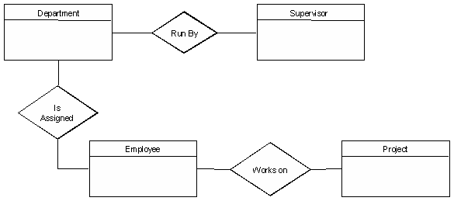We connect the entities whenever a relationship is shown in the entity Relationship Matrix.

Figure 1: ER Diagram

#### Fill in Cardinality

From the description of the problem we see that:

* Each department has exactly one supervisor.
* A supervisor is in charge of one and only one department.
* Each department is assigned at least one employee.
* Each employee works for at least one department.
* Each project has at least one employee working on it.

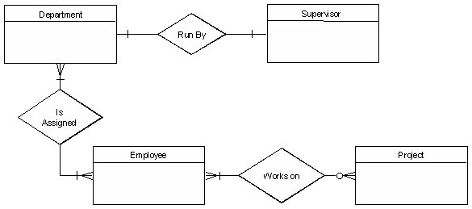An employee is assigned to 0 or more projects.

Figure 2: ER Diagram with Relationships

#### DefinePrimary Keys

The primary keys are Department Name, Supervisor Number, Employee Number, Project Number.

#### DrawKey-Based ERD

There are two many-to-many relationships in the rough ERD above, between Department and Employee and between Employee and Project. Thus we need the associative entities Department-Employee and Employee-Project. The primary key for Department-Employee is the concatenated key Department Name and Employee Number. The primary key for Employee- Project is the concatenated key Employee Number and Project Number.

#### Identify Attributes

The only attributes indicated are the names of the departments, projects, supervisors and employees, as well as the supervisor and employee NUMBER and a unique project number.

#### Map Attributes

Table 3 Entity Relationship Attributes Mapping

|  |  |  |  |
| --- | --- | --- | --- |
| **Attribute** | **Entity** | **Attribute** | **Entity** |
| Department  Name | Department | Supervisor  Number | Supervisor |
| Employee  Number | Employee | Supervisor  Name | Supervisor |
| Employee  Name | Employee | Project Name | Project |
|  |  | Project  Number | Project |

#### DrawFully Attributed ERD

Figure 3 Fully Attributed ER Diagram

#### Check Results

Thefinal ERD appears tomodel the data in this system well.

### FURTHER DISCUSSION:

#### Step 1. Identify Entities

A data entity is anything real or abstract about which we want to store data. Entity types fall into five classes: roles, events, locations, tangible things, or concepts. The best way to identify entities is to ask the system owners and users to identify things about which they would like to capture, store and produce information. Another source for identifying entities is to study the forms, files, and reports generated by the current system. E.g. a student registration form would refer to Student (a role), but also Course (an event), Instructor (a role), Advisor (a role), Room (a location), etc.

#### Step 2. Find Relationships

There are natural associations between pairs of entities. Listing the entities down the left column and across the top of a table, we can form a relationship matrix by filling in an active verb at the intersection of two entities which are related. Each row and column should have at least one relationship listed or else the entity associated with that row or column does not interact with the rest of the system. In this case, you should question whether it makes sense to include that entity in the system.

#### Step 3. DrawRoughERD

Using rectangles for entities and lines for relationships, we can draw an Entity Relationship Diagram (ERD).

#### Step 4. Fill in Cardinality

At each end of each connector joining rectangles, we need to place a symbol indicating the minimum and maximum number of instances of the adjacent rectangle there are for one instance of the rectangle at the other end of the relationship line. The placement of these numbers is often confusing. The first symbol is either 0 to indicate that it is possible for no instances of the entity joining the connector to be related to a given instance of the entity on the other side of the relationship, 1 if at least one instance is necessary or it is omitted if more than one instance is required. For example, more than one student must be enrolled in a course for it to run, but it is possible for no students to have a particular instructor (if they are on leave).

The second symbol gives the maximum number of instances of the entity joining the connector for each instance of the entity on the other side of the relationship. If there is only one such instance, this symbol is 1. If more than 1, the symbol is a crows foot opening towards the rectangle.

If you read it like a sentence, the first entity is the subject, the relationship is the verb, the cardinality after the relationship tells how many direct objects (second entity) there are.

#### Step 5. DefinePrimaryKeys

For each entity we must find a unique primary key so that instances of that entity can be distinguished from one another. Often a single field or property is a primary key (e.g. a Student ID). Other times the identifier is a set of fields or attributes (e.g. a course needs a department identifier, a course number, and often a section number; a Room needs a Building Name and a Room Number). When the entity is written with all its attributes, the primary key is underlined.

#### Step 6. DrawKey-Based ERD

Looking at the Rough Draft ERD, we may see some relationships which are non-specific or many-to-many. I.e., there are crows feet on both ends of the relationship line. Such relationships spell trouble later when we try to implement the related entities as data stores or data files, since each record will need an indefinite number of fields to maintain the many-to-many relationship.

Fortunately, by introducing an extra entity, called an associative entity for each many-to-many relationship, we can solve this problem. The new associative entity's name will be the hyphenation of the names of the two originating entities. It will have a concatenated key consisting of the keys of these two entities. It will have a 1-1 relationship with each of its parent entities and each parent will have the same relationship with the associative entity that they had with each other before we introduced the associative entity. The original relationship between the parents will be deleted from the diagram.

The key-based ERD has no many-to-many relationships and each entity has its primary and foreign keys listed below the entity name in its rectangle.

#### Step 7. Identify Attributes

A data attribute is a characteristic common to all or most instances of a particular entity. In this step we try to identify and name all the attributes essential to the system we are studying without trying to match them to particular entities. The best way to do this is to study the forms, files and reports currently kept by the users of the system and circle each data item on the paper copy. Cross out those which will not be transferred to the new system, extraneous items such as signatures, and constant information which is the same for all instances of the form (e.g. your company name and address). The remaining circled items should represent the attributes you need. You should always verify these with your system users. (Sometimes forms or reports are out of date.)

#### Step 8. Map Attributes

For each attribute we need to match it with exactly one entity. Often it seems like an attribute should go with more than one entity (e.g. Name). In this case you need to add a modifier to the attribute name to make it unique (e.g. Customer Name, Employee Name, etc.) or determine which entity an attribute "best' describes. If you have attributes left over without corresponding entities, you may have missed an entity and its corresponding relationships. Identify these missed entities and add them to the relationship matrix now.

#### Step 9. DrawFully-Attributed ERD

If you introduced new entities and attributes in step 8, you need to redraw the entity relationship diagram. When you do so, try to rearrange it so no lines cross by putting the entities with the most relationships in the middle. If you use a tool like Systems Architect, redrawing the diagram is relatively easy.

Even if you have no new entities to add to the Key-Based ERD, you still need to add the attributes to the Non-Key Data section of each rectangle. Adding these attributes automatically puts them in the repository, so when we use the entity to design the new system, all its attributes will be available.

#### Step 10. Check Results

Look at your diagram from the point of view of a system owner or user. Is everything clear? Check through the Cardinality pairs. Also, look over the list of attributes associated with each entity to see if anything has been omitted.

## Task:

Draw an ERD diagram of any project of your choice here. Project must contain atleast three Entities. To make an accurate diagram you can follow the above mentioned steps.

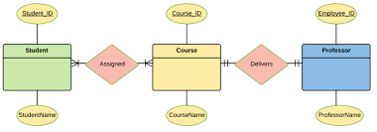.

## Observations:

In This Lab We learn about Er Digram. How we use Lucid Chart to make relations between entities. Its Considered best practice to complete ER Modeling before implementing your database.

## Rubrics

|  |  |  |  |  |  |  |
| --- | --- | --- | --- | --- | --- | --- |
| **Demonstration** | Absent | Student is unable to follow the provided instructions properly.  The student can name the hardware or simulation platform, but unable to implement anything practically or on the software | Student can understand the provided laboratory instructions and familiar with the lab environment (Trainer/ software/ IDE), but cannot implement on the platform practically or on the software | Student has followed instructions to construct the fundamental schematic/ block diagram/ code/ model on the protoboard/ trainer/ simulation software. | Student has constructed the functional/ working schematic/ model/ block diagram/ code, and have successfully executed the program/ run circuit on software platform | Student perfectly implemented a working model/ logic/ circuit/ block diagram/ code and successfully executed the lab objective in Realtime or in a simulation environment and produced the desired results |
| **Category** | ***Ungraded*** | **Very Poor** | **Poor** | **Fair** | **Good** | **Excellent** |
| **Percentage** | [0] | [1-20] | [21-40] | [41-60] | [61-80] | [81-100] |
| **Marks** | 0.0 | 0.01 - 0.20 | 0.21 - 0.40 | 0.41 - 0.60 | 0.61 - 0.80 | 0.81 - 1.0 |
| **Date** |  | **Total Marks** |  | **Instructor’s Signature** | |  |

|  |  |  |  |  |  |  |
| --- | --- | --- | --- | --- | --- | --- |
| **Laboratory Reports** | Report not submitted | Plagiarized content presented or incomplete submission | Requirements are listed and experimental procedure is presented | Observations are recorded along with detailed procedure | Appropriate computations or numerical analysis is performed | Correctly drawn conclusion with  exact results and complete report in all respects |
| **Category** | ***Ungraded*** | **Very Poor** | **Poor** | **Fair** | **Good** | **Excellent** |
| **Percentage** | [0] | [1-20] | [21-40] | [41-60] | [61-80] | [81-100] |
| **Marks** | 0.0 | 0.01 - 0.20 | 0.21 - 0.40 | 0.41 - 0.60 | 0.61 - 0.80 | 0.81 - 1.0 |
| **Date** |  | **Total Marks** |  | **Instructor’s Signature** | |  |

29/11/2021

LAB NO.2

# PROJECT GANTT CHART EXPLORATION AND MAKING

## Lab outcomes:

After completing this lab, students will be able to:

* Schedule Estimation using Gantt Chart.
* Make Gantt Chart using Microsoft Excel

## Corresponding CLO and PLO:

* CLO-2, PLO-5(Modern Tool Usage)

## Theory:

**Introduction:**

Gantt chart is a type of a bar chart that is used for illustrating project schedules. Gantt charts can be used in any projects that involve effort, resources, milestones and deliveries.

At present, Gantt charts have become the popular choice of project managers in every field. Gantt charts allow project managers to track the progress of the entire project. Through Gantt charts, the project manager can keep a track of the individual tasks as well as of the overall project progression.

In addition to tracking the progression of the tasks, Gantt charts can also be used for tracking the utilization of the resources in the project. These resources can be human resources as well as materials used.

Gantt chart was invented by a mechanical engineer named Henry Gantt in 1910. Since the invention, Gantt chart has come a long way. By today, it takes different forms from simple paper-based charts to sophisticated software packages.

The underlying concept of a Gantt chart is to map out which tasks can be done in parallel and which need to be done sequentially. If we combine this with the project resources, we can explore the trade-off between the scope (doing more or less work), cost (using more or less resources) and the time scales for the project. By adding more resources or reducing the scope the project manager can see the effect on the end date.

A Gantt chart displays information visually as a type of bar chart in a clear and easy-to- understand way and is used for the following activities:

* Establish the initial project schedule
* Allocate resources
* Monitor and report progress
* Control and communicate the schedule
* Display milestones
* Identify and report problems

To create a chart you need to know all of the individual tasks required to complete the project, an estimate of how long each task will take and which tasks are dependent on others. The very process of pulling this information together helps a project manager focus on the essential parts of the project and begin to establish a realistic timeframe for completion.

**The Use:**

As we have already discussed, Gantt charts are used for project management purposes. In order to use Gantt charts in a project, there are a few initial requirements fulfilled by the project.

First of all, the project should have a sufficiently detailed Work Breakdown Structure (WBS).

Secondly, the project should have identified its milestones and deliveries.

In some instances, project managers try to define the work break down structure while creating Gantt chart. This is one of the frequently practised errors in using Gantt charts. Gantt charts are not designed to assist WBS process; rather Gantt charts are for task progress tracking.

Gantt charts can be successfully used in projects of any scale. When using Gantt charts for large projects, there can be an increased complexity when tracking the tasks.

This problem of complexity can be successfully overcome by using computer software packages designed for offering Gantt chart functionalities.

**Tools Available:**

There are dozens of Gantt chart tools that can be used for successful project tracking. These tools usually vary by the feature offered.

Figure 1 Gantt Chart using Microsoft Excel

The simplest kind of Gantt chart can be created using a software tool such as Microsoft Excel. For that matter, any spreadsheet tool can be used to design a Gantt chart template.

If the project is small scale and does not involve many parallel tasks, a spreadsheet-based Gantt chart can be the most effective type.

Microsoft Project is one of the key Gantt chart tools used today. Especially for software development projects, MS Project based Gantt charts are essential to track the hundreds of parallel tasks involved in the software development life cycle.

There are many other Gantt chart tools available for free and for price. The features offered by these tools range from the same features offered by Excel based Gantt charts to MS Project Gantt charts. These tools come with different price tags and feature levels, so one can select the suitable Gantt chart tool for the purpose in hand.

*Creating Your Own*

Sometimes, one may decide to create their own Gantt chart tool without buying an existing one. If this is the case, first of all, one should search the Internet for free Gantt chart templates.

This way, one may actually find the exact Gantt chart template (probably in Excel) required for the purpose. In case, if no match is found, then it is sensible to create one's own.

Excel is the most popular tool for creating custom Gantt charts. Of course, one can create a

Gantt chart from scratch in Excel, but it is always advisable to use a Project Management add-on in Excel to create Gantt charts.

These project management add-ons are published by Microsoft and other third-party companies.

**Why Use Gantt Charts?**

When you set up a Gantt chart, you need to think through all of the tasks involved in your project. As part of this process, you'll work out who will be responsible for each task, how long each task will take, and what problems your team may encounter.

This detailed thinking helps you ensure that the schedule is workable, that the right people are assigned to each task, and that you have workarounds for potential problems before you start.

They also help you work out practical aspects of a project, such as the minimum time it will take to deliver, and which tasks need to be completed before others can start. Plus, you can use them to identify the critical path – the sequence of tasks that must individually be completed on time if the whole project is to deliver on time.

Finally, you can use them to keep your team and your sponsors informed of progress. Simply update the chart to show schedule changes and their implications, or use it to communicate that key tasks have been completed.

**Advantages & Disadvantages:**

The ability to grasp the overall status of a project and its tasks at once is the key advantage in using a Gantt chart tool. Therefore, upper management or the sponsors of the project can make informed decisions just by looking at the Gantt chart tool.

The software-based Gantt charts are able to show the task dependencies in a project schedule. This helps to identify and maintain the critical path of a project schedule.

Gantt chart tools can be used as the single entity for managing small projects. For small projects, no other documentation may be required; but for large projects, the Gantt chart tool should be supported by other means of documentation.

For large projects, the information displayed in Gantt charts may not be sufficient for decision making.

Although Gantt charts accurately represent the cost, time and scope aspects of a project, it does not elaborate on the project size or size of the work elements. Therefore, the magnitude of constraints and issues can be easily misunderstood.

How to make a Gantt chart in Excel

##### **1. List your project schedule in an Excel table**

1. Break down the entire project into chunks of work, or phases. These will be called [project tasks](https://en.wikipedia.org/wiki/Task_(project_management)) and they form the basis of your Gantt chart.
2. In Excel 2007, 2010, 2013 or 2016, enter your data by listing the Start Date and Finish Date of each task, and also it's Duration (count of days required to complete that task). Also include a brief description of the task. Make sure to sort these tasks in order, by placing the earliest start date first and the latest start date last.
3. In this tutorial, I will convert the following table into an Excel Gantt chart and a PowerPoint Gantt chart:

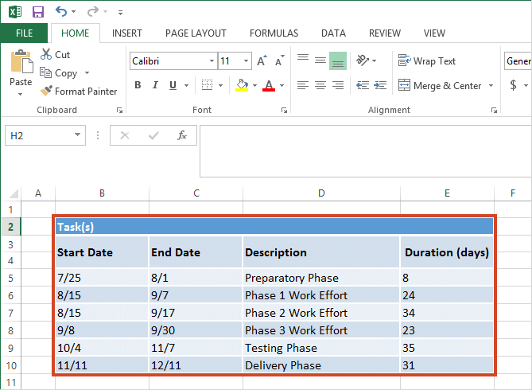

##### **2. Begin making your Excel Gantt by setting it up as a Stacked Bar chart**

1. From the same worksheet that your Excel table is on, click in any blank cell.
2. Then from the Excel ribbon, select the **INSERT** tab.
3. In the Charts section of the ribbon, drop down the **Bar Chart** selection menu.
4. Select **Stacked Bar** which will insert a large blank white chart space onto your Excel worksheet (do not select 100% Stacked Bar).

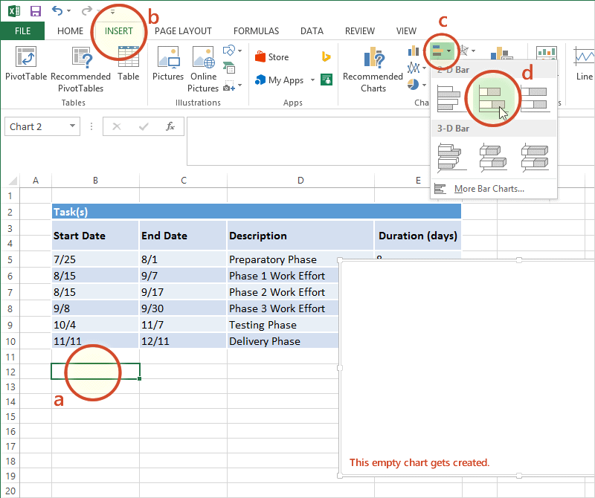

##### **3. Add the start dates of your Tasks to the Gantt chart**

1. Right-click the white chart space and click **Select Data** to bring up Excel's **Select Data Source** window.

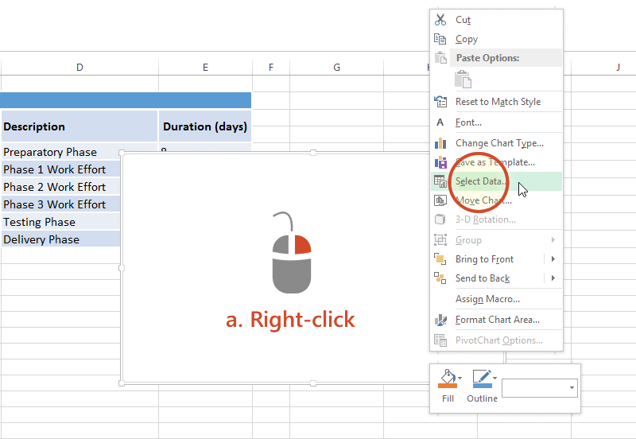

1. On the left side of Excel's **Data Source** window you will see a table named **Legend Entries (Series)**. Click on the **Add** button to bring up Excel's Edit Series window and here you will begin adding Task data to your Gantt chart.

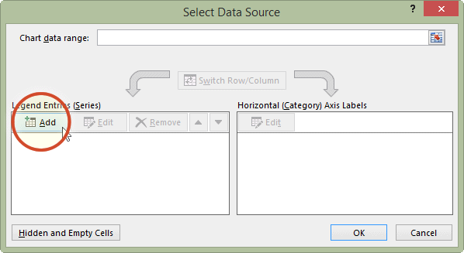

1. Now we're going to add your task data.

i. First we need to name the data (Series) we will be entering. Click and place your cursor in the empty field under the title **Series name**, then click on the column header that reads Start Date in your table.

ii. Staying in the **Edit Series** window move down to **Series value**. This is where you will enter your Task start dates. It is easy to do. To the right of the Series values field you will see an icon which looks like a spreadsheet with a red arrow on it.



Click on it (the one by Series values) and Excel will open a smaller **Edit Series** window. Now simply click the first start date in your task table and drag your mouse down to the last start date. This highlights all of the start dates for your tasks and inputs them into your Gantt chart. Make sure you have not mistakenly highlighted the header or any extra cells.

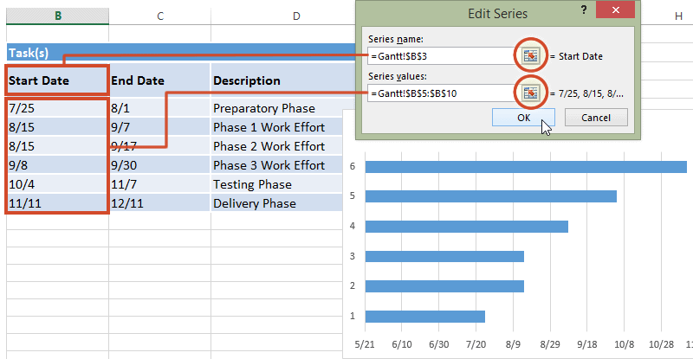

iii. When finished, click on the small spreadsheet icon again  (the one with the red arrow) which will return you to the previous window called Edit Series. Click OK. Your Gantt should now look like this:

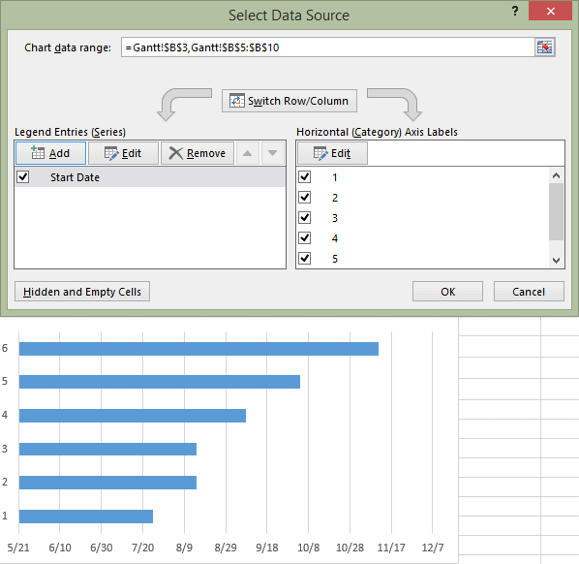

##### **4. Add the durations of your Tasks to the Gantt chart**

1. Staying in the **Select Data Source** window, click on the **Add** button again to bring up **Excel's Edit Series** window.

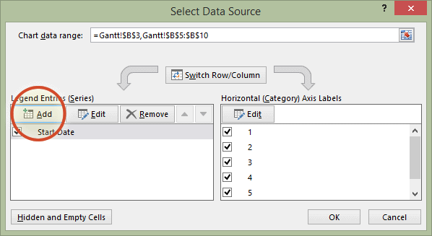

1. Here we will add the duration data to your Gantt chart.

i. In the **Edit Series** window, click in the empty field under the title **Series Name**, then click in your Task table again, on the column header that reads Duration.

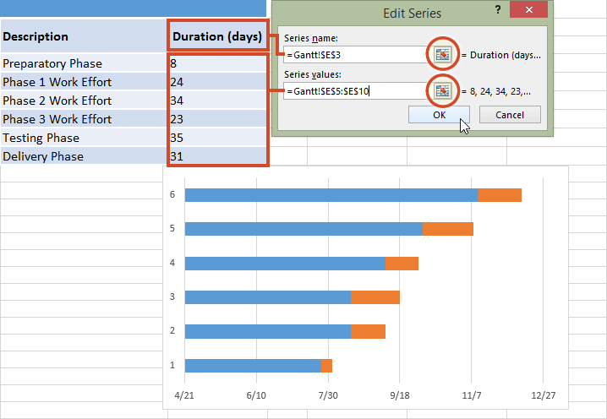

ii. Staying in the **Edit Series** window move down to **Series value** and click on spreadsheet icon with a red arrow on it  again.

iii. Select your Duration data by clicking on the first Duration in your project table and drag your mouse down to the last duration so all durations are now highlighted.

iv. To exit, once again click on the small spreadsheet icon with the red arrow to which will return you to the previous window. Select **OK** and you should now be back at the **Select Data Source** window. Click **OK** again to build your Gantt chart which should now look something like this:

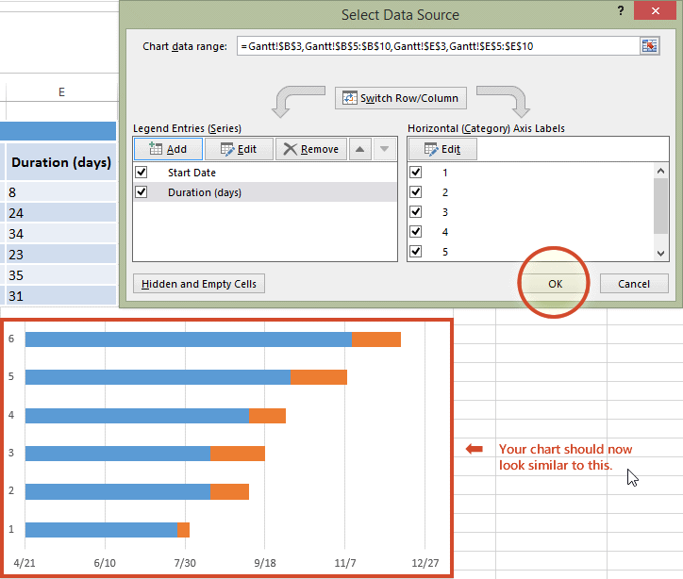

##### **5. Add the descriptions of your Tasks to the Gantt chart**

1. Right-click on one of the blue bars in the Gantt chart, then click on **Select Data** again to bring up the **Select Data Source** window.

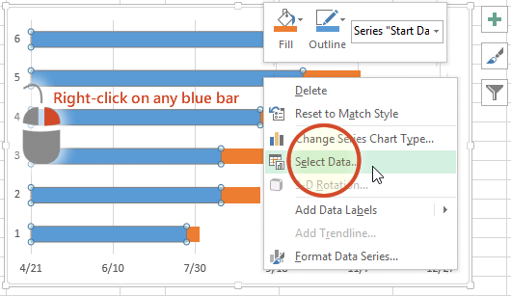

1. On the right side of Excel's **Data Source** window you will see a table named **Horizontal (Category) Axis Labels**. Select the **Edit** button to bring up a smaller **Axis Label** windows.

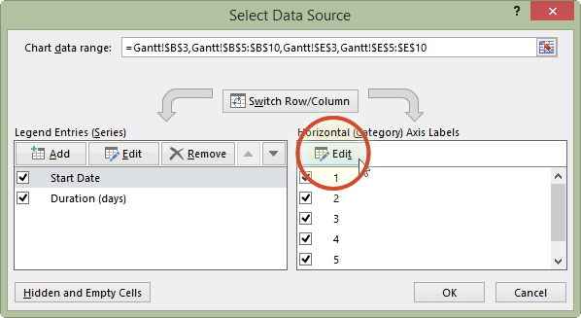

1. Again, click on the small spreadsheet icon. Click on the first name of your tasks (my first Task description is "Preparatory Phase") and select them all. Be careful not to include the name of the column itself. When you are done, exit this window by clicking on the small spreadsheet icon again.

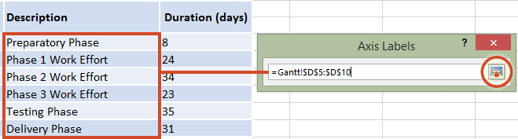

1. Click on **OK** and then **OK** again to exit the **Select Data Source** window, and now your Gantt chart should have the correct Task descriptions next to their respective bars. Your chart should now look something like this:

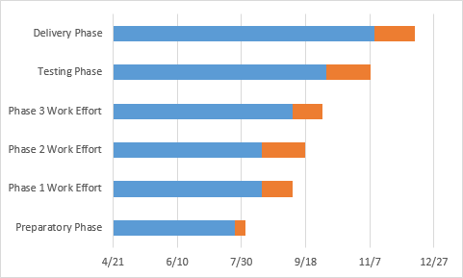

##### **6. Format your chart so it looks like a Gantt chart**

You have really built a Stacked bar chart. Now we need to format it so it looks like a Gantt chart. To do that, we must make the blue parts of each task bar transparent so only the orange parts will be visible. These will become the tasks of your Gantt chart.

1. To select all of the tasks bars at once, click on the blue part of any bar in your Gantt chart, then right-click and select **Format Data Series**, which will bring up the **Format Data Series** window in Excel.

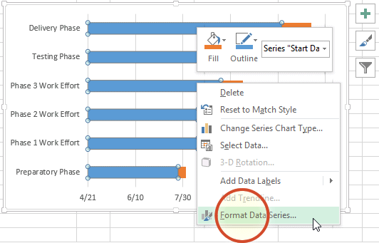

1. In the **Format Data Series** task pane, click on the **Fill & Line** icon (it looks like a paint can) to get the Fill & Line options. Under **Fill**, choose the **No Fill** radial button and under **Border** choose the **No Line** option. Don't close the Format Data Series task pane because we're going to use it in the next step.

Your Gantt chart should now look like this:

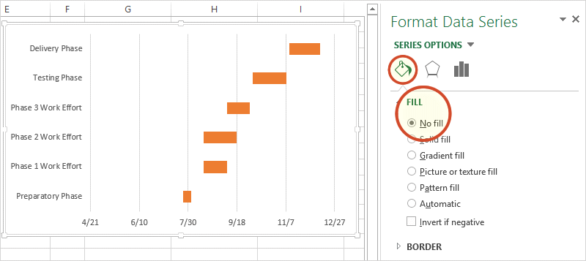

1. You probably also see that the tasks on your Gantt chart are listed in reverse order with the last task on top of the Gantt chart and the first Task listed at the bottom. This is easy to change in Excel.

i. To do so click on the list of tasks along the vertical axis of your Gantt chart. This will select them all and it will also open the **Format Axis** task pane.

ii. Click on the **Bar Chart** icon in the Format Axis Task Pane and expand out the **Axis Options** menu.

iii. In the **Format Axis** task pane under the header **Axis Options** and the sub-header **Axis Position** put a check into the checkbox called **Categories in reverse order**.

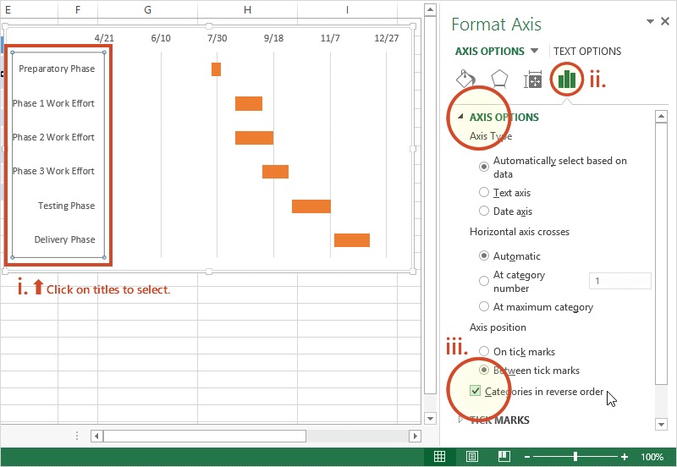

You will notice that Excel arranged your tasks into proper order, listing them from first to last on your Gantt chart. You will also notice that Excel moved the date markers from beneath to the top of the Gantt chart. Now it is really starting to look more like a Gantt chart should.

##### **7. Finish your Gantt chart with these styling tips**

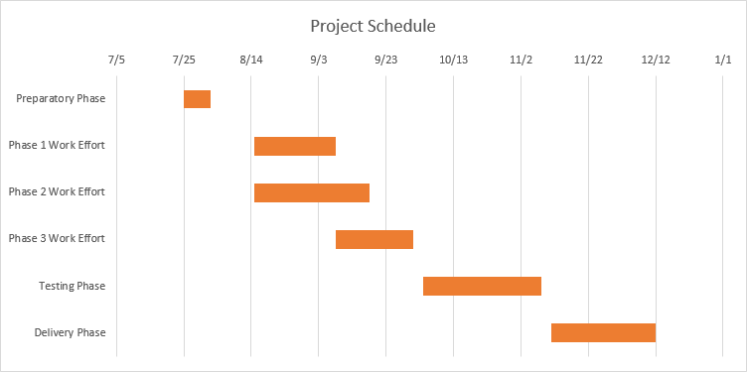

1. Optimize the Gantt chart

Removing some of the blank white space where the blue bars used to be will bring your tasks a little closer to the vertical axis of your Gantt chart. To remove some of the blank white space in the chart, click on the dates above the task bars. One click should select all the dates, then right click and select Format Axis to bring up Excel's Axis Options window.

In the Axis Options window, under the header called Bounds, note the current number for Minimum Bounds. It represents the left most boundary of your Gantt chart. Changing this number by making it larger will bring your tasks closer to the vertical axis of your Gantt chart. In my case I changed the original number which was 41750.0 to 41820.0. At any time you can hit the reset button to return the original settings. This gives you the opportunity to try a number of different settings until you find the one the makes your Gantt chart look best.

1. Adjust the density of the dates across the top of your Gantt chart

In the same Axis Options window under the header Units, you can adjustment the spacing between each of the dates listed at the top of the horizontal Axis. If you increase the unit number your Gantt chart will enlarge the space between each date, which will also lessen the number of dates your Gantt chart shows. Doing the opposite, reduces the space between each date and therefore crowds more dates onto your Gantt chart. In my case I changed the original number from 20 to 30.

1. Thickening Task bars on your Gantt chart to reduce white space

Right-click on the first Task bar and choose Format Data Series to open the Format Data Series control. Under the Series Options header you will find the Gap Width control. Sliding it up or down will increase or reduce the size of your Task bars on your Gantt chart. Play around until you find something that best works for you.

## Task:

Make a Gantt Chart of any project of your choice here.

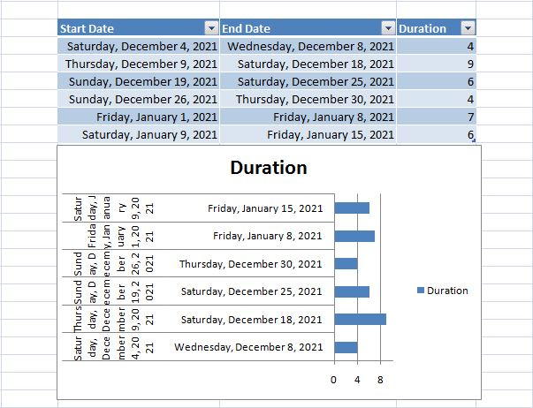.

## Observations:

In this Lab We learn about Gantt Chart we also learn ho to make Gant Chart in Ms Excel.Gantt Chart concept can be considered as well-known and successful approach of project management practice.

## Rubrics

|  |  |  |  |  |  |  |
| --- | --- | --- | --- | --- | --- | --- |
| **Demonstration** | Absent | Student is unable to follow the provided instructions properly.  The student can name the hardware or simulation platform, but unable to implement anything practically or on the software | Student can understand the provided laboratory instructions and familiar with the lab environment (Trainer/ software/ IDE), but cannot implement on the platform practically or on the software | Student has followed instructions to construct the fundamental schematic/ block diagram/ code/ model on the protoboard/ trainer/ simulation software. | Student has constructed the functional/ working schematic/ model/ block diagram/ code, and have successfully executed the program/ run circuit on software platform | Student perfectly implemented a working model/ logic/ circuit/ block diagram/ code and successfully executed the lab objective in Realtime or in a simulation environment and produced the desired results |
| **Category** | ***Ungraded*** | **Very Poor** | **Poor** | **Fair** | **Good** | **Excellent** |
| **Percentage** | [0] | [1-20] | [21-40] | [41-60] | [61-80] | [81-100] |
| **Marks** | 0.0 | 0.01 - 0.20 | 0.21 - 0.40 | 0.41 - 0.60 | 0.61 - 0.80 | 0.81 - 1.0 |
| **Date** |  | **Total Marks** |  | **Instructor’s Signature** | |  |

|  |  |  |  |  |  |  |
| --- | --- | --- | --- | --- | --- | --- |
| **Laboratory Reports** | Report not submitted | Plagiarized content presented or incomplete submission | Requirements are listed and experimental procedure is presented | Observations are recorded along with detailed procedure | Appropriate computations or numerical analysis is performed | Correctly drawn conclusion with  exact results and complete report in all respects |
| **Category** | ***Ungraded*** | **Very Poor** | **Poor** | **Fair** | **Good** | **Excellent** |
| **Percentage** | [0] | [1-20] | [21-40] | [41-60] | [61-80] | [81-100] |
| **Marks** | 0.0 | 0.01 - 0.20 | 0.21 - 0.40 | 0.41 - 0.60 | 0.61 - 0.80 | 0.81 - 1.0 |
| **Date** |  | **Total Marks** |  | **Instructor’s Signature** | |  |

06/12/2021

LAB NO.3

# USE CASE DIAGRAM

## Lab outcomes:

After completing this lab, students will be able to:

* Understand concepts of data modeling and its purpose
* Learn what is a use case diagram
* Learn when to apply a use case diagram
* Learn about Use case diagram components, symbols and notation

## Corresponding CLO and PLO:

* CLO-1, PLO-3(Design/Development of Solutions)

## SOFTWARE REQUIRED:

www.Lucidchart.com

## Theory:

UML stands for **U**nified **M**odeling **L**anguage. It’s a rich language to model software solutions, application structures, system behavior and [business processes](https://creately.com/blog/diagrams/importance-of-business-process-modeling/). There are **14 UML diagram types** to help you model these behaviors.

### List of UML Diagram Types

So what are the different UML diagram types? There are two main categories; **structure diagrams** and **behavioral diagrams**.

* **Structure Diagrams**
  + [Class Diagram](https://creately.com/blog/diagrams/uml-diagram-types-examples/#ClassDiagram)
  + [Component Diagram](https://creately.com/blog/diagrams/uml-diagram-types-examples/#ComponentDiagram)
  + [Deployment Diagram](https://creately.com/blog/diagrams/uml-diagram-types-examples/#DeploymentDiagram)
  + [Object Diagram](https://creately.com/blog/diagrams/uml-diagram-types-examples/#ObjectDiagram)
  + [Package Diagram](https://creately.com/blog/diagrams/uml-diagram-types-examples/#PackageDiagram)
  + [Profile Diagram](https://creately.com/blog/diagrams/uml-diagram-types-examples/#ProfileDiagram)
  + [Composite Structure Diagram](https://creately.com/blog/diagrams/uml-diagram-types-examples/#CompStrDiagram)
* **Behavioral Diagrams**
  + [Use Case Diagram](https://creately.com/blog/diagrams/uml-diagram-types-examples/#UseCaseDiagram)
  + [Activity Diagram](https://creately.com/blog/diagrams/uml-diagram-types-examples/#ActivityDiagram)
  + [State Machine Diagram](https://creately.com/blog/diagrams/uml-diagram-types-examples/#StateMachDiagram)
  + [Sequence Diagram](https://creately.com/blog/diagrams/uml-diagram-types-examples/#SequenceDiagram)
  + [Communication Diagram](https://creately.com/blog/diagrams/uml-diagram-types-examples/#CommDiagram)
  + [Interaction Overview Diagram](https://creately.com/blog/diagrams/uml-diagram-types-examples/#IntOverDiagram)
  + [Timing Diagram](https://creately.com/blog/diagrams/uml-diagram-types-examples/#TimingDiagram)

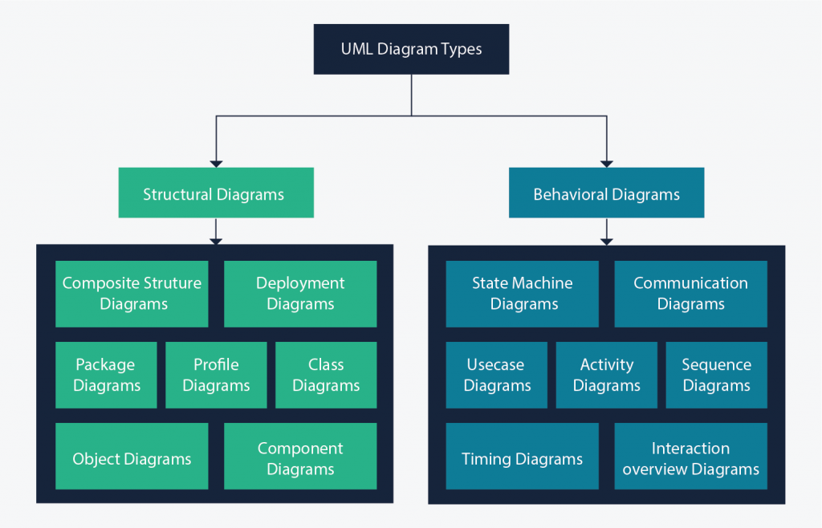

**Structure diagrams** show the things in the modeled system. In a more technical term, they show different objects in a system. **Behavioral diagrams** show what should happen in a system. They describe how the objects interact with each other to create a functioning system.

### What is a use case diagram?

In the Unified Modeling Language (UML), a use case diagram can summarize the details of your system's users (also known as actors) and their interactions with the system. To build one, you'll use a set of specialized symbols and connectors. An effective use case diagram can help your team discuss and represent:

* Scenarios in which your system or application interacts with people, organizations, or external systems
* Goals that your system or application helps those entities (known as actors) achieve
* The scope of your system

### When to apply use case diagrams

A use case diagram doesn't go into a lot of detail—for example, don't expect it to model the order in which steps are performed. Instead, a proper use case diagram depicts a high-level overview of the relationship between use cases, actors, and systems. Experts recommend that use case diagrams be used to supplement a more descriptive textual use case.

UML is the modeling toolkit that you can use to build your diagrams. Use cases are represented with a labeled oval shape. Stick figures represent actors in the process, and the actor's participation in the system is modeled with a line between the actor and use case. To depict the system boundary, draw a box around the use case itself.

UML use case diagrams are ideal for:

* Representing the goals of system-user interactions
* Defining and organizing functional requirements in a system
* Specifying the context and requirements of a system
* Modeling the basic flow of events in a use case

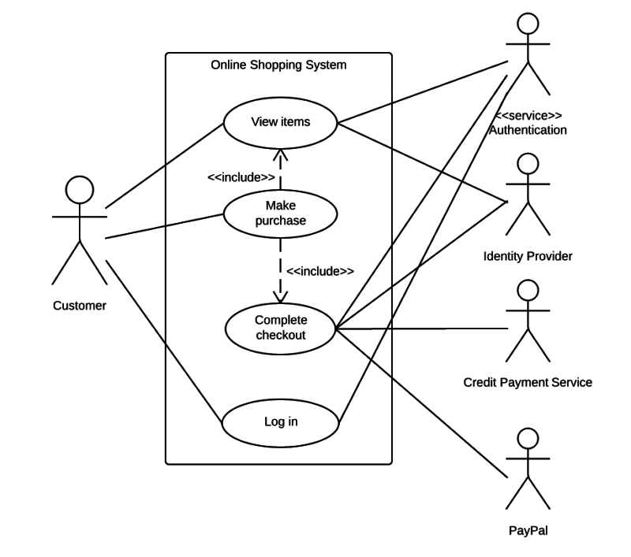

### Use case diagram components

To answer the question, "What is a use case diagram?" you need to first understand its building blocks. Common components include:

* **Actors:** The users that interact with a system. An actor can be a person, an organization, or an outside system that interacts with your application or system. They must be external objects that produce or consume data.
* **System:** A specific sequence of actions and interactions between actors and the system. A system may also be referred to as a scenario.
* **Goals:** The end result of most use cases. A successful diagram should describe the activities and variants used to reach the goal.

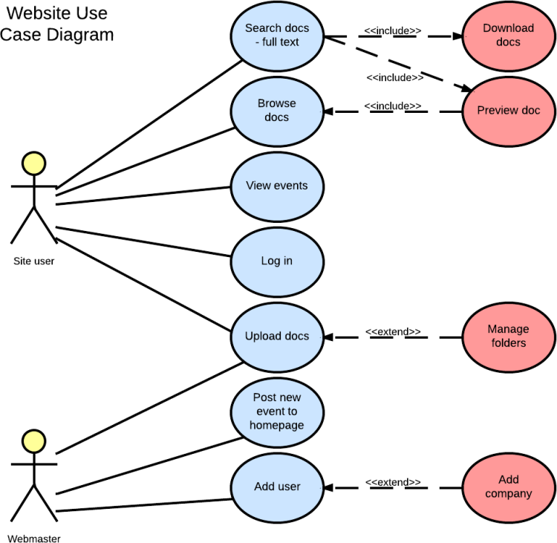

### Use case diagram symbols and notation

The notation for a use case diagram is pretty straightforward and doesn't involve as many types of symbols as other UML diagrams. You can use this guide to learn [how to draw a use case diagram](https://www.lucidchart.com/pages/how-to-draw-a-use-case-diagram-in-UML) if you need a refresher. Here are all the shapes you will be able to find in Lucidchart:

* **Use cases:** Horizontally shaped ovals that represent the different uses that a user might have.
* **Actors:** Stick figures that represent the people actually employing the use cases.
* **Associations:** A line between actors and use cases. In complex diagrams, it is important to know which actors are associated with which use cases.
* **System boundary boxes:** A box that sets a system scope to use cases. All use cases outside the box would be considered outside the scope of that system. For example, Psycho Killer is outside the scope of occupations in the chainsaw example found below.
* **Packages:** A UML shape that allows you to put different elements into groups. Just as with component diagrams, these groupings are represented as file folders.

### Use case diagram examples

#### Book publishing use case diagram example

This use case diagram is a visual representation of the process required to write and publish a book. Whether you’re an author, an agent, or a bookseller, inserting this diagram into your use case scenario can help your team publish the next big hit.

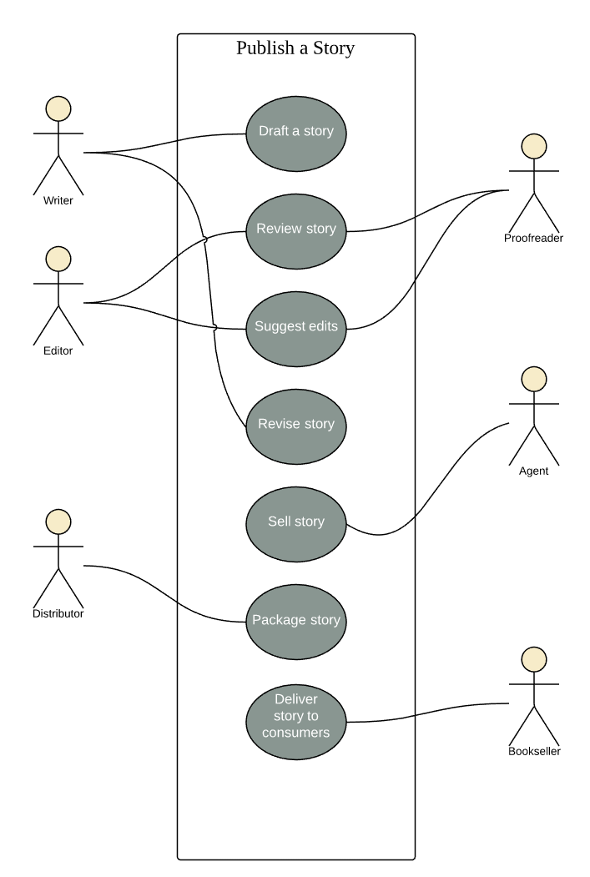

#### Railway reservation use case diagram example

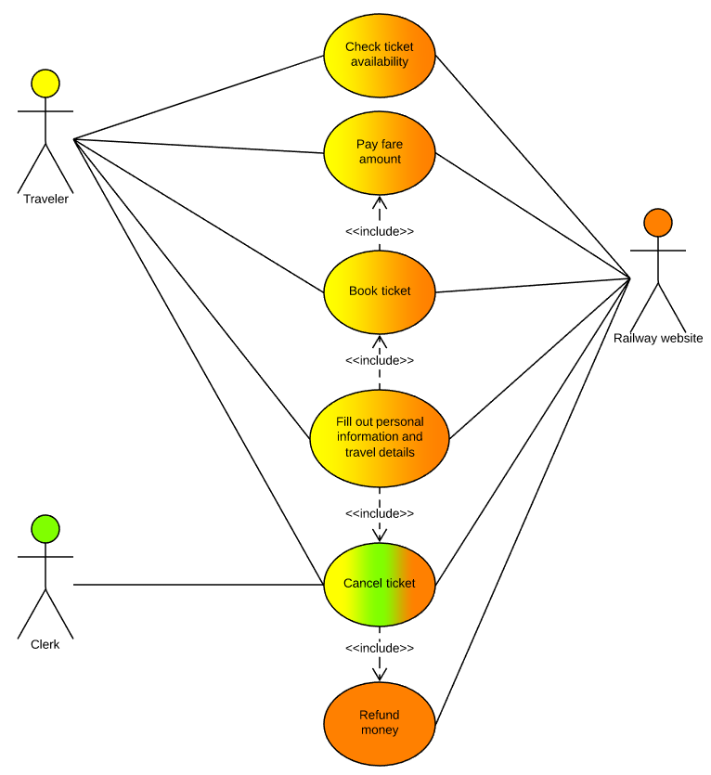

### Chainsaw use case diagram example

Consider this example: A man with a chainsaw interacts with the environment around him. Depending on the situation and the context of the situation, he might fall into one of many different use cases. Does he seem to be on his way to work? Is there anything ominous about the way he is wielding his chainsaw? For example, if he is using the chainsaw in a non-occupational setting, we might have reason to think that he falls within the scope of "scary."

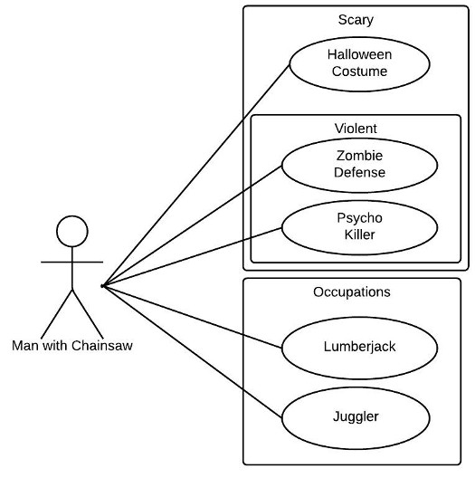

## Task:

Draw a Use Case diagram of any project of your choice here. The diagram must contain at least three actors with seven use cases at least. To make an accurate diagram you can follow the above-mentioned steps.

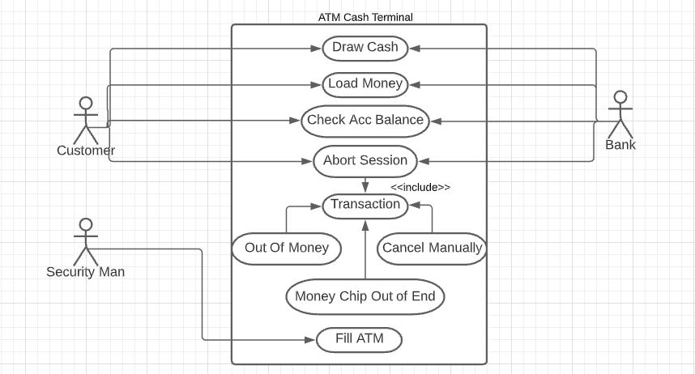

## Observations:

In this Lab We learn ho to use Lucid chart and also understand about use case Diagram.

Use Case Diagram give us an overview of what interfaces our precious code must expose.

Use Case Diagram come in the form of simple stick figure, Boxes & Actors.

## Rubrics

|  |  |  |  |  |  |  |
| --- | --- | --- | --- | --- | --- | --- |
| **Demonstration** | Absent | Student is unable to follow the provided instructions properly.  The student can name the hardware or simulation platform, but unable to implement anything practically or on the software | Student can understand the provided laboratory instructions and familiar with the lab environment (Trainer/ software/ IDE), but cannot implement on the platform practically or on the software | Student has followed instructions to construct the fundamental schematic/ block diagram/ code/ model on the protoboard/ trainer/ simulation software. | Student has constructed the functional/ working schematic/ model/ block diagram/ code, and have successfully executed the program/ run circuit on software platform | Student perfectly implemented a working model/ logic/ circuit/ block diagram/ code and successfully executed the lab objective in Realtime or in a simulation environment and produced the desired results |
| **Category** | ***Ungraded*** | **Very Poor** | **Poor** | **Fair** | **Good** | **Excellent** |
| **Percentage** | [0] | [1-20] | [21-40] | [41-60] | [61-80] | [81-100] |
| **Marks** | 0.0 | 0.01 - 0.20 | 0.21 - 0.40 | 0.41 - 0.60 | 0.61 - 0.80 | 0.81 - 1.0 |
| **Date** |  | **Total Marks** |  | **Instructor’s Signature** | |  |

|  |  |  |  |  |  |  |
| --- | --- | --- | --- | --- | --- | --- |
| **Laboratory Reports** | Report not submitted | Plagiarized content presented or incomplete submission | Requirements are listed and experimental procedure is presented | Observations are recorded along with detailed procedure | Appropriate computations or numerical analysis is performed | Correctly drawn conclusion with  exact results and complete report in all respects |
| **Category** | ***Ungraded*** | **Very Poor** | **Poor** | **Fair** | **Good** | **Excellent** |
| **Percentage** | [0] | [1-20] | [21-40] | [41-60] | [61-80] | [81-100] |
| **Marks** | 0.0 | 0.01 - 0.20 | 0.21 - 0.40 | 0.41 - 0.60 | 0.61 - 0.80 | 0.81 - 1.0 |
| **Date** |  | **Total Marks** |  | **Instructor’s Signature** | |  |

13/12/2021

LAB NO.4

# CLASS DIAGRAM

## Lab outcomes:

After completing this lab, students will be able to:

* Learn about class diagram in UML
* Learn about benefits of class diagrams
* Learn about asic components of a class diagram
* Learn about how to make a class diagram

## Corresponding CLO and PLO:

* CLO-1, PLO-3(Design/Development of Solutions)

## SOFTWARE REQUIRED:

www.Lucidchart.com

## Theory:

UML stands for **U**nified **M**odeling **L**anguage. It’s a rich language to model software solutions, application structures, system behavior and [business processes](https://creately.com/blog/diagrams/importance-of-business-process-modeling/). There are **14 UML diagram types** to help you model these behaviors.

### List of UML Diagram Types

So what are the different UML diagram types? There are two main categories; **structure diagrams** and **behavioral diagrams**.

* **Structure Diagrams**
  + [Class Diagram](https://creately.com/blog/diagrams/uml-diagram-types-examples/#ClassDiagram)
  + [Component Diagram](https://creately.com/blog/diagrams/uml-diagram-types-examples/#ComponentDiagram)
  + [Deployment Diagram](https://creately.com/blog/diagrams/uml-diagram-types-examples/#DeploymentDiagram)
  + [Object Diagram](https://creately.com/blog/diagrams/uml-diagram-types-examples/#ObjectDiagram)
  + [Package Diagram](https://creately.com/blog/diagrams/uml-diagram-types-examples/#PackageDiagram)
  + [Profile Diagram](https://creately.com/blog/diagrams/uml-diagram-types-examples/#ProfileDiagram)
  + [Composite Structure Diagram](https://creately.com/blog/diagrams/uml-diagram-types-examples/#CompStrDiagram)
* **Behavioral Diagrams**
  + [Use Case Diagram](https://creately.com/blog/diagrams/uml-diagram-types-examples/#UseCaseDiagram)
  + [Activity Diagram](https://creately.com/blog/diagrams/uml-diagram-types-examples/#ActivityDiagram)
  + [State Machine Diagram](https://creately.com/blog/diagrams/uml-diagram-types-examples/#StateMachDiagram)
  + [Sequence Diagram](https://creately.com/blog/diagrams/uml-diagram-types-examples/#SequenceDiagram)
  + [Communication Diagram](https://creately.com/blog/diagrams/uml-diagram-types-examples/#CommDiagram)
  + [Interaction Overview Diagram](https://creately.com/blog/diagrams/uml-diagram-types-examples/#IntOverDiagram)
  + [Timing Diagram](https://creately.com/blog/diagrams/uml-diagram-types-examples/#TimingDiagram)



**Structure diagrams** show the things in the modeled system. In a more technical term, they show different objects in a system. **Behavioral diagrams** show what should happen in a system. They describe how the objects interact with each other to create a functioning system.

### What is a class diagram in UML?

The Unified Modeling Language (UML) can help you model systems in various ways. One of the more popular types in UML is the class diagram. Popular among software engineers to document software architecture, class diagrams are a type of structure diagram because they describe what must be present in the system being modeled. No matter your level of familiarity with UML or class diagrams, our UML software is designed to be simple and easy to use.

UML was set up as a standardized model to describe an object-oriented programming approach. Since classes are the building block of objects, class diagrams are the building blocks of UML. The various components in a class diagram can represent the classes that will actually be programmed, the main objects, or the interactions between classes and objects.

The class shape itself consists of a rectangle with three rows. The top row contains the name of the class, the middle row contains the attributes of the class, and the bottom section expresses the methods or operations that the class may use. Classes and subclasses are grouped together to show the static relationship between each object.

The UML shape library in Lucidchart can help you create nearly any custom class diagram using our UML diagram tool.

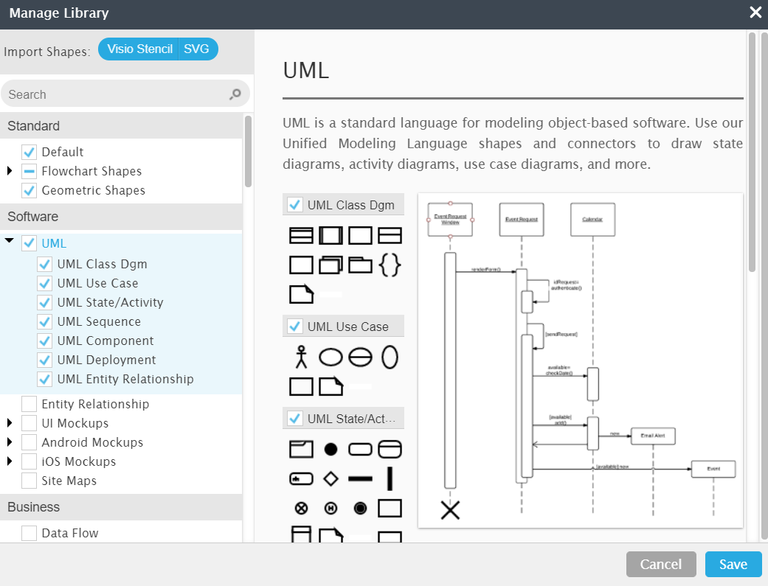

### Benefits of class diagrams

### Class diagrams offer a number of benefits for any organization. Use UML class diagrams to:

### Illustrate data models for information systems, no matter how simple or complex.

### Better understand the general overview of the schematics of an application.

### Visually express any specific needs of a system and disseminate that information throughout the business.

### Create detailed charts that highlight any specific code needed to be programmed and implemented to the described structure.

### Provide an implementation-independent description of types used in a system that are later passed between its components.

### Basic components of a class diagram

The standard class diagram is composed of three sections:

**Upper section:** Contains the name of the class. This section is always required, whether you are talking about the classifier or an object.

**Middle section:** Contains the attributes of the class. Use this section to describe the qualities of the class. This is only required when describing a specific instance of a class.

**Bottom section:** Includes class operations (methods). Displayed in list format, each operation takes up its own line. The operations describe how a class interacts with data.

**Member access modifiers**

All classes have different access levels depending on the access modifier (visibility). Here are the access levels with their corresponding symbols:

* Public (+)
* Private (-)
* Protected (#)
* Package (~)
* Derived (/)
* Static (underlined)

**Member scopes**

There are two scopes for members: classifiers and instances.

Classifiers are static members while instances are the specific instances of the class. If you are familiar with basic Object Oriented theory, this isn't anything groundbreaking.

**Additional class diagram components**

Depending on the context, classes in a class diagram can represent the main objects, interactions in the application, or classes to be programmed. To answer the question "What is a class diagram in UML?" you should first understand its basic makeup.

* **Classes:** A template for creating objects and implementing behavior in a system. In UML, a class represents an object or a set of objects that share a common structure and behavior. They're represented by a rectangle that includes rows of the class name, its attributes, and its operations. When you draw a class in a class diagram, you're only required to fill out the top row—the others are optional if you'd like to provide more detail.  
  **Name**: The first row in a class shape.  
  **Attributes**: The second row in a class shape. Each attribute of the class is displayed on a separate line.  
  **Methods**: The third row in a class shape. Also known as operations, methods are displayed in list format with each operation on its own line.
* **Signals**: Symbols that represent one-way, asynchronous communications between active objects.
* **Data types**: Classifiers that define data values. Data types can model both primitive types and enumerations.
* **Packages**: Shapes designed to organize related classifiers in a diagram. They are symbolized with a large tabbed rectangle shape.
* **Interfaces**: A collection of operation signatures and/or attribute definitions that define a cohesive set of behaviors. Interfaces are similar to classes, except that a class can have an instance of its type, and an interface must have at least one class to implement it.
* **Enumerations**: Representations of user-defined data types. An enumeration includes groups of identifiers that represent values of the enumeration.
* **Objects**: Instances of a class or classes. Objects can be added to a class diagram to represent either concrete or prototypical instances.
* **Artifacts**: Model elements that represent the concrete entities in a software system, such as documents, databases, executable files, software components, etc.

**Interactions**

The term "interactions" refers to the various relationships and links that can exist in class and object diagrams. Some of the most common interactions include:

* **Inheritance**: The process of a child or sub-class taking on the functionality of a parent or superclass, also known as generalization. It's symbolized with a straight connected line with a closed arrowhead pointing towards the superclass.

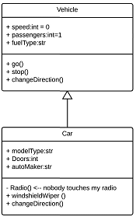

In this example, the object "Car" would inherit all of the attributes (speed, numbers of passengers, fuel) and methods (go(), stop(), changeDirection()) of the parent class ("Vehicle") in addition to the specific attributes (model type, number of doors, auto maker) and methods of its own class (Radio(), windshieldWiper(), ac/heat()). Inheritance is shown in a class diagram by using a solid line with a closed, hollow arrow.

* **Bidirectional association:** The default relationship between two classes. Both classes are aware of each other and their relationship with the other. This association is represented by a straight line between two classes.

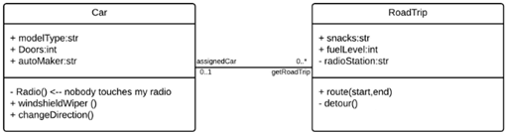

In the example above, the Car class and RoadTrip class are interrelated. At one end of the line, the Car takes on the association of "assignedCar" with the multiplicity value of 0..1, so when the instance of RoadTrip exists, it can either have one instance of Car associated with it or no Cars associated with it. In this case, a separate Caravan class with a multiplicity value of 0..* is needed to demonstrate that a RoadTrip could have multiple instances of Cars associated with it. Since one Car instance could have multiple "getRoadTrip" associations—in other words, one car could go on multiple road trips—the multiplicity value is set to 0..*

* **Unidirectional association**: A slightly less common relationship between two classes. One class is aware of the other and interacts with it. Unidirectional association is modeled with a straight connecting line that points an open arrowhead from the knowing class to the known class.

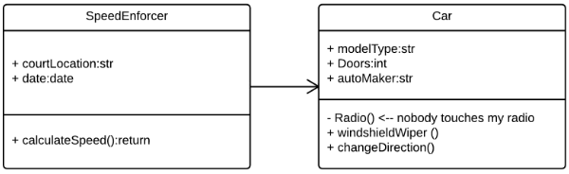

As an example, on your road trip through Arizona, you might run across a speed trap where a speed cam records your driving activity, but you won't know about it until you get a notification in the mail. It isn't drawn in the image, but in this case, the multiplicity value would be 0..* depending on how many times you drive by the speed cam.

### ****Relationships in Class Diagrams****

Classes are interrelated to each other in specific ways. In particular, relationships in class diagrams include different types of logical connections. The following are such types of logical connections that are possible in [UML](https://creately.com/lp/uml-diagram-tool):

* [Association](https://creately.com/blog/diagrams/class-diagram-relationships/#Association)
* [Directed Association](https://creately.com/blog/diagrams/class-diagram-relationships/#Directed)
* [Reflexive Association](https://creately.com/blog/diagrams/class-diagram-relationships/#Reflexive)
* [Multiplicity](https://creately.com/blog/diagrams/class-diagram-relationships/#Multiplicity)
* [Aggregation](https://creately.com/blog/diagrams/class-diagram-relationships/#Aggregation)
* [Composition](https://creately.com/blog/diagrams/class-diagram-relationships/#Composition)
* [Inheritance/Generalization](https://creately.com/blog/diagrams/class-diagram-relationships/#Inheritance)
* [Realization](https://creately.com/blog/diagrams/class-diagram-relationships/#Realization)

### Association

[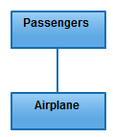](https://d3n817fwly711g.cloudfront.net/blog/wp-content/uploads/2012/03/Association-Relationship.jpeg)

*Association*

is a broad term that encompasses just about any logical connection or relationship between [classes](https://creately.com/lp/online-class-diagram-tool). For example, passenger and airline may be linked as above:

### Directed Association

[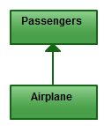](https://d3n817fwly711g.cloudfront.net/blog/wp-content/uploads/2012/03/Directed-Association-Relationship.jpeg)

*Directed Association*

refers to a directional relationship represented by a line with an arrowhead. The arrowhead depicts a container-contained directional flow.

### Reflexive Association

[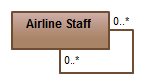](https://d3n817fwly711g.cloudfront.net/blog/wp-content/uploads/2012/03/Reflexive-Association-Relationship.jpeg)

*Reflexive Association*

This occurs when a class may have multiple functions or responsibilities. For example, a staff member working in an airport may be a pilot, aviation engineer, a ticket dispatcher, a guard, or a maintenance crew member. If the maintenance crew member is managed by the aviation engineer there could be a managed by relationship in two instances of the same class.

### Multiplicity

[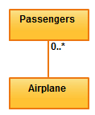](https://d3n817fwly711g.cloudfront.net/blog/wp-content/uploads/2012/03/Multiplicity-Relationship.jpeg)

*Multiplicity*

is the active logical association when the cardinality of a class in relation to another is being depicted. For example, one fleet may include multiple airplanes, while one commercial airplane may contain zero to many passengers. The notation 0..* in the diagram means “zero to many”.

### Aggregation

[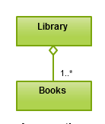](https://d3n817fwly711g.cloudfront.net/blog/wp-content/uploads/2012/03/Aggregation-Relationship.png)

*Aggregation*

refers to the formation of a particular class as a result of one class being aggregated or built as a collection. For example, the class “library” is made up of one or more books, among other materials. In aggregation, the contained classes are not strongly dependent on the lifecycle of the container. In the same example, books will remain so even when the library is dissolved. To show aggregation in a diagram, draw a line from the parent class to the child class with a diamond shape near the parent class.

To show aggregation in a diagram, draw a line from the parent class to the child class with a diamond shape near the parent class.

### Composition

[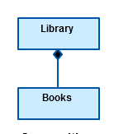](https://d3n817fwly711g.cloudfront.net/blog/wp-content/uploads/2012/03/Composition-Relationship-UML.png)

*Composition*

The composition relationship is very similar to the aggregation relationship. with the only difference being its key purpose of emphasizing the dependence of the contained class to the life cycle of the container class. That is, the contained class will be obliterated when the container class is destroyed. For example, a shoulder bag’s side pocket will also cease to exist once the shoulder bag is destroyed.

To show a composition relationship in a [UML diagram](https://creately.com/lp/uml-diagram-tool), use a directional line connecting the two classes, with a filled diamond shape adjacent to the container class and the directional arrow to the contained class.

### Inheritance / Generalization

[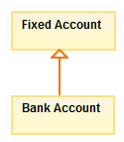](https://d3n817fwly711g.cloudfront.net/blog/wp-content/uploads/2012/03/Inheritance-Relationship.jpeg)

*Inheritance*

refers to a type of relationship wherein one associated class is a child of another by virtue of assuming the same functionalities of the parent class. In other words, the child class is a specific type of the parent class. To show inheritance in a [UML diagram](https://creately.com/lp/uml-diagram-tool), a solid line from the child class to the parent class is drawn using an unfilled arrowhead.

### Realization

[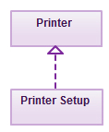](https://d3n817fwly711g.cloudfront.net/blog/wp-content/uploads/2012/03/Realization-Relationship.jpeg)

*Realization*

denotes the implementation of the functionality defined in one class by another class. To show the relationship in [UML](https://creately.com/diagram-type/uml-diagram), a broken line with an unfilled solid arrowhead is drawn from the class that defines the functionality of the class that implements the function. In the example, the printing preferences that are set using the printer setup interface are being implemented by the printer.

### Class diagram examples

Creating a class diagram to map out process flows is easy. Consider the two examples below as you build your own class diagrams in UML.

**Class diagram for a hotel management system**

A class diagram can show the relationships between each object in a hotel management system, including guest information, staff responsibilities, and room occupancy. The example below provides a useful overview of the hotel management system. Get started on a class diagram by clicking the template below.

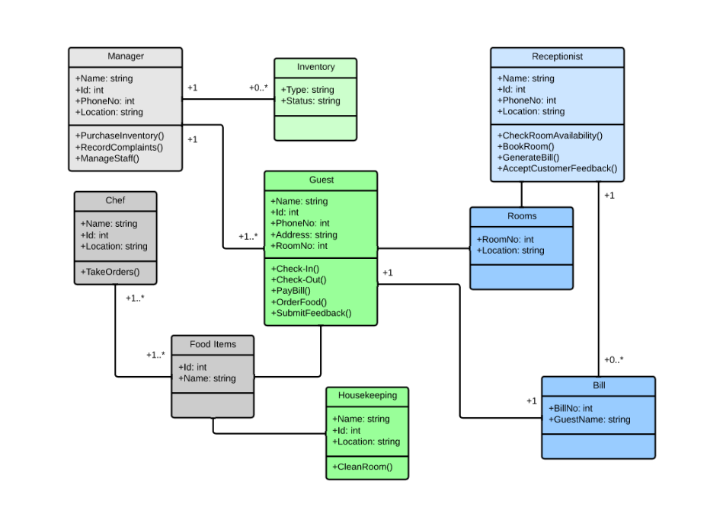

**Class diagram for an ATM system**

ATMs are deceptively simple: although customers only need to press a few buttons to receive cash, there are many layers of security that a safe and effective ATM must pass through to prevent fraud and provide value for banking customers. The various human and inanimate parts of an ATM system are illustrated by this easy-to-read diagram—every class has its title, and the attributes are listed beneath. You can edit, save, and share this chart by opening the document and signing up for a free Lucidchart account.

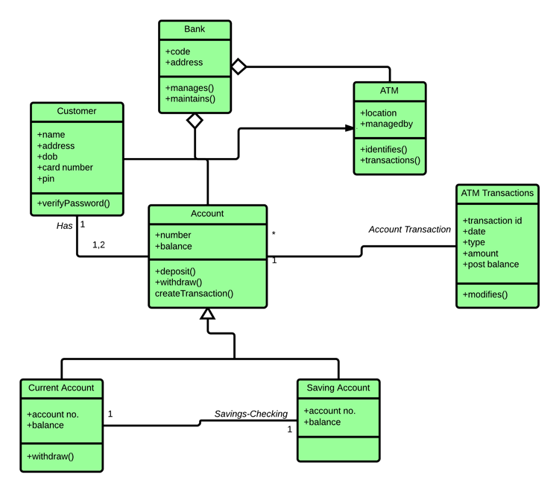

### How to make a class diagram

In Lucidchart, creating a class diagram from scratch is surprisingly simple. Just follow these steps:

1. Open a blank document or start with a template.
2. Enable the UML shape library. On the left side of the Lucidchart editor, click "Shapes." Once you're in the Shape Library Manager, check "UML" and click "Save."
3. From the libraries you just added, select the shape you want and drag it from the toolbox to the canvas.
4. Model the process flow by drawing lines between shapes while adding text.

## Task:

Draw a Class diagram of any project of your choice here. The diagram must contain at least fiveclasses with fiveattributes and methods each. To make an accurate diagram you can follow the above-mentioned steps

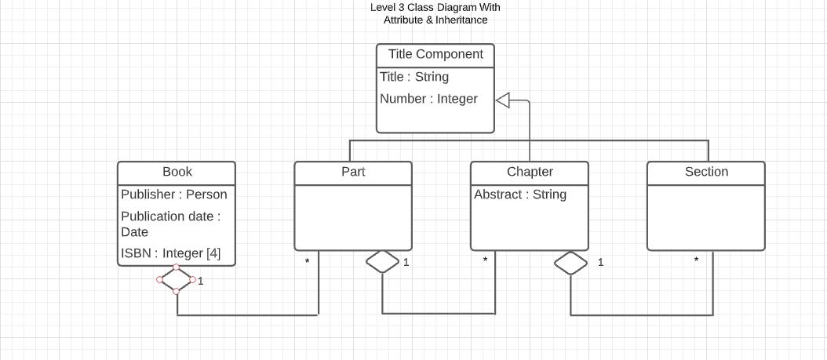.

## Observations:

In this lab we learn about class Diagram. We learn how to display the relation between the objects. Class Diagram are useful in many ways of system design.

## Rubrics

|  |  |  |  |  |  |  |
| --- | --- | --- | --- | --- | --- | --- |
| **Demonstration** | Absent | Student is unable to follow the provided instructions properly.  The student can name the hardware or simulation platform, but unable to implement anything practically or on the software | Student can understand the provided laboratory instructions and familiar with the lab environment (Trainer/ software/ IDE), but cannot implement on the platform practically or on the software | Student has followed instructions to construct the fundamental schematic/ block diagram/ code/ model on the protoboard/ trainer/ simulation software. | Student has constructed the functional/ working schematic/ model/ block diagram/ code, and have successfully executed the program/ run circuit on software platform | Student perfectly implemented a working model/ logic/ circuit/ block diagram/ code and successfully executed the lab objective in Realtime or in a simulation environment and produced the desired results |
| **Category** | ***Ungraded*** | **Very Poor** | **Poor** | **Fair** | **Good** | **Excellent** |
| **Percentage** | [0] | [1-20] | [21-40] | [41-60] | [61-80] | [81-100] |
| **Marks** | 0.0 | 0.01 - 0.20 | 0.21 - 0.40 | 0.41 - 0.60 | 0.61 - 0.80 | 0.81 - 1.0 |
| **Date** |  | **Total Marks** |  | **Instructor’s Signature** | |  |

|  |  |  |  |  |  |  |
| --- | --- | --- | --- | --- | --- | --- |
| **Laboratory Reports** | Report not submitted | Plagiarized content presented or incomplete submission | Requirements are listed and experimental procedure is presented | Observations are recorded along with detailed procedure | Appropriate computations or numerical analysis is performed | Correctly drawn conclusion with  exact results and complete report in all respects |
| **Category** | ***Ungraded*** | **Very Poor** | **Poor** | **Fair** | **Good** | **Excellent** |
| **Percentage** | [0] | [1-20] | [21-40] | [41-60] | [61-80] | [81-100] |
| **Marks** | 0.0 | 0.01 - 0.20 | 0.21 - 0.40 | 0.41 - 0.60 | 0.61 - 0.80 | 0.81 - 1.0 |
| **Date** |  | **Total Marks** |  | **Instructor’s Signature** | |  |

20/12/2021

LAB NO.5

# Software Requirements Specification(SRS) Exploration and Making

## Lab outcomes:

After completing this lab, students will be able to:

* Understand an SRS.
* Write an SRS for any type of software.

## Corresponding CLO and PLO:

* CLO-1, PLO-3(Design/Development of Solutions)

## Requirements:

### *Hardware Requirements:*

* PC with 300 megahertz or higher processor clock speed recommended; 233 MHz minimum required.
* 128 megabytes (MB) of RAM or higher recommended (64 MB minimum supported)
* 1.5 gigabytes (GB) of available hard disk space
* CD ROM or DVD Drive
* Keyboard and Mouse (compatible pointing device).

### *Software Requirements:*

Microsoft Word, Overleaf.

## Theory:

An SRS is basically an organization's understanding (in writing) of a customer or potential client's system requirements and dependencies at a particular point in time (usually) prior to any actual design or development work. It's a two-way insurance policy that assures that both the client and the organization understand the other's requirements from that perspective at a given point in time.

The SRS document itself states in precise and explicit language those functions and capabilities a software system (i.e., a software application, an eCommerce Web site, and so on) must provide, as well as states any required constraints by which the system must abide. The SRS also functions as a blueprint for completing a project with as little cost growth as possible. The SRS is often referred to as the "parent" document because all subsequent project management documents, such as design specifications, statements of work, software architecture specifications, testing and validation plans, and documentation plans, are related to it.

It's important to note that an SRS contains functional and nonfunctional requirements only; it doesn't offer design suggestions, possible solutions to technology or business issues, or any other information other than what the development team understands the customer's system requirements to be.

A well-designed, well-written SRS accomplishes four major goals:

1. It provides feedback to the customer. An SRS is the customer's assurance that the development organization understands the issues or problems to be solved and the software behavior necessary to address those problems. Therefore, the SRS should be written in natural language (versus a formal language, explained later in this article), in an unambiguous manner that may also include charts, tables, data flow diagrams, decision tables, and so on.
2. It decomposes the problem into component parts. The simple act of writing down software requirements in a well-designed format organizes information, places borders around the problem, solidifies ideas, and helps break down the problem into its component parts in an orderly fashion.
3. It serves as an input to the design specification. As mentioned previously, the SRS serves as the parent document to subsequent documents, such as the software design specification and statement of work. Therefore, the SRS must contain sufficient detail in the functional system requirements so that a design solution can be devised.
4. It serves as a product validation check. The SRS also serves as the parent document for testing and validation strategies that will be applied to the requirements for verification.

SRSs are typically developed during the first stages of "Requirements Development," which is the initial product development phase in which information is gathered about what requirements are needed--and not. This information-gathering stage can include onsite visits, questionnaires, surveys, interviews, and perhaps a return-on-investment (ROI) analysis or needs analysis of the customer or client's current business environment. The actual specification, then, is written after the requirements have been gathered and analyzed.

### SRSshouldaddressthefollowing

The basic issues that the SRS shall address are the following:

1. Functionality. What is the software supposed to do?
2. External interfaces. How does the software interact with people, the system‘s hardware, other hardware, and other software?
3. Performance. What is the speed, availability, response time, recovery time of various software functions, etc.?
4. Attributes. What are the portability, correctness, maintainability, security, etc. considerations?
5. Design constraints imposed on an implementation. Are there any required standards in effect, implementation language, policies for database integrity, resource limits, operating environment(s) etc.?

### CharacteristicsofagoodSRS

An SRS should be

1. Correct
2. Unambiguous
3. Complete
4. Consistent
5. Ranked for importance and/or stability
6. Verifiable
7. Modifiable
8. Traceable

Correct - This is like motherhood and apple pie. Of course you want the specification to be correct. No one writes a specification that they know is incorrect. We like to say - "Correct and Ever Correcting." The discipline is keeping the specification up to date when you find things that are not correct.

Unambiguous - An SRS is unambiguous if, and only if, every requirement stated therein has only one interpretation. Again, easier said than done. Spending time on this area prior to releasing the SRS can be a waste of time. But as you find ambiguities - fix them.

Complete - A simple judge of this is that is should be all that is needed by the software designers to create the software.

Consistent - The SRS should be consistent within itself and consistent to its reference documents. If you call an input "Start and Stop" in one place, don't call it "Start/Stop" in another.

Ranked for Importance - Very often a new system has requirements that are really marketing wish lists. Some may not be achievable. It is useful provide this information in the SRS.

Verifiable - Don't put in requirements like - "It should provide the user a fast response." Another of my favourites is - "The system should never crash." Instead, provide a quantitative requirement like: "Every key stroke should provide a user response within 100 milliseconds."

Modifiable - Having the same requirement in more than one place may not be wrong - but tends to make the document not maintainable.

Traceable - Often, this is not important in a non-politicized environment. However, in most organizations, it is sometimes useful to connect the requirements in the SRS to a higher level document. Why do we need this requirement?

### AsampleofbasicSRSOutline

##### **Introduction**

* 1. Purpose
  2. Document conventions
  3. Intended audience
  4. Additional information
  5. Contact information/SRS team members
  6. References

##### **Overall Description**

* 1. Product perspective
  2. Product functions
  3. User classes and characteristics
  4. Operatingenvironment
  5. User environment
  6. Design/implementation constraints
  7. Assumptions and dependencies

##### **External InterfaceRequirements**

* 1. User interfaces
  2. Hardwareinterfaces
  3. Softwareinterfaces
  4. Communication protocols and interfaces

##### **SystemFeatures**

* 1. System featureA
     1. Description and priority
     2. Action/result
     3. Functional requirements

4.2 System feature B

##### **OtherNonfunctionalRequirements**

* 1. Performancerequirements
  2. Safetyrequirements
  3. Securityrequirements
  4. Softwarequalityattributes
  5. Project documentation
  6. User documentation

##### **OtherRequirements**

AppendixA: Terminology/Glossary/Definitions list

AppendixB: To bedetermined

## Task:

Please write an SRS on software of your choice

A **Functional Requirement** (FR) is a description of the service that the software must offer. It describes a software system or its component. A function is nothing but inputs to the software system, its behavior, and outputs. It can be a calculation, data manipulation, business process, user interaction, or any other specific functionality which defines what function a system is likely to perform. Functional Requirements in Software Engineering are also called **Functional Specification**. In software engineering and systems engineering, a Functional Requirement can range from the high-level abstract statement of the sender’s necessity to detailed mathematical functional requirement specifications. [Functional software](https://www.guru99.com/learn-software-requirements-analysis-with-case-study.html) requirements help you to capture the intended behaviour of the system. Here is how to write functional requirements document:

Functional Requirements of a system should include the following things:

* Details of operations conducted in every screen
* Data handling logic should be entered into the system
* It should have descriptions of system reports or other outputs
* Complete information about the workflows performed by the system
* It should clearly define who will be allowed to create/modify/delete the data in the system
* How the system will fulfill applicable regulatory and compliance needs should be captured in the functional documen

## Observations:

In this lab we learn Investing time in writing the SRS document will lead to the successful development of the software the customer need.

## Rubrics

|  |  |  |  |  |  |  |
| --- | --- | --- | --- | --- | --- | --- |
| **Demonstration** | Absent | Student is unable to follow the provided instructions properly.  The student can name the hardware or simulation platform, but unable to implement anything practically or on the software | Student can understand the provided laboratory instructions and familiar with the lab environment (Trainer/ software/ IDE), but cannot implement on the platform practically or on the software | Student has followed instructions to construct the fundamental schematic/ block diagram/ code/ model on the protoboard/ trainer/ simulation software. | Student has constructed the functional/ working schematic/ model/ block diagram/ code, and have successfully executed the program/ run circuit on software platform | Student perfectly implemented a working model/ logic/ circuit/ block diagram/ code and successfully executed the lab objective in Realtime or in a simulation environment and produced the desired results |
| **Category** | ***Ungraded*** | **Very Poor** | **Poor** | **Fair** | **Good** | **Excellent** |
| **Percentage** | [0] | [1-20] | [21-40] | [41-60] | [61-80] | [81-100] |
| **Marks** | 0.0 | 0.01 - 0.20 | 0.21 - 0.40 | 0.41 - 0.60 | 0.61 - 0.80 | 0.81 - 1.0 |
| **Date** |  | **Total Marks** |  | **Instructor’s Signature** | |  |

|  |  |  |  |  |  |  |
| --- | --- | --- | --- | --- | --- | --- |
| **Laboratory Reports** | Report not submitted | Plagiarized content presented or incomplete submission | Requirements are listed and experimental procedure is presented | Observations are recorded along with detailed procedure | Appropriate computations or numerical analysis is performed | Correctly drawn conclusion with  exact results and complete report in all respects |
| **Category** | ***Ungraded*** | **Very Poor** | **Poor** | **Fair** | **Good** | **Excellent** |
| **Percentage** | [0] | [1-20] | [21-40] | [41-60] | [61-80] | [81-100] |
| **Marks** | 0.0 | 0.01 - 0.20 | 0.21 - 0.40 | 0.41 - 0.60 | 0.61 - 0.80 | 0.81 - 1.0 |
| **Date** |  | **Total Marks** |  | **Instructor’s Signature** | |  |

27/12/2021

LAB NO.6

# Sequence Diagram

## Lab outcomes:

After completing this lab, students will be able to:

* Draw the Sequence Diagram

## Corresponding CLO and PLO:

* CLO-1, PLO-3(Design/Development of Solutions)

## Requirements:

www.Lucidchart.com

## Theory:

## What is a sequence diagram in UML?

To understand what a sequence diagram is, it's important to know the role of the [Unified Modeling Language](https://www.lucidchart.com/pages/what-is-UML-unified-modeling-language), better known as UML. UML is a modeling toolkit that guides the creation and notation of many types of diagrams, including behavior diagrams, interaction diagrams, and structure diagrams.

A sequence diagram is a type of interaction diagram because it describes how—and in what order—a group of objects works together. These diagrams are used by software developers and business professionals to understand requirements for a new system or to document an existing process. Sequence diagrams are sometimes known as event diagrams or event scenarios.  
  
Note that there are two types of sequence diagrams: UML diagrams and code-based diagrams. The latter is sourced from programming code and will not be covered in this guide. Lucidchart’s [UML diagramming software](https://www.lucidchart.com/pages/examples/uml_diagram_tool) is equipped with all the shapes and features you will need to model both.

## Benefits of sequence diagrams

Sequence diagrams can be useful references for businesses and other organizations. Try drawing a sequence diagram to:

* Represent the details of a UML use case.
* Model the logic of a sophisticated procedure, function, or operation.
* See how objects and components interact with each other to complete a process.
* Plan and understand the detailed functionality of an existing or future scenario.

## Use cases for sequence diagrams

The following scenarios are ideal for using a sequence diagram:

* **Usage scenario:** A usage scenario is a diagram of how your system could potentially be used. It's a great way to make sure that you have worked through the logic of every usage scenario for the system.
* **Method logic:** Just as you might use a UML sequence diagram to explore the logic of a use case, you can use it to explore the logic of any function, procedure, or complex process.
* **Service logic:** If you consider a service to be a high-level method used by different clients, a sequence diagram is an ideal way to map that out.
* **Sequence diagram Visio** - Any sequence diagram that you create with Visio can also be uploaded into Lucidchart. Lucidchart supports .vsd and .vdx file import and is a great Microsoft Visio alternative. Almost all of the images you see in the UML section of this site were generated using Lucidchart.

Diagramming is quick and easy with Lucidchart. Start a free trial today to start creating and collaborating.

## Basic symbols and components

To understand what a sequence diagram is, you should be familiar with its symbols and components. Sequence diagrams are made up of the following icons and elements:

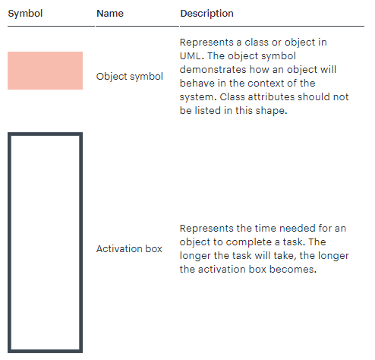

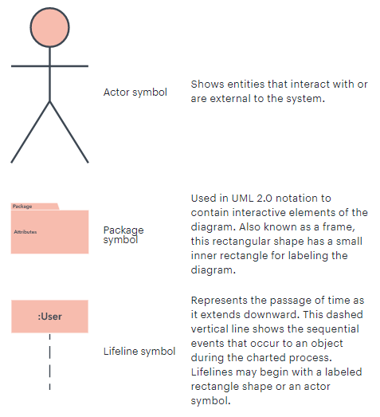

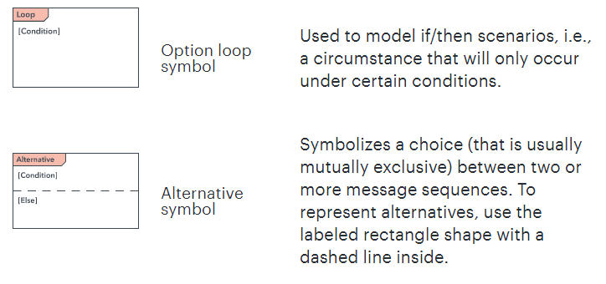

### Common message symbols

Use the following arrows and message symbols to show how information is transmitted between objects. These symbols may reflect the start and execution of an operation or the sending and reception of a signal.

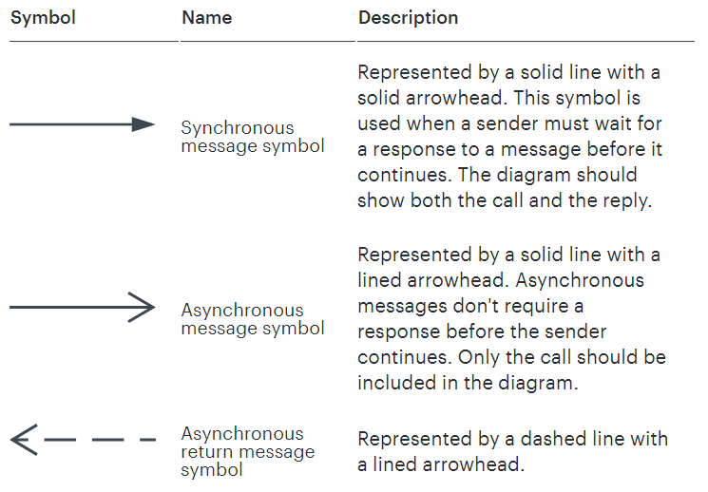

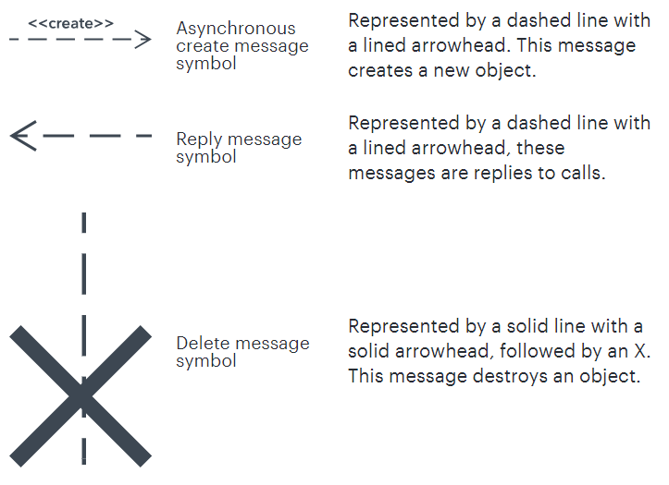

## Sequence diagram examples

### Sequence diagram of a hospital management system

Technology has completely transformed the field of medicine, as it has with most industries. A hospital information system, also known as a hospital information system, helps doctors, administrators, and hospital staff managing all of the activities and information collected at a hospital, including checkups, prescriptions, appointments, and information on the patients and their caretakers. The diagram below provides a simple view of how the primary processes operate with each other over time. You can use Lucidchart to reshape the diagram any way you choose and to share it with your colleagues or collaborators.

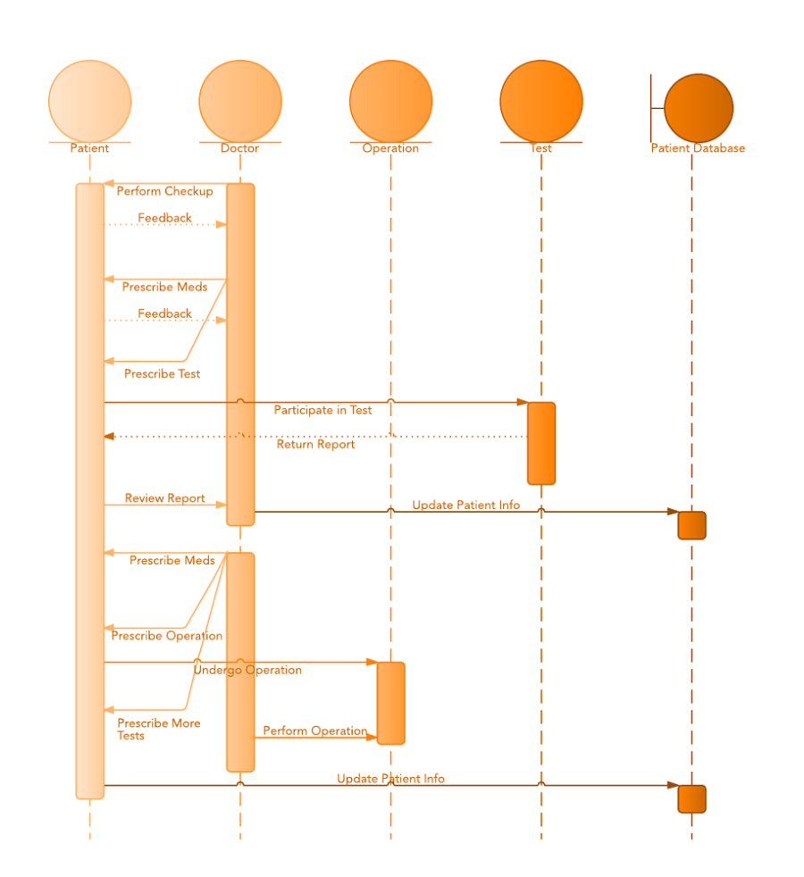

### Sequence diagram for ATM systems

An ATM allows patrons to access their bank accounts through a completely automated process. You can examine the steps of this process in a manageable way by drawing or viewing a sequence diagram. The example below outlines the sequential order of the interactions in the ATM system. Just click to edit the template, and customize the sequence diagram so it suits your own needs.

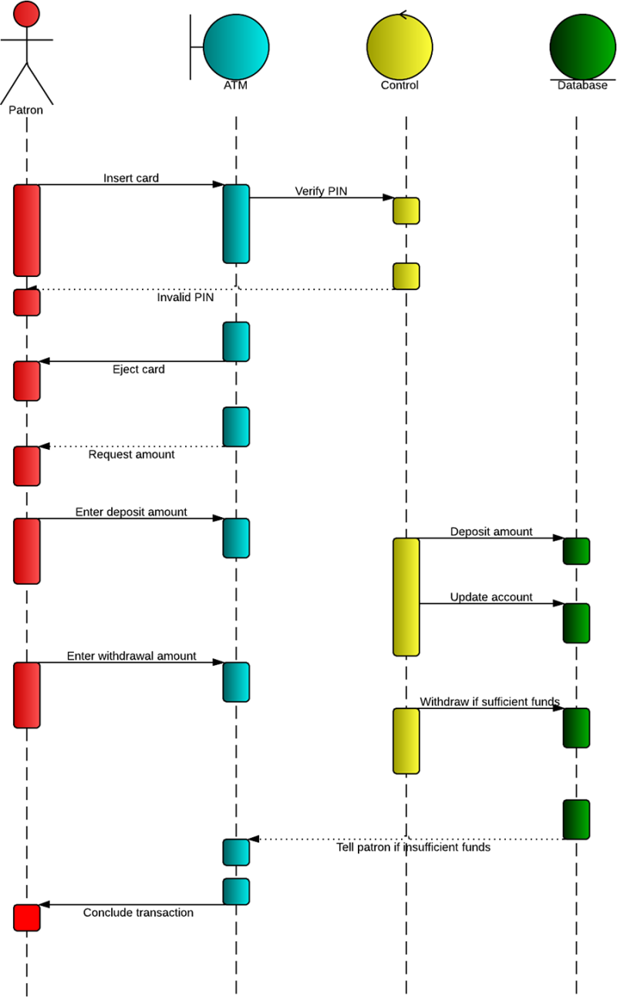

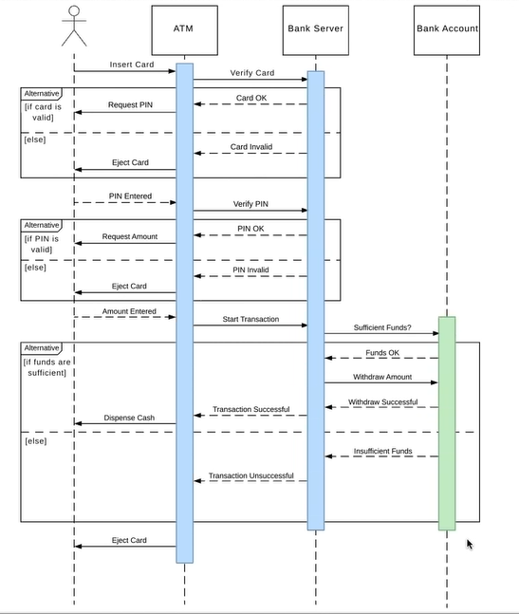

## How to make a sequence diagram

In Lucidchart, creating a sequence diagram from scratch is surprisingly simple. Just follow these steps:

1. Open a blank document or start with a template.
2. To the left of the editor, click "Shapes" to open the Shape Library Manager.
3. Check "UML" to enable all of the UML shape libraries or "UML" to enable shapes specific to UML sequence diagrams. Click "Save."
4. Drag the symbols you need from the toolbox to the canvas.
5. Then model the process flow by drawing lines between shapes while adding text.

## Task:

Please draw a Sequence Diagram of your choice. It must contain one actor and three objects atleast.

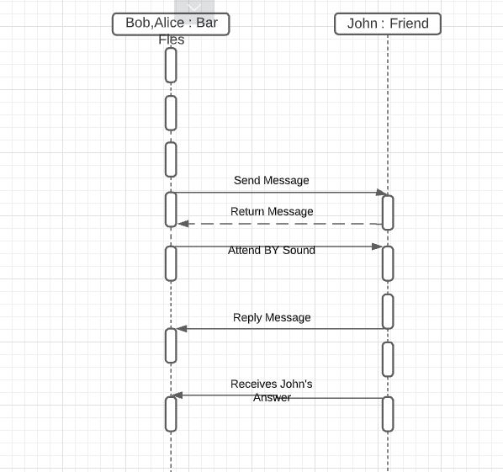

## Observations:

Sequence Diagram is a popular dynamic modeling solution in UML they Specifically focus on Lifeline, or a process and objects that live simulataneously.

## Rubrics

|  |  |  |  |  |  |  |
| --- | --- | --- | --- | --- | --- | --- |
| **Demonstration** | Absent | Student is unable to follow the provided instructions properly.  The student can name the hardware or simulation platform, but unable to implement anything practically or on the software | Student can understand the provided laboratory instructions and familiar with the lab environment (Trainer/ software/ IDE), but cannot implement on the platform practically or on the software | Student has followed instructions to construct the fundamental schematic/ block diagram/ code/ model on the protoboard/ trainer/ simulation software. | Student has constructed the functional/ working schematic/ model/ block diagram/ code, and have successfully executed the program/ run circuit on software platform | Student perfectly implemented a working model/ logic/ circuit/ block diagram/ code and successfully executed the lab objective in Realtime or in a simulation environment and produced the desired results |
| **Category** | ***Ungraded*** | **Very Poor** | **Poor** | **Fair** | **Good** | **Excellent** |
| **Percentage** | [0] | [1-20] | [21-40] | [41-60] | [61-80] | [81-100] |
| **Marks** | 0.0 | 0.01 - 0.20 | 0.21 - 0.40 | 0.41 - 0.60 | 0.61 - 0.80 | 0.81 - 1.0 |
| **Date** |  | **Total Marks** |  | **Instructor’s Signature** | |  |

|  |  |  |  |  |  |  |
| --- | --- | --- | --- | --- | --- | --- |
| **Laboratory Reports** | Report not submitted | Plagiarized content presented or incomplete submission | Requirements are listed and experimental procedure is presented | Observations are recorded along with detailed procedure | Appropriate computations or numerical analysis is performed | Correctly drawn conclusion with  exact results and complete report in all respects |
| **Category** | ***Ungraded*** | **Very Poor** | **Poor** | **Fair** | **Good** | **Excellent** |
| **Percentage** | [0] | [1-20] | [21-40] | [41-60] | [61-80] | [81-100] |
| **Marks** | 0.0 | 0.01 - 0.20 | 0.21 - 0.40 | 0.41 - 0.60 | 0.61 - 0.80 | 0.81 - 1.0 |
| **Date** |  | **Total Marks** |  | **Instructor’s Signature** | |  |

14/02/2022

LAB NO.7

# Data Flow Diagram (DFD)

## Lab outcomes:

After completing this lab, students will be able to:

* Prepare Data Flow Diagram for any project

## Corresponding CLO and PLO:

* CLO-1, PLO-3(Design/Development of Solutions)

## Requirements:

[www.lucidchart.com](http://www.lucidchart.com)

## Theory:

Data flow diagrams illustrate how data is processed by a system in terms of inputs and outputs.



Data Flow Diagram

**Data Flow Diagram Notations:** You can use two different types of notations on your data flow diagrams: Yourdon & Coad or Gane & Sarson.

**Process Notations**



Yourdon and Coad Process Notations



Gane and Sarson Process Notation

**Process** A process transforms incoming data flow into outgoing data flow.

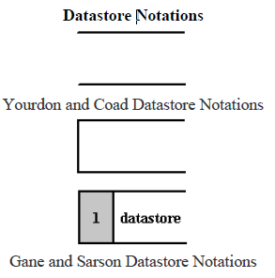

**DataStore** Datastores are repositories of data in the system. They are sometimes also referred to as files.

**Dataflow Notations**



**Dataflow**

Dataflows are pipelines through which packets of information flow. Label the arrows with the name of the data that moves through it.

**Data Flow Diagram Layers**

Draw data flow diagrams in several nested layers. A single process node on a high level diagram can be expanded to show a more detailed data flow diagram. Draw the context diagram first, followed by various layers of data flow diagrams.



Data Flow Diagram Layers

**Context Diagrams**

A context diagram is a top level (also known as Level 0) data flow diagram. It only contains one process node (process 0) that generalizes the function of the entire system in relationship to external entities.



Context Diagrams



External Entity

**External Entity**

External entities are objects outside the system, with which the system communicates. External entities are sources and destinations of the system's inputs and outputs.

**DFD levels**

The first level DFD shows the main processes within the system. Each of these processes can be broken into further processes until you reach pseudocode.



DGD Levels

## Task:

Make DFD of your choice.

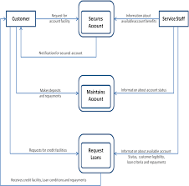

## Observations:

Data Flow Diagram is highly useful tool to maintain these aspects of the operation. DFD provide critical insights into the system and way the information passes through it.

## Rubrics

|  |  |  |  |  |  |  |
| --- | --- | --- | --- | --- | --- | --- |
| **Demonstration** | Absent | Student is unable to follow the provided instructions properly.  The student can name the hardware or simulation platform, but unable to implement anything practically or on the software | Student can understand the provided laboratory instructions and familiar with the lab environment (Trainer/ software/ IDE), but cannot implement on the platform practically or on the software | Student has followed instructions to construct the fundamental schematic/ block diagram/ code/ model on the protoboard/ trainer/ simulation software. | Student has constructed the functional/ working schematic/ model/ block diagram/ code, and have successfully executed the program/ run circuit on software platform | Student perfectly implemented a working model/ logic/ circuit/ block diagram/ code and successfully executed the lab objective in Realtime or in a simulation environment and produced the desired results |
| **Category** | ***Ungraded*** | **Very Poor** | **Poor** | **Fair** | **Good** | **Excellent** |
| **Percentage** | [0] | [1-20] | [21-40] | [41-60] | [61-80] | [81-100] |
| **Marks** | 0.0 | 0.01 - 0.20 | 0.21 - 0.40 | 0.41 - 0.60 | 0.61 - 0.80 | 0.81 - 1.0 |
| **Date** |  | **Total Marks** |  | **Instructor’s Signature** | |  |

|  |  |  |  |  |  |  |
| --- | --- | --- | --- | --- | --- | --- |
| **Laboratory Reports** | Report not submitted | Plagiarized content presented or incomplete submission | Requirements are listed and experimental procedure is presented | Observations are recorded along with detailed procedure | Appropriate computations or numerical analysis is performed | Correctly drawn conclusion with  exact results and complete report in all respects |
| **Category** | ***Ungraded*** | **Very Poor** | **Poor** | **Fair** | **Good** | **Excellent** |
| **Percentage** | [0] | [1-20] | [21-40] | [41-60] | [61-80] | [81-100] |
| **Marks** | 0.0 | 0.01 - 0.20 | 0.21 - 0.40 | 0.41 - 0.60 | 0.61 - 0.80 | 0.81 - 1.0 |
| **Date** |  | **Total Marks** |  | **Instructor’s Signature** | |  |

21/2/2022

LAB NO.8

# Introduction to Anaconda, Python, and Selenium WebDriver

## Lab outcomes:

After completing this lab, students will be able to:

* Learn about Anaconda
* Learn about python
* Learn about selenium webdriver

## Corresponding CLO and PLO:

* CLO-2, PLO-5(Modern Tool Usage)

## SOFTWARE REQUIRED:

* Anaconda
* Python
* Selenium WebDriver

## Theory:

**Anaconda:**

[Anaconda](https://www.anaconda.com/) is a free and open-source distribution of the programming languages Python. The distribution comes with the Python interpreter and various packages related to [machine learning](https://www.venturelessons.com/best-machine-learning-online-classes/) and [data science](https://www.venturelessons.com/best-data-science-online-classes/).

Basically, the idea behind Anaconda is to make it easy for people interested in those fields to install all (or most) of the packages needed with a single installation.

**Python:**

Python is a popular programming language. It was created by Guido van Rossum, and released in 1991.

It is used for.

* web development (server-side),
* software development,
* mathematics,
* system scripting.

Advantages of python:

* Python works on different platforms (Windows, Mac, Linux, Raspberry Pi, etc).
* Python has a simple syntax similar to the English language.
* Python has syntax that allows developers to write programs with fewer lines than some other programming languages.

**Selenium web driver:**

Selenium WebDriver is a web framework that permits you to execute cross-browser tests. This tool is used for automating web-based application testing to verify that it performs expectedly.It mainly supports browsers like Firefox, Chrome, Safari and Internet Explorer.

Selenium WebDriver allows you to choose a programming language to create test scripts.

Following programming languages are supported by WebDriver

* [Java](https://www.guru99.com/java-tutorial.html)
* .Net
* [PHP](https://www.guru99.com/php-tutorials.html)
* [Python](https://www.guru99.com/python-tutorials.html)
* [Perl](https://www.guru99.com/perl-tutorials.html)
* Ruby

### Installation of anaconda:

* Double click the installer to launch.
* Click Next.
* Read the licensing terms and click I Agree.
* Select an install for “Just Me” unless you’re installing for all users (which requires Windows Administrator privileges).
* Select a destination folder to install Anaconda and click Next.

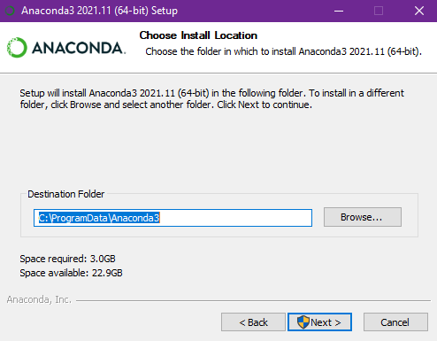

* Click the Install button to start the installation of anaconda.

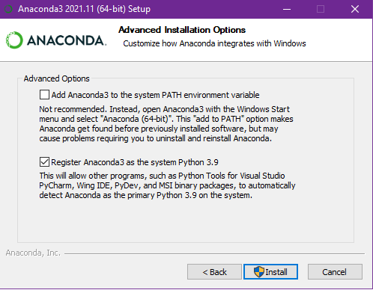

* After that installation will be start.

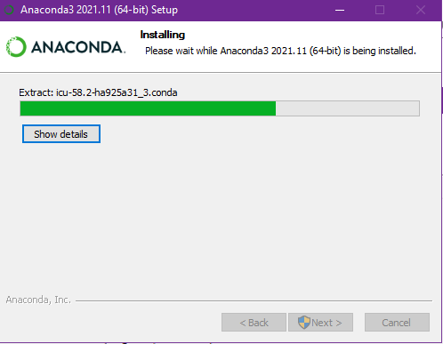

* Click the next button

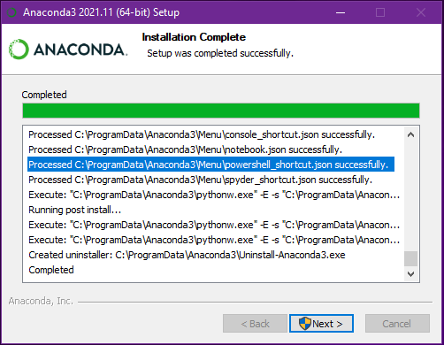

* Optional: To install PyCharm for Anaconda, click on the link to <https://www.anaconda.com/pycharm>.

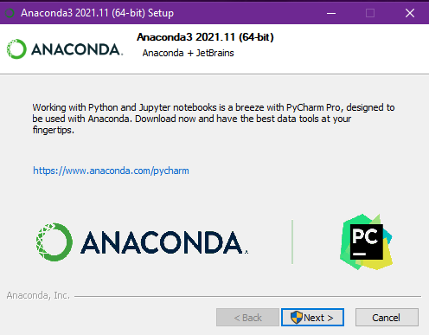

* After a successful installation click the finish button.

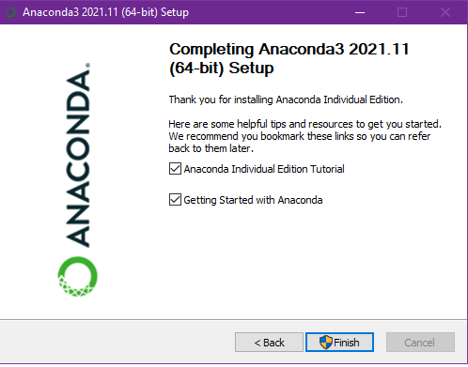

### Installation of python:

* Double-click the icon labeling the file **python-3.10.2-amd64.exe**.
* Click on **install now** to start the installation.

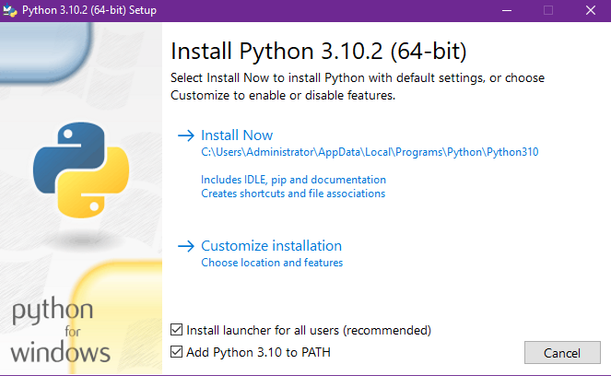

Ensure that **both** the **Install launcher for all users (recommended)** and the **Add Python 3.10 to PATH** checkboxes at the bottom are checked.

* Installation will be start

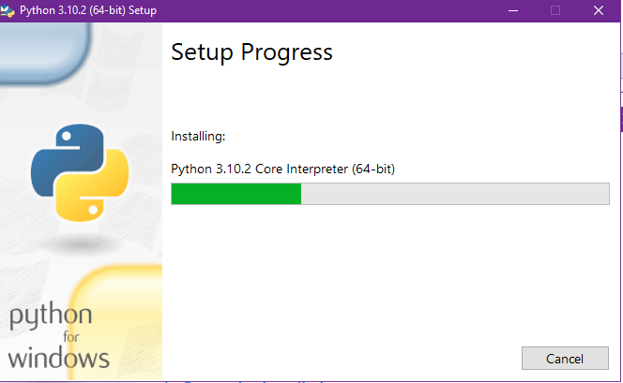

* After the successful installation click on **close** button.

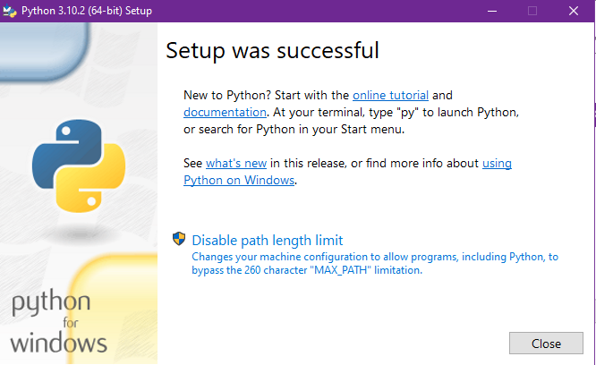

### Selenium webdriver:

* Download the webdriver from provided link. <https://sites.google.com/a/chromium.org/chromedriver/downloads>.
* Select the driver according to your chrome version.
* After the downloading, extract the downloaded file and then copy that file in to pyhton file location, as mention in the figure.

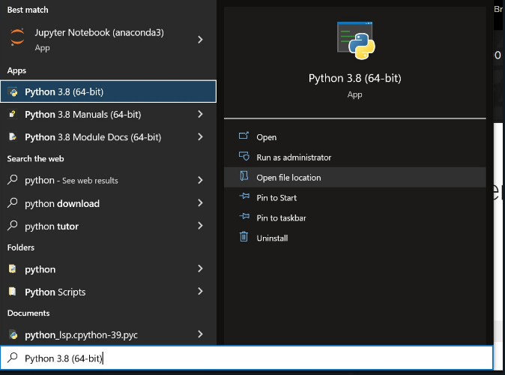

* Follow this path and copy the extracted file on the destination.

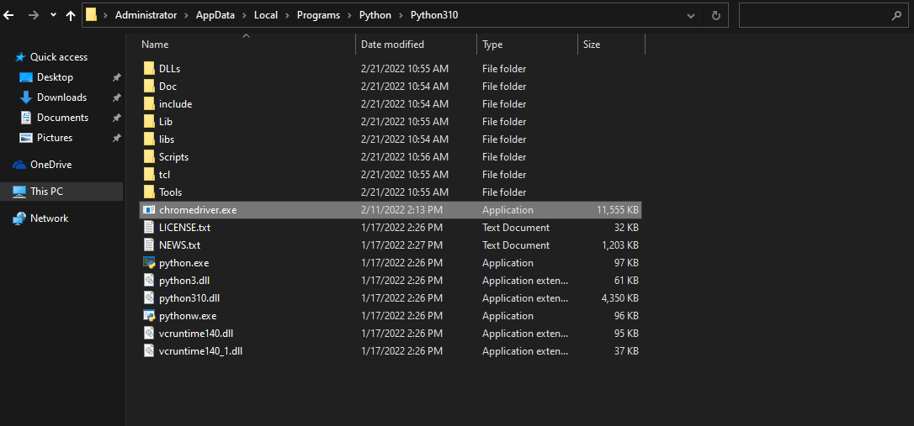

## Observations:

In this Lab we learn about different software and drivers such as python , anaconda and selenium web driver. In this lab I also learn how to download and install these softwares and also the use of these softwares. Now I am able to to run these applications to perform different task according to my requirements.

## Rubrics

|  |  |  |  |  |  |  |
| --- | --- | --- | --- | --- | --- | --- |
| **Demonstration** | Absent | Student is unable to follow the provided instructions properly.  The student can name the hardware or simulation platform, but unable to implement anything practically or on the software | Student can understand the provided laboratory instructions and familiar with the lab environment (Trainer/ software/ IDE), but cannot implement on the platform practically or on the software | Student has followed instructions to construct the fundamental schematic/ block diagram/ code/ model on the protoboard/ trainer/ simulation software. | Student has constructed the functional/ working schematic/ model/ block diagram/ code, and have successfully executed the program/ run circuit on software platform | Student perfectly implemented a working model/ logic/ circuit/ block diagram/ code and successfully executed the lab objective in Realtime or in a simulation environment and produced the desired results |
| **Category** | ***Ungraded*** | **Very Poor** | **Poor** | **Fair** | **Good** | **Excellent** |
| **Percentage** | [0] | [1-20] | [21-40] | [41-60] | [61-80] | [81-100] |
| **Marks** | 0.0 | 0.01 - 0.20 | 0.21 - 0.40 | 0.41 - 0.60 | 0.61 - 0.80 | 0.81 - 1.0 |
| **Date** |  | **Total Marks** |  | **Instructor’s Signature** | |  |

|  |  |  |  |  |  |  |
| --- | --- | --- | --- | --- | --- | --- |
| **Laboratory Reports** | Report not submitted | Plagiarized content presented or incomplete submission | Requirements are listed and experimental procedure is presented | Observations are recorded along with detailed procedure | Appropriate computations or numerical analysis is performed | Correctly drawn conclusion with  exact results and complete report in all respects |
| **Category** | ***Ungraded*** | **Very Poor** | **Poor** | **Fair** | **Good** | **Excellent** |
| **Percentage** | [0] | [1-20] | [21-40] | [41-60] | [61-80] | [81-100] |
| **Marks** | 0.0 | 0.01 - 0.20 | 0.21 - 0.40 | 0.41 - 0.60 | 0.61 - 0.80 | 0.81 - 1.0 |
| **Date** |  | **Total Marks** |  | **Instructor’s Signature** | |  |

28/02/2022

LAB NO.9

# An Introduction to Selenium with Python

## Lab outcomes:

After completing this lab, students will be able to:

* Bind Selenium with Python
* Know about Selenium
* Know about Selenium WebDriver
* Navigate through pages Automatically using Selenium
* Write test cases using Python’s unittest module

## Corresponding CLO and PLO:

* CLO-2, PLO-5(Modern Tool Usage)

## Requirements:

* Anaconda(Jupyter Notebook)
* Python
* ChromeDriver

## Theory:

Python is one of the most popular and on-demand programming languages right now. The reason is obvious; it offers plenty of benefits to its users and is considered as an all-rounder. You can create websites using Python by leveraging tools such as Flask, Django, and so on. It is also possible to perform web automation using Selenium. And you can use Python for Data Science and Machine Learning, etc. Its simple syntax and the tons of libraries and packages it provides, make it a favorite among programmers.

Python is incredibly easy to learn. It's open-source, free to use, high-level, interpreted, and has one of the largest developer communities worldwide, who are ready to solve any problem you have.

Now, if you are a software developer, you might have heard of Agile workflows. With the need to perform in-sprint testing for every new feature that is added, it is a popular tool. For applications that are small, it is okay to perform manual testing. However, for applications with complex requirements and tons of dependencies, it’s impossible to perform in-sprint testing continuously. Moreover, most of these tests are repeated, and it’s not wise to perform the same testing again and again, although it’s necessary. This problem can be easily solved by automating testing.

Python has a plethora of in-built frameworks for testing, which allows you to perform debugging and create fast workflows. Python modules such as Selenium, Splinter, and other cross-browser or cross-platform frameworks such as Robot, PyTest, etc. make this task very easy.

One of the most widely used test automation tools in Python is Selenium. It’s open-source and free to use. Selenium with Python is used to carry out automated test cases for browsers or web applications. You can easily use it to simulate tests such as tapping on a button, entering content to the structures, skimming the entire site, etc.

### Binding Selenium with Python

The first step for you to start working on Selenium with Python is that you need to write functional test cases using the Selenium web driver. Then, you need to forward a request to the Selenium server that sits at the back-end, which will execute the test cases on the browsers automatically. You can perform tests on any browser including Firefox, Chrome, IE, etc. The only thing that changes are the web drivers, which are specific for each browser.

Binding Selenium with Python is usually via APIs - which you can use to write functional or acceptance test cases with the help of the Selenium web driver. Using this API, you can easily access all the different types of functionalities in an intuitive manner.

### Why Should You Learn Selenium?

There are multiple reasons as to why Selenium is way more popular and powerful when compared to other web-automation tools in the market. Here are the reasons why:

1. It is an open-source, free-to-use, portable tool that is used to perform web-testing in a seamless manner.
2. It is a combination of several Domain Specific Language (DSL) and other tools which allow you to perform various types of testing.
3. It is quite easy to understand, intuitive, and has a low learning curve. The commands are categorized as multiple classes, making them easier to understand.
4. It takes off a load of the burden from testers, since the amount of time that is required to perform testing, especially on repeated test cases reduces drastically.
5. There is a significant reduction in the costs incurred to the business clients, which is a win-win situation.

### Web Drivers for Using Selenium With Python

Selenium requires a web driver, which will help it interface with the browser that you want to run your tests on.

### Selenium WebDriver Methods

The parent of all the classes and methods that are used for Selenium with Python is the Selenium WebDriver. Using this, you can perform any type of function or operation on any element on a webpage, hence, it is considered as the driving force of Selenium. It has a ton of attributes and methods that are used to aid automation testing in Selenium Python. Some of the most frequently used methodsfor Selenium WebDriver are –

Method Description

* **add_cookie** Adds a cookie to your current session.
* **back** Goes one step backward in the browser history.
* **close** Closes the current window.
* **create_web_element** Creates a web element with the specified element_id.
* **delete_all_cookies** Delete all cookies in the scope of the session.
* **delete_cookie** Deletes a single cookie with the given name.
* **execute_async_script** Asynchronously Executes JavaScript in the current window/frame.
* **execute_script**Synchronously Executes JavaScript in the current window/frame.
* **forward**Goes one step forward in the browser history.
* **fullscreen_window** Invokes the window manager-specific ‘full screen’ operation
* **get_cookie** Get a single cookie by name. Returns the cookie if found, None if not.
* **get_cookies** Returns a set of dictionaries, corresponding to cookies visible in the current session.
* **get_log** Gets the log for a given log type
* **get_screenshot_as_base64** Gets the screenshot of the current window as a base64 encoded string which is useful in embedded images in HTML.
* **get_screenshot_as_file** Saves a screenshot of the current window to a PNG image file.
* **get_screenshot_as_png** Gets the screenshot of the current window as a binary data.
* **get_window_position** Gets the x, y position of the current window.
* **get_window_rect** Gets the x, y coordinates of the window as well as height and width of the current window.
* **get_window_size** Gets the width and height of the current window.
* **implicitly_wait** Sets a sticky timeout to implicitly wait for an element to be found,
* **maximize_window** Maximizes the current window that webdriver is using
* **minimize_window** Invokes the window manager-specific ‘minimize’ operation
* **quit** Quits the driver and closes every associated window.
* **refresh** Refreshes the current page.
* **set_page_load_timeout** Set the amount of time to wait for a page load to complete before throwing an error.
* **set_script_timeout** Set the amount of time that the script should wait during an execute_async_script call before throwing an error.
* **set_window_position** Sets the x, y position of the current window. (window.moveTo)
* **set_window_rect** Sets the x, y coordinates of the window as well as height and width of the current window.
* **current_url** Gets the URL of the current page.
* **current_window_handle** Returns the handle of the current window.
* **page_source** Gets the source of the current page.
* **title**

### WebElement Methods for Selenium With Python

The class called selenium.webdriver.remote.webelement.WebElement encloses a plethora of elements within it. These elements can be property, class, tag, or anything. For example, when you find an element in a web page using the driver, you can perform certain actions such as clicking on it or finding the sub-elements. For this, you can leverage several Selenium WebElement methods. Some of the popular Selenium WebElement methods are –

Element MethodsDescription

* **is_selected()**This method returns a boolean value based on whether the element is selected or not.
* **is_displayed()**This method returns a boolean value based on whether or not the element is displayed.
* **is_enabled()**This method returns a boolean value based on whether or not the element is enabled.
* **get_property()**This method can be used to get the properties of a particular element, like text_length property, etc.
* **get_attribute()**This method can be used to get attributes of a particular element, like getting an href attribute, etc.
* **send_keys()**This method is used to send a text property to any input field or even an anchor tag or a paragraph.
* **click()**This method is used to click on any element.
* **clear()**This method is used to clear the text of any input field.
* **screenshot_as_png()**This method is used to take a screenshot of the current element.
* **submit()**This method is used to submit a form.
* **value_of_css_property()**This method is used to get the value of a specific element’s CSS property.
* **location**This method is used to get the location of the elements.
* **screenshot()**This method is used to take the screenshot in the form of binary data.
* **parent**This method is used to get the parent of the current element.
* **size**This method is used to receive the size of the current element.
* **tag_name**This method is used to get the tag name.
* **text**This method is used to get the text.
* **rect**This method is used to get a dictionary containing the location and size of the element.
* **screenshot_as_base64**This method is used to take the screenshot as a base64 encoded string.

### Walkthrough of the example

Initially, all the basic modules required are imported. The [unittest](http://docs.python.org/library/unittest.html) module is a built-in Python based on Java’s JUnit. This module provides the framework for organizing the test cases. The selenium.webdriver module provides all the WebDriver implementations. Currently supported WebDriver implementations are Firefox, Chrome, IE and Remote. The Keys class provides keys in the keyboard like RETURN, F1, ALT etc.

**importunittest**

**fromseleniumimport**webdriver

**fromselenium.webdriver.common.byimport**By

**fromselenium.webdriver.common.keysimport**Keys

The test case class is inherited from unittest.TestCase. Inheriting from TestCase class is the way to tell unittest module that this is a test case:

**classPythonOrgSearch**(unittest.TestCase):

The setUp is part of initialization, this method will get called before every test function which you are going to write in this test case class. Here you are creating the instance of Chrome WebDriver.

**def**setUp(self):

self.driver=webdriver.Chrome()

This is the test case method. The test case method should always start with characters test. The first line inside this method create a local reference to the driver object created in setUp method.

**def**test_search_in_python_org(self):

driver=self.driver

The driver.get method will navigate to a page given by the URL. WebDriver will wait until the page has fully loaded (that is, the “onload” event has fired) before returning control to your test or script. Be aware that if your page uses a lot of AJAX on load then WebDriver may not know when it has completely loaded:

driver.get("http://www.python.org")

The next line is an assertion to confirm that title has “Python” word in it:

self.assertIn("Python",driver.title)

WebDriver offers a number of ways to find elements using one of the find_element* method. For example, the input text element can be located by its NAME attribute using find_element method. Detailed explanation of finding elements is available in the [Locating Elements](https://selenium-python.readthedocs.io/locating-elements.html#locating-elements) chapter:

elem=driver.find_element(By.NAME,'q')

Next, we are sending keys, this is similar to entering keys using your keyboard. Special keys can be send using Keys class imported from selenium.webdriver.common.keys:

elem.send_keys("pycon")

elem.send_keys(Keys.RETURN)

After submission of the page, you should get the result as per search if there is any. To ensure that some results are found, make an assertion:

self.assertNotIn("No results found.",driver.page_source)

The tearDown method will get called after every test method. This is a place to do all cleanup actions. In the current method, the browser window is closed. You can also call quit method instead of close. The quit will exit the entire browser, whereas close will close a tab, but if it is the only tab opened, by default most browser will exit entirely.:

**def**tearDown(self):

self.driver.close()

Final lines are some boiler plate code to run the test suite:

**if**__name__=="__main__":

unittest.main()

Note: To run the above test in IPython or Jupyter, you should pass a couple of arguments to the *main* function as shown below:

unittest.main(argv=['first-arg-is-ignored'], exit=**False**)

### Wrapping Up!

We looked into how you can leverage Selenium with Python to automate test cases and perform automation of web browsers and web applications. Selenium is an open-source and powerful tool with a vast community, and using it with Python is just a cherry on the top because Python is far less verbose and easy-to-work-with compared to any other programming language.

For Seleniumwith Python Documentation visit:

<https://selenium-python.readthedocs.io/index.html>

## Experiment:

1. If you have not already installed Python then first download it from <https://www.python.org/downloads/windows/> and Install it.
2. After that download ChromeDriver from <https://sites.google.com/a/chromium.org/chromedriver/downloads> and keep it in the python installed directory

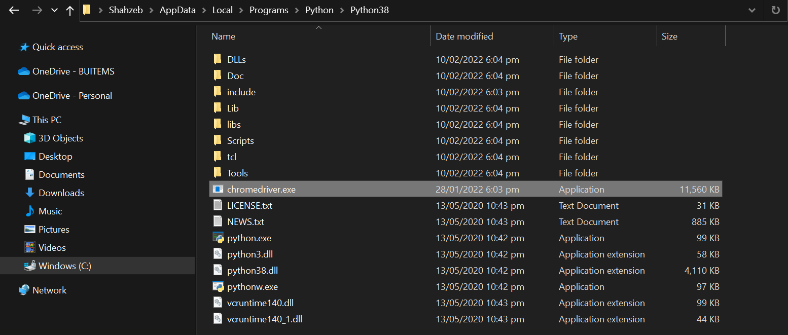

1. Download and Install Anaconda Distribution from<https://www.anaconda.com/products/individual#windows>
2. Open Jupyter Notebook using Anaconda and create newPython script
3. Install Selenium using this command

*!pip install selenium*

1. Now Write this code and run it.

|  |
| --- |
| from selenium import webdriver  from selenium.webdriver.common.by import By  from selenium.webdriver.support.ui import WebDriverWait  from selenium.webdriver.support import expected_conditions as EC  try:  driver = webdriver.Chrome();  driver.get('https://www.daraz.pk');  driver.maximize_window();  driver.find_element(By.ID,'anonLogin').click();  usernameTB = driver.find_element(By.XPATH, '/html/body/div[2]/div/div[2]/div/div[2]/form/div/div[1]/div[1]/input');  usernameTB.send_keys("selabbuitems@gmail.com");  passwordTB = driver.find_element(By.XPATH, '/html/body/div[2]/div/div[2]/div/div[2]/form/div/div[1]/div[2]/input');  passwordTB.send_keys("CE5@HBLlab1");  submitBTN = driver.find_element(By.XPATH, '/html/body/div[2]/div/div[2]/div/div[2]/form/div/div[2]/div[1]/button');  submitBTN.click();  element = WebDriverWait(driver, 10).until(  #EC.presence_of_element_located((By.XPATH, "/html/body/div[2]/div/div[2]/div/div[2]/form/div/div[2]/div[1]/button"));  EC.invisibility_of_element_located((By.XPATH, "/html/body/div[2]/div/div[2]/div/div[2]/form/div/div[2]/div[1]/button"))  )  searchTB = driver.find_element(By.ID,'q');  searchTB.send_keys("pencil box");  searchBTN = driver.find_element(By.XPATH,'/html/body/div[1]/div/div/div[1]/div/div/div[2]/div/div[2]/form/div/div[2]/button')  searchBTN.click();  firstProduct = driver.find_element(By.XPATH,'/html/body/div[3]/div/div[2]/div[1]/div/div[1]/div[2]/div[1]/div');  firstProduct.click();  firstProductAddToCartBTN = driver.find_element(By.XPATH,'/html/body/div[4]/div/div[2]/div[2]/div/div[1]/div[15]/div/button[2]');  firstProductAddToCartBTN.click();  except Exception as e:  print(e); |

## Task:

1. Perform the steps mentioned in Experiment. Take ScreenShots of each step and explain it.
2. Now Write a script to go to <https://priceoye.pk/> login and then search and add one product to cart

## 

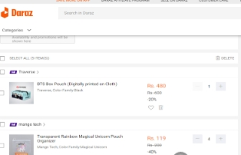

## 

Please write your observation after conducting this lab, you have to write in few lines, what did you learn in this lab.

## Python language is used with Selenium for testing. It has far less verbose and easy to use than any other programming language. The Python APIs empower you to connect with the browser through Selenium. Selenium can send the standard Python commands to different browsers, despite variation in their browser's design.

## Rubrics

|  |  |  |  |  |  |  |
| --- | --- | --- | --- | --- | --- | --- |
| **Demonstration** | Absent | Student is unable to follow the provided instructions properly.  The student can name the hardware or simulation platform, but unable to implement anything practically or on the software | Student can understand the provided laboratory instructions and familiar with the lab environment (Trainer/ software/ IDE), but cannot implement on the platform practically or on the software | Student has followed instructions to construct the fundamental schematic/ block diagram/ code/ model on the protoboard/ trainer/ simulation software. | Student has constructed the functional/ working schematic/ model/ block diagram/ code, and have successfully executed the program/ run circuit on software platform | Student perfectly implemented a working model/ logic/ circuit/ block diagram/ code and successfully executed the lab objective in Realtime or in a simulation environment and produced the desired results |
| **Category** | ***Ungraded*** | **Very Poor** | **Poor** | **Fair** | **Good** | **Excellent** |
| **Percentage** | [0] | [1-20] | [21-40] | [41-60] | [61-80] | [81-100] |
| **Marks** | 0.0 | 0.01 - 0.20 | 0.21 - 0.40 | 0.41 - 0.60 | 0.61 - 0.80 | 0.81 - 1.0 |
| **Date** |  | **Total Marks** |  | **Instructor’s Signature** | |  |

|  |  |  |  |  |  |  |
| --- | --- | --- | --- | --- | --- | --- |
| **Laboratory Reports** | Report not submitted | Plagiarized content presented or incomplete submission | Requirements are listed and experimental procedure is presented | Observations are recorded along with detailed procedure | Appropriate computations or numerical analysis is performed | Correctly drawn conclusion with  exact results and complete report in all respects |
| **Category** | ***Ungraded*** | **Very Poor** | **Poor** | **Fair** | **Good** | **Excellent** |
| **Percentage** | [0] | [1-20] | [21-40] | [41-60] | [61-80] | [81-100] |
| **Marks** | 0.0 | 0.01 - 0.20 | 0.21 - 0.40 | 0.41 - 0.60 | 0.61 - 0.80 | 0.81 - 1.0 |
| **Date** |  | **Total Marks** |  | **Instructor’s Signature** | |  |

7/03/2022

LAB NO.10

# Performance Testing with JMeter

## Lab outcomes:

After completing this lab, students will be able to:

* Install Java on Windows
* Install JMeter on Windows
* Performance Testing with JMeter

## Corresponding CLO and PLO:

* CLO-2, PLO-5(Modern Tool Usage)

## Requirements:

* Java
* JMeter

## Theory:

The last decade has seen an overwhelming evolution of the Software Testing industry giving way to greener pastures. It is important to ensure effective performance of software application and Software Testing is required to ensure that the application runs without any failures.

### What is Performance Testing?

It is very important to verify whether the product meets expected or required performance. Unfortunately, we figure out this pitfall post delivery of the product. But performance has become an inevitable factor nowadays, especially for web and mobile applications as the user strength is very huge for each application.

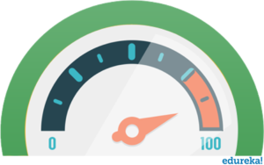

Performance Testing is defined as a [type of software testing](https://www.edureka.co/blog/types-of-software-testing/) to ensure that software applications will perform well under their expected workload. It focuses on certain factors of a Software Program such as:

* **Speed** – It Checks whether the response of the application is fast.
* **Scalability** – It determines the maximum user load.
* **Stability** – It checks if the application is stable under varying loads.

#### ****Tools used for Performance Testing****

Performance testing is significant in real time, particularly from a point of view of customer satisfaction. There are several performance testing tools available such as:

* Apache JMeter
* LoadRunner
* WebLOAD
* LoadUI
* LoadView
* NeoLoad

JMeter is one of the most preferred tool for Performance Testing.

### What is JMeter?

Apache JMeter is a testing tool used for analyzing and measuring the performance of different software services and products. It is a pure Java open source software used for testing Web Application or FTP application.



It is used to execute performance testing, load testing and functional testing of web applications. JMeter can also simulate a heavy load on a server by creating tons of virtual concurrent users to web server.

#### How does JMeter perform Testing?

Let’s have a look at the different steps performed by JMeter during testing:

1. It creates a request and sends to the server.
2. It receives the response from server, collects them and visualizes those details in a chart or graph.
3. It processes the response from the server.
4. It generates the test result in several formats such as text, XML, JSON so that the tester can analyze data.

#### Advantages of JMeter

Apache JMeter open source software fills a big void by making the testing process easy. Some of the advantages of JMeter include:

**Open-source** – JMeter is an open source software. This means that it can be downloaded free of cost. It is also a 100% pure Java application. The developer can use its source code, can modify and customize it as per their requirement.

**User-friendly** – JMeter has a comprehensive GUI, which helps to create test plan and configure the elements. Adding elements is also easy. You just have to right-click on the tree scenario and add what you need to do.

**Support** – Basically it is designed for performance testing, but also supports other non-functional tests such as Stress Testing, Distributed Testing, Web service testing, etc by creating test plans.

**Comprehensive Documentation** – This is one of the most important things to be highlighted. Because of its robust documentation, user can have a clear idea on each and every step, starting from scratch including installation and configuration of the test settings and generating final report.

**Recording** – JMeter allows user to record HTTP/HTTPS to create Test plan using Recording facility. We use Proxy Server that allows JMeter to watch and record your actions while you browse your web application with your normal browser.

**Reporting** – JMeter supports dashboard report generation. A host of reports are generated through JMeter which helps the user to understand Performance test execution results.

### Elements of JMeter

The different components of JMeter are called Elements. Each Element is designed for a specific purpose. Some of the main elements are :

* Thread Group
* Samplers
* Listeners
* Configuration

#### Thread Group

Thread Groups is a collection of Threads. Each thread represents one user using the application under test. It simulates one real user request to the server. The controls for a thread group also allow you to set the number of threads for each group.

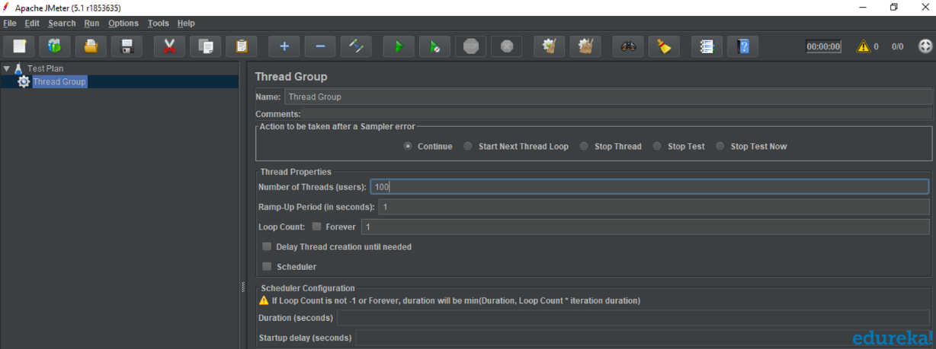

For example, if you set the number of threads as 100, JMeter will create and simulate 100 user requests to the server under test.

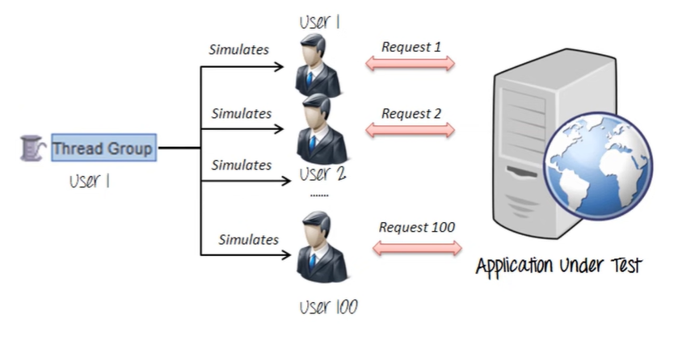

#### ****Samplers****

JMeter supports testing HTTP, FTP, JDBC and many more protocols.Thread Groups simulate user request to the server. Samplers help the Thread Group to know which type of requests (HTTP, FTP etc.) it needs to make.

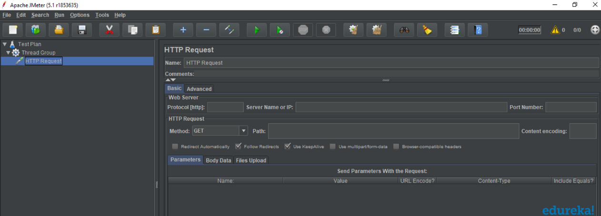

* **FTP request:**You can use an FTP request sampler in JMeter to do a performance test on FTP server. This controller lets you send an FTP “download file” or “upload file” request to an FTP server.
* **HTTP request:**This sampler lets you send an HTTP/HTTPS request to a web server.
* [**JDBC**](https://www.edureka.co/blog/advanced-java-tutorial)**request:**This sampler lets you execute Database Performance Testing. It sends a JDBC Request to a database.
* **BSF Sampler:**This sampler allows you to write a sampler using a BSF scripting language.
* **Access Log Sampler:**This sampler allows you to read access logs and generate HTTP requests.
* **SMTP Sampler:**This sampler is used to send email messages using the SMTP protocol.

#### ****Listeners****

Listeners show the results of the test execution. They can show results in a different format such as a tree, table, graph or log file.

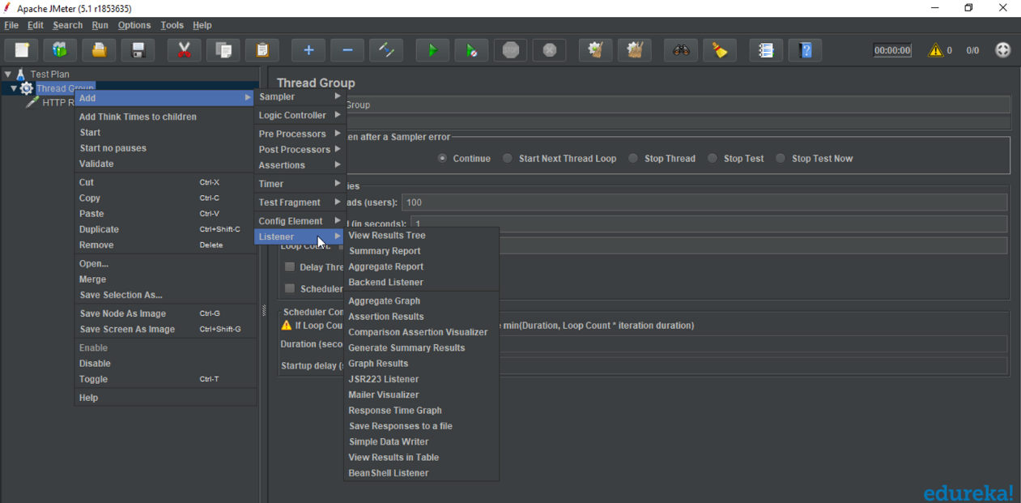

* Graph result listeners display the server response times on a Graph
* View Result Tree show results of the user request in basic HTML format
* Table Result show summary of a test result in table format
* Log show summary of a test results in the text file

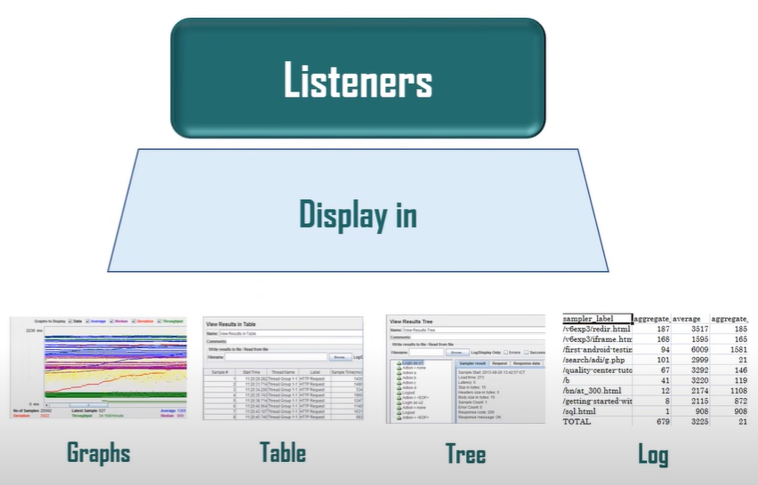

#### ****Configuration Elements****

Configuration Elements are used to set up defaults and variables for later use by samplers.

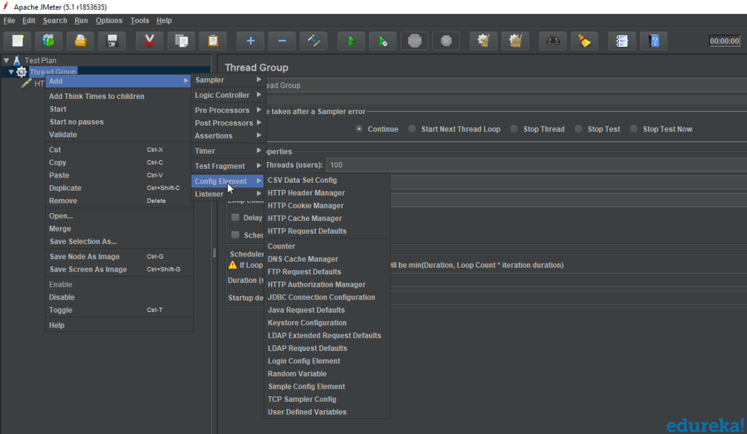

* **CSV Data Set Config :**TheCSV Data Set Config  allows you to read different parameters from text file. It is used to read lines from a file, and split them into variables.
* **HTTP Cookie Manager :**HTTP Cookie Manager has the same feature as a web browser. If you have an HTTP Request and the response contains a cookie, the Cookie Manager automatically stores that cookie to use it for all future requests.
* **HTTP request default :**This element lets you set default values that your HTTP Request controllers use.
* **Login Config Element :**The Login Config Element lets you add or override username and password settings in samplers.

## Experiment:

### Installation of JMeter:

1. If you have not already installed Javathen first download it from<https://www.java.com/download/ie_manual.jsp> and Install it. JMeter is pure Java desktop application and it requires a fully compliant JVM 6 or higher. You can download and install the latest version of Java SE Development Kit.

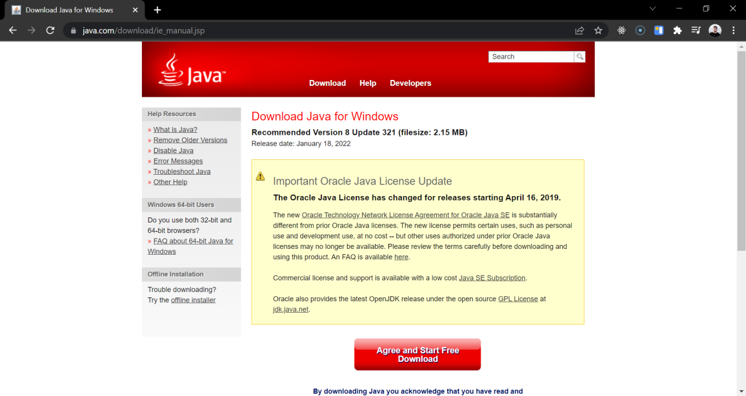

1. You can check in the command prompt if the installation is successful. It will give you the following output :

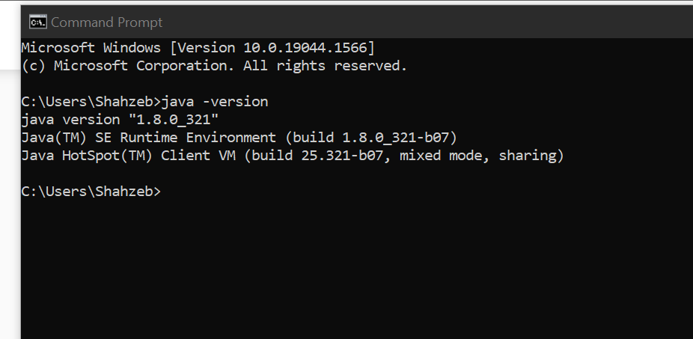

1. The download apache-jmeter zip file from <https://jmeter.apache.org/download_jmeter.cgi>. Installation of JMeter is extremely easy and simple. You simply unzip the zip/tar file into the directory where you want JMeter to be installed. There is no tedious installation screen to deal with.

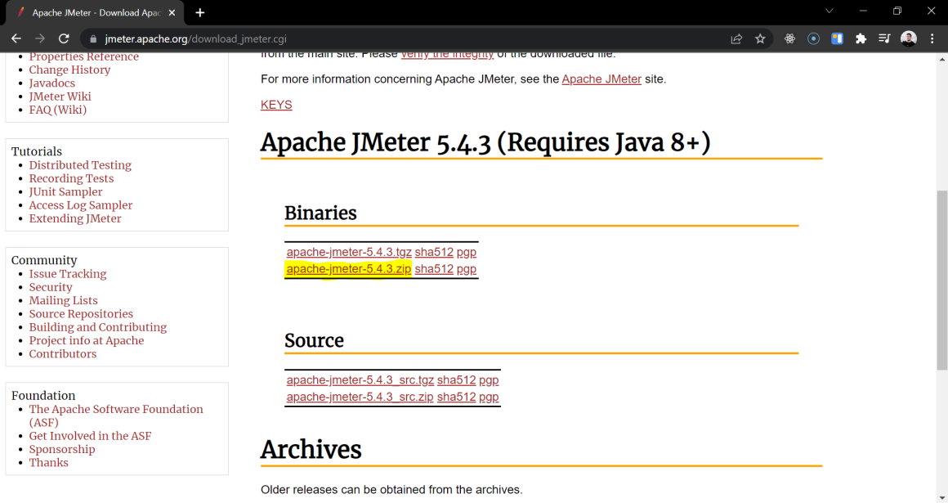

1. After you unzip the file, execute the**jmeter.bat** file from bin directory.

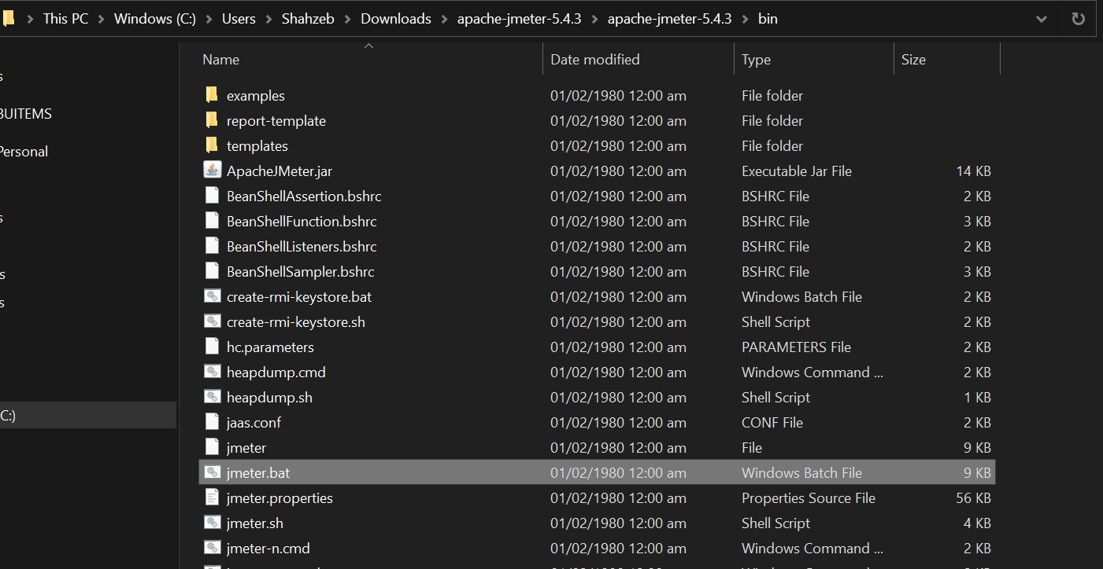

1. The GUI of JMeter will look like this

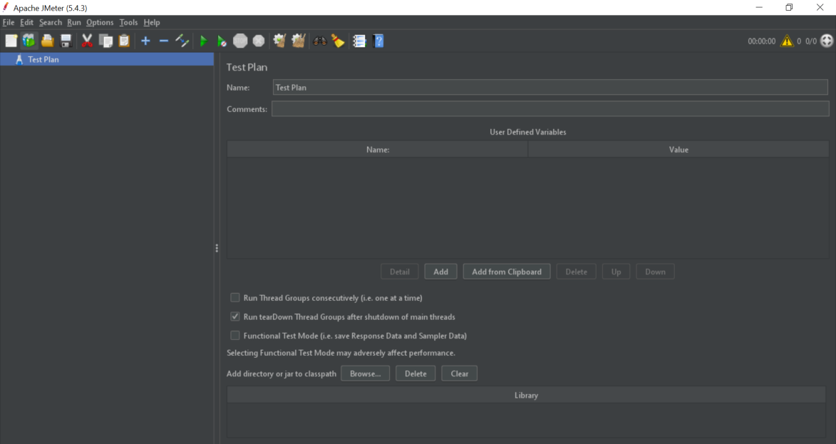

### Performance Testing with JMeter

1. Start by Creating a Test Plan.

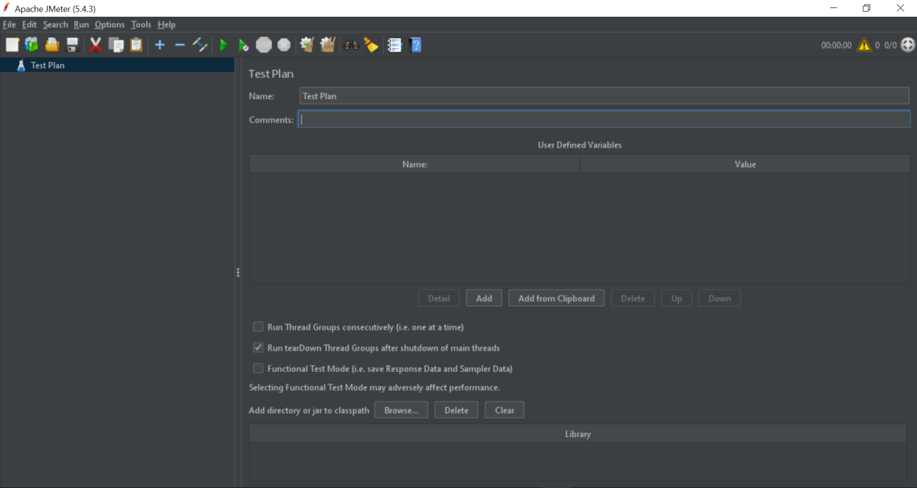

1. Then Add a Thread Group to that Test Plan

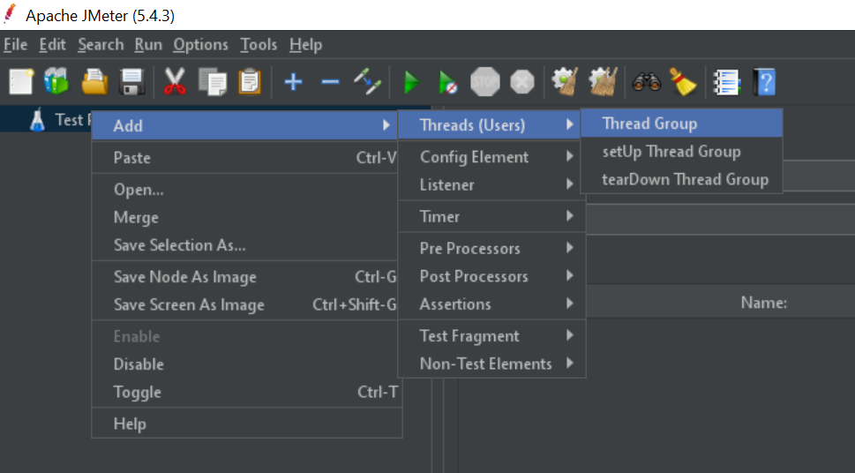

1. Configure the Thread Group. The ramp-up period tells JMeter how long to take to "ramp-up" to the full number of threads chosen. If 10 threads are used, and the ramp-up period is 100 seconds, then JMeter will take 100 seconds to get all 10 threads up and running. Each thread will start 10 (100/10) seconds after the previous thread was begun.

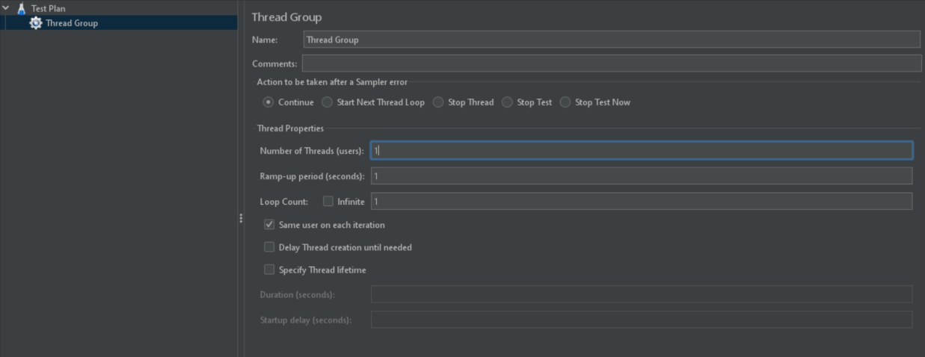

1. Then Add the HTTP Request

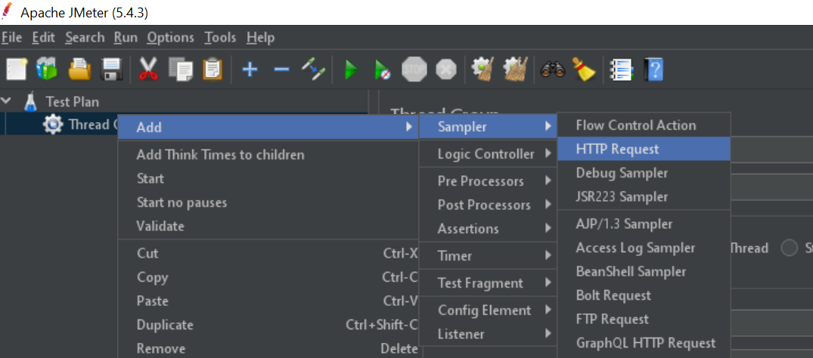

1. Configure the HTTP Request  
   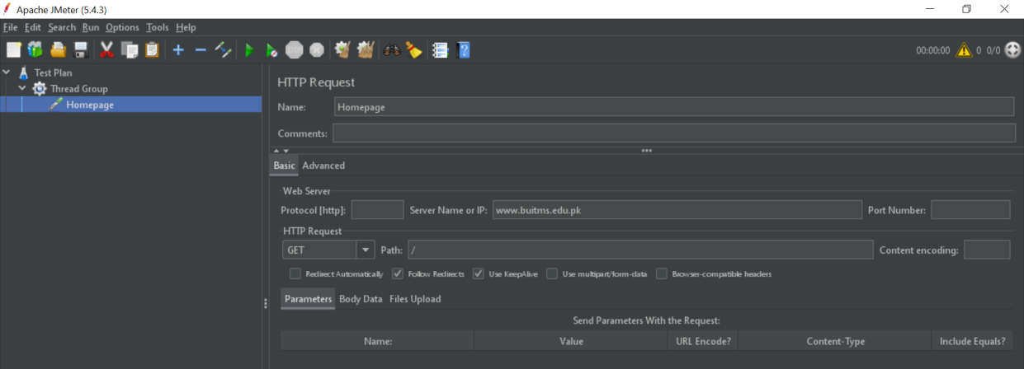
2. Add the Listener of your choice to view the results  
   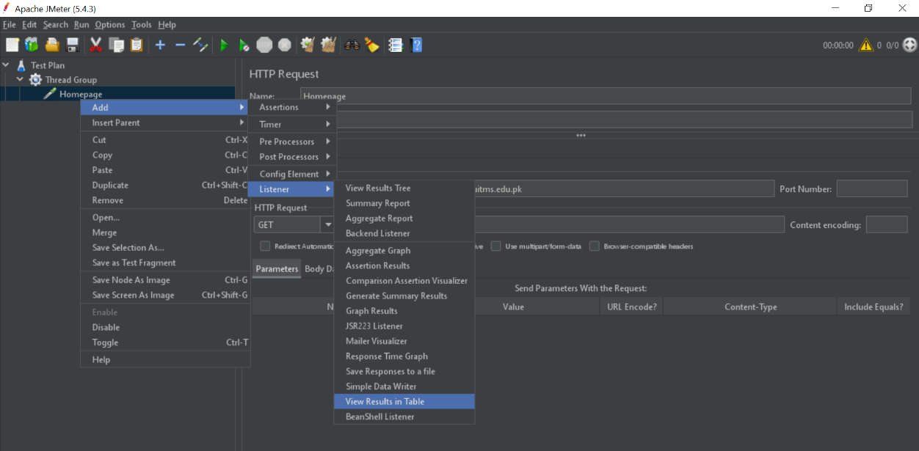
3. In order to run this test we have to save it first with the help of Save Icon.

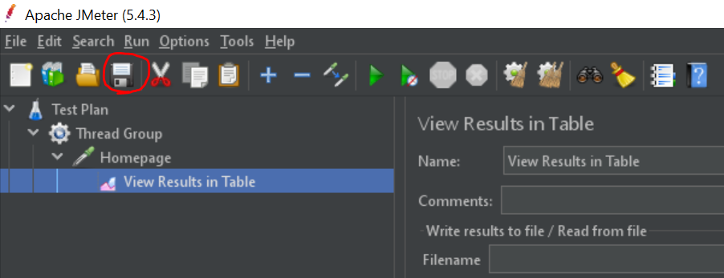

1. Now run this test with the help of Start icon  
   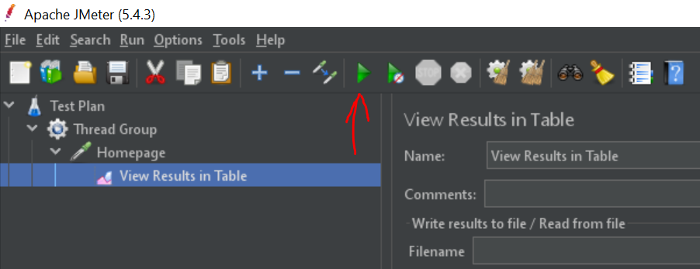
2. Your results may look like this depending upon the number of threads you have choose in Thread Group section.

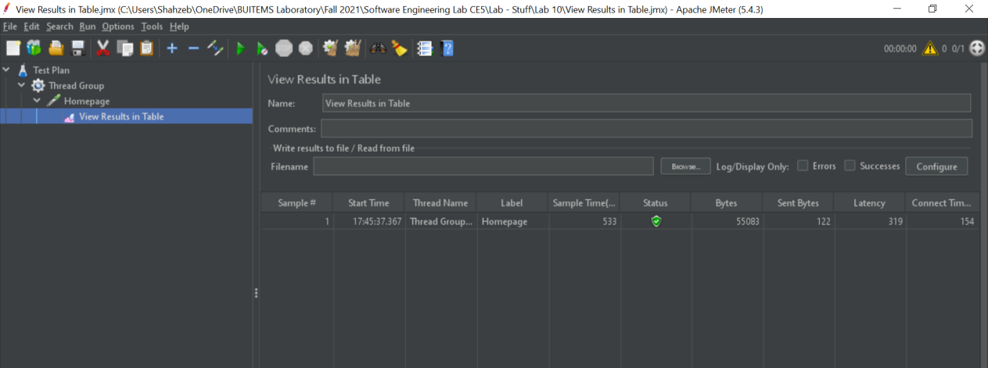  
***Latency:***travel time from client to server and server to client. Some tester called it “Delay”.  
***Connect Time:***time it took to establish the connection, including SSL handshake.

***Deviation:*** is a measure of the variability of a data set.

***Throughput:*** is calculated as requests/unit of time.

## Task:

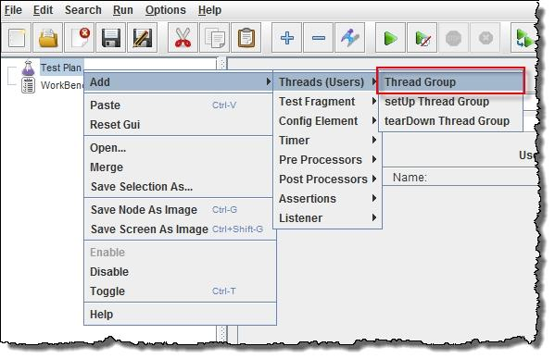Perform the performance testing on the website of your choice. Show results in different listeners including Graphs, Tree and Tables.

## 

## 

## Observations:

Please write your observation after conducting this lab, you have to write in few lines, what did you learn in this lab.

## The JMeter tool is easy to use for injecting load on web application servers. Development and quality engineers can easily simulate a heavy load on a server using JMeter tool without doing extra setup for virtual users, extra efforts for scripting and can measure accurate response time in form of charts and table summary. JMeter results charts are useful locate bottlenecks and improve performance of the web server application. Quality engineers can identify the culprit RestAPI by analyzing JMeter results charts. JMeter tool is also used to perform server benchmark tests and scalabiity tests.

## Rubrics:

|  |  |  |  |  |  |  |
| --- | --- | --- | --- | --- | --- | --- |
| **Demonstration** | Absent | Student is unable to follow the provided instructions properly.  The student can name the hardware or simulation platform, but unable to implement anything practically or on the software | Student can understand the provided laboratory instructions and familiar with the lab environment (Trainer/ software/ IDE), but cannot implement on the platform practically or on the software | Student has followed instructions to construct the fundamental schematic/ block diagram/ code/ model on the protoboard/ trainer/ simulation software. | Student has constructed the functional/ working schematic/ model/ block diagram/ code, and have successfully executed the program/ run circuit on software platform | Student perfectly implemented a working model/ logic/ circuit/ block diagram/ code and successfully executed the lab objective in Realtime or in a simulation environment and produced the desired results |
| **Category** | ***Ungraded*** | **Very Poor** | **Poor** | **Fair** | **Good** | **Excellent** |
| **Percentage** | [0] | [1-20] | [21-40] | [41-60] | [61-80] | [81-100] |
| **Marks** | 0.0 | 0.01 - 0.20 | 0.21 - 0.40 | 0.41 - 0.60 | 0.61 - 0.80 | 0.81 - 1.0 |
| **Date** |  | **Total Marks** |  | **Instructor’s Signature** | |  |

|  |  |  |  |  |  |  |
| --- | --- | --- | --- | --- | --- | --- |
| **Laboratory Reports** | Report not submitted | Plagiarized content presented or incomplete submission | Requirements are listed and experimental procedure is presented | Observations are recorded along with detailed procedure | Appropriate computations or numerical analysis is performed | Correctly drawn conclusion with  exact results and complete report in all respects |
| **Category** | ***Ungraded*** | **Very Poor** | **Poor** | **Fair** | **Good** | **Excellent** |
| **Percentage** | [0] | [1-20] | [21-40] | [41-60] | [61-80] | [81-100] |
| **Marks** | 0.0 | 0.01 - 0.20 | 0.21 - 0.40 | 0.41 - 0.60 | 0.61 - 0.80 | 0.81 - 1.0 |
| **Date** |  | **Total Marks** |  | **Instructor’s Signature** | |  |

14/03/2022

LAB NO.11

# Work Management with Asana

## Lab outcomes:

After completing this lab, students will be able to:

* Configure Project in Asana
* Manage any project

## Corresponding CLO and PLO:

* CLO-2, PLO-5(Modern Tool Usage)

## Requirements:

* Asana

## Theory:

Asana is a software-as-a-service platform designed to improve team collaboration and work management. It helps teams manage projects and tasks in one tool.

## 1. How to create a task

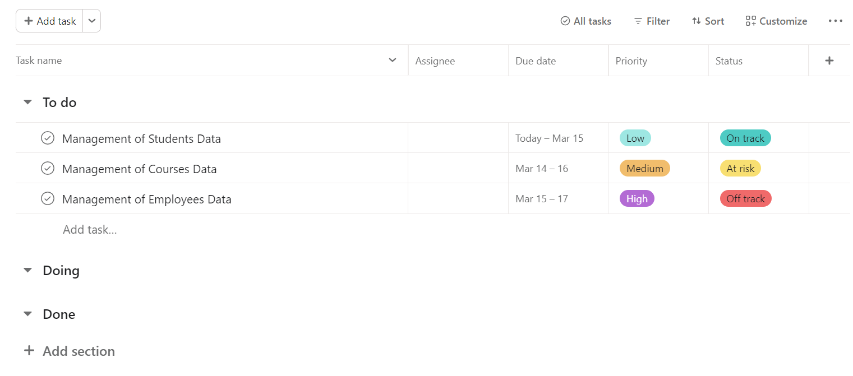

Everything starts with a [**task**](https://asana.com/guide/get-started/begin/adding-assigning-tasks). Tasks are actionable to-do’s and the most important building block of Asana.

To create a task, start in a project, type a task name, then press enter to keep adding more.

### Task best practice

* Make task names specific and action-based so it's clear what you need to do. Add a task description so the assignee knows what they need to do.
* [Assign the task](https://asana.com/guide/help/tasks/people#gl-assignee) to a teammate and set a [due date](https://asana.com/guide/help/tasks/fields#gl-due-date) (even if it's just a guess). That way it's clear who is responsible for what.
* [Attach files](https://asana.com/guide/help/tasks/comments#gl-attachments) with any relevant context, information, or working documents. Also, make sure to attach completed files when you're [marking the task complete](https://asana.com/guide/help/tasks/fields#gl-completing) so teammates can find your work and know it's done.
* Add [teammates as task collaborators](https://asana.com/guide/help/tasks/people#gl-followers) so they can stay up to date on task progress. You can ping them by [@mentioning](https://asana.com/guide/team/advanced/connect-your-work#gl-atmentioning) them when you [comment on a task](https://asana.com/guide/help/tasks/comments).

## 2. How to create your first project

[**Projects**](https://asana.com/guide/get-started/begin/quick-start#lessons) are how you organize and plan all of the tasks related to a specific initiative, goal, or big piece of work. You can visualize projects on [**list**](https://asana.com/guide/help/views/list), [**board**](https://asana.com/guide/help/views/boards), [**calendar**](https://asana.com/guide/team/onboard/asana-calendar), or [**Timeline**](https://asana.com/guide/team/onboard/timeline) and toggle between these views at anytime.

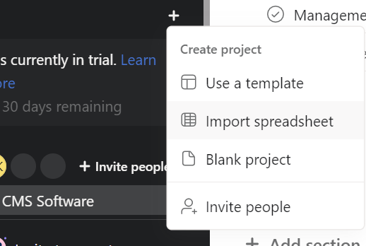

### Types of projects you can managein Asana

You can plan and manage almost any project or process in Asana, but here are the most common examples:

**[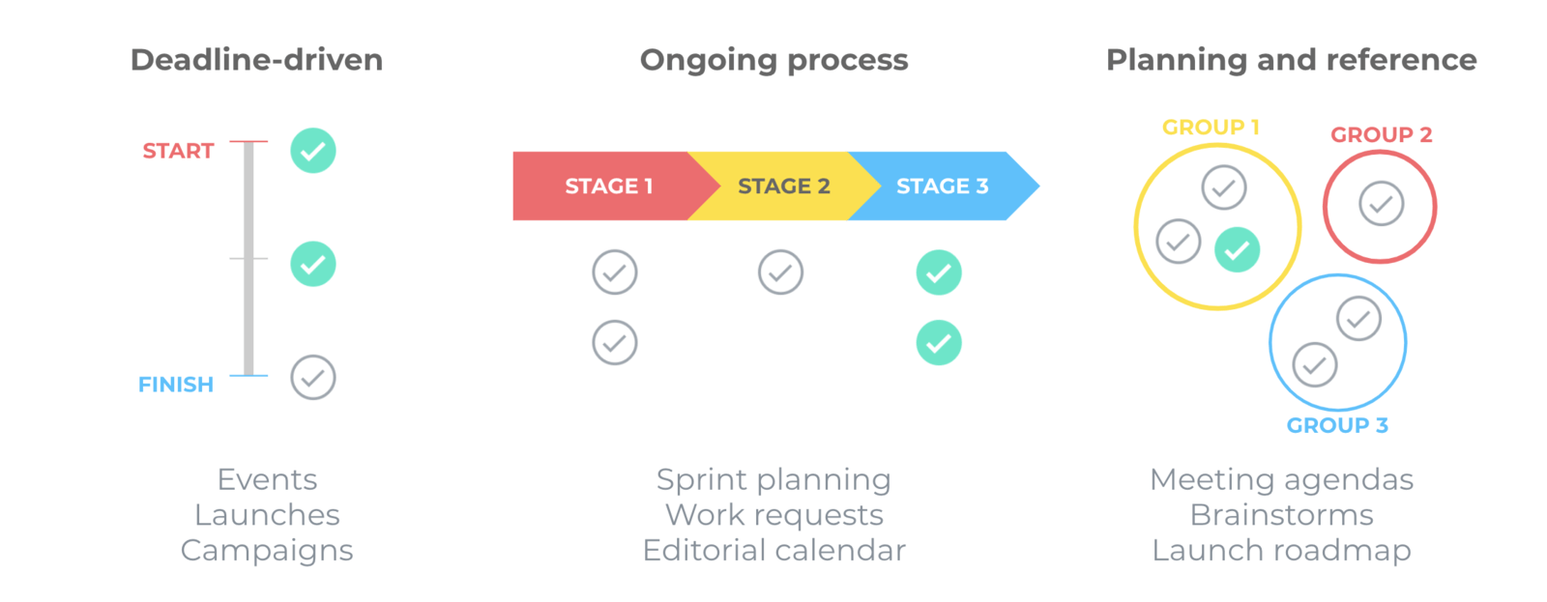](http://asana.com/templates)**

See more examples in our [**ways to use Asana**](https://asana.com/guide/examples) section or get started with a pre-made project in our [**templates library**](https://asana.com/templates).

## 3. Organize your project

### Group related tasks together with sections

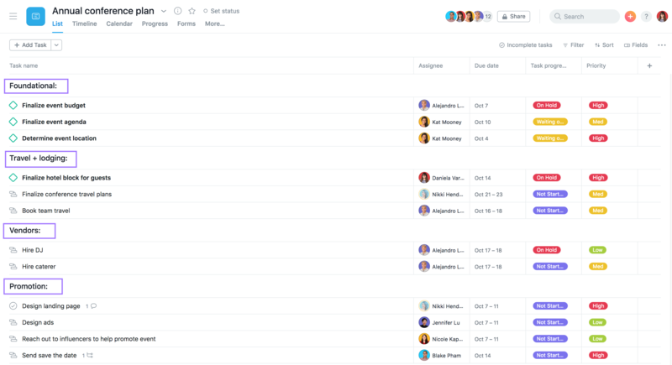

[**Sections**](https://asana.com/guide/help/projects/sections) group your tasks, making it easier to parse the project. They’re most helpful for categories that won’t change as work moves forward. For example, you could create sections by timeframe (like quarters or month), project phase, or a Kanban style “to do,” “doing,” and “done.”

### Sort and filter tasks in projects with custom fields

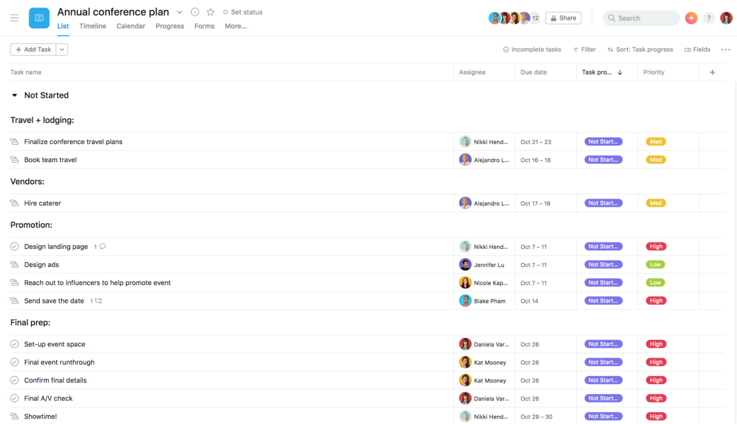

[**Custom fields**](https://asana.com/guide/team/advanced/connect-your-work#gl-custom-fields) are like spreadsheet column headers to help you filter and sort tasks in your project by things like priority, task status, cost, or approval. Group your project by clicking any header and using the [**filter and sort buttons**](https://asana.com/guide/help/views/list#gl-recommended).

## 4. How to find your work and updates about it

As projects move forward, and new work comes your way, Asana gives you lots of options to stay on top of it. Open the [**sidebar**](https://asana.com/guide/help/fundamentals/navigating-asana#gl-sidebar) to quickly see:

### My Tasks

[**My Tasks**](https://asana.com/guide/get-started/begin/quick-start#lessons) shows only the tasks assigned to you and when they’re due. Come back to My Tasks throughout the day to check off tasks you’ve completed, see any new work that’s come in, and get started on your next task.

### Inbox

[**Inbox**](https://asana.com/guide/get-started/begin/quick-start#lessons) is a filtered news feed of updates, but only for the work you’re following. You can also respond to things right from Inbox and quickly navigate to your work.

## 5. How Asana's organized

Projects and tasks are the most fundamental building blocks of Asana.

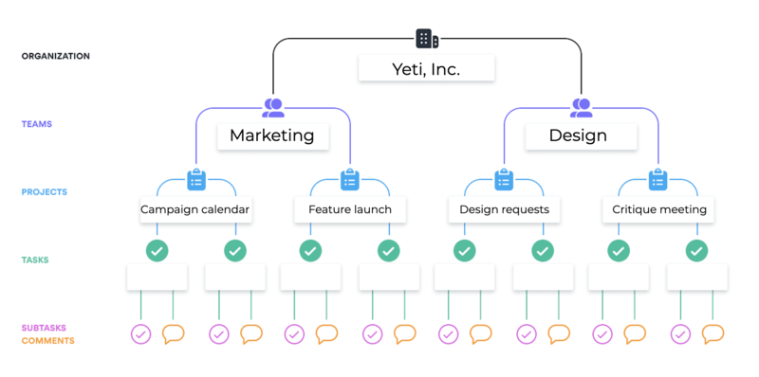

1. [**Organizations**](https://asana.com/guide/help/organizations/basics) are based on your company’s shared email domain, and connect everybody within your company that uses Asana.
2. [**Teams**](https://asana.com/guide/help/organizations/team-basics) are functional groups in an Organization that likely correspond to general teams, like marketing or sales, or functional groups like "NYC Office."
3. [**Projects**](https://asana.com/guide/get-started/begin/create-project) are stored in Teams (and Portfolios) to track all the actionable steps, information, and communications towards achieving a goal, initiative, or objective.
4. [**Tasks**](https://asana.com/guide/get-started/begin/adding-assigning-tasks) are stored in projects and make it clear who’s responsible for what by when. Tasks store all the files, conversations, and instructions related to it so they're easy to find in one place.
5. [**Portfolios**](https://asana.com/guide/team/onboard/portfolio-management) store groups of projects. You can use them to see all the projects and status updates towards an initiative or objective in one place.

## Task:

Create a new Project, Add Tasks and Explore the Asana Environment. Insert the screenshots here.

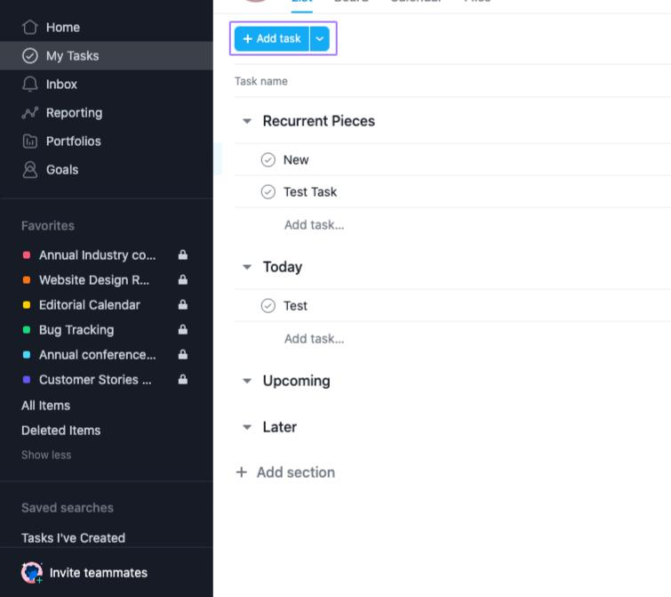

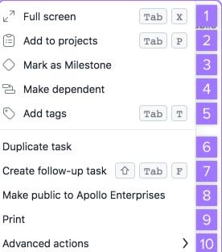

## Observations:

Please write your observation after conducting this lab, you have to write in few lines, what did you learn in this lab.

Asana is made for teams to improve the tasks management and collaboration. ... In general, it´s a very good structured tool, especially with the parts teams and projects. Everything is in place and makes it easy to find everything.

**Rubrics**:

|  |  |  |  |  |  |  |
| --- | --- | --- | --- | --- | --- | --- |
| Demonstration | Absent | Student is unable to follow the provided instructions properly.  The student can name the hardware or simulation platform, but unable to implement anything practically or on the software | Student can understand the provided laboratory instructions and familiar with the lab environment (Trainer/ software/ IDE), but cannot implement on the platform practically or on the software | Student has followed instructions to construct the fundamental schematic/ block diagram/ code/ model on the protoboard/ trainer/ simulation software. | Student has constructed the functional/ working schematic/ model/ block diagram/ code, and have successfully executed the program/ run circuit on software platform | Student perfectly implemented a working model/ logic/ circuit/ block diagram/ code and successfully executed the lab objective in Realtime or in a simulation environment and produced the desired results |
| **Category** | ***Ungraded*** | **Very Poor** | **Poor** | **Fair** | **Good** | **Excellent** |
| **Percentage** | [0] | [1-20] | [21-40] | [41-60] | [61-80] | [81-100] |
| **Marks** | 0.0 | 0.01 - 0.20 | 0.21 - 0.40 | 0.41 - 0.60 | 0.61 - 0.80 | 0.81 - 1.0 |
| **Date** |  | **Total Marks** |  | **Instructor’s Signature** | |  |

|  |  |  |  |  |  |  |
| --- | --- | --- | --- | --- | --- | --- |
| **Laboratory Reports** | Report not submitted | Plagiarized content presented or incomplete submission | Requirements are listed and experimental procedure is presented | Observations are recorded along with detailed procedure | Appropriate computations or numerical analysis is performed | Correctly drawn conclusion with  exact results and complete report in all respects |
| **Category** | ***Ungraded*** | **Very Poor** | **Poor** | **Fair** | **Good** | **Excellent** |
| **Percentage** | [0] | [1-20] | [21-40] | [41-60] | [61-80] | [81-100] |
| **Marks** | 0.0 | 0.01 - 0.20 | 0.21 - 0.40 | 0.41 - 0.60 | 0.61 - 0.80 | 0.81 - 1.0 |
| **Date** |  | **Total Marks** |  | **Instructor’s Signature** | |  |

14/03/2022

LAB NO.12

# Bug Tracking and Agile Project Management with Jira

## Lab outcomes:

After completing this lab, students will be able to:

* Configure Project in Jira
* Manage any project
* Bug Tracking

## Corresponding CLO and PLO:

* CLO-2, PLO-5(Modern Tool Usage)

## Requirements:

* Jira

## Theory:

Jira is a proprietary issue tracking product developed by Atlassian that allows bug tracking and agile project management.

### What is agile project management?

Agile project management is an iterative approach to managing software development projects that focuses on continuous releases and incorporating customer feedback with every iteration.

Software teams that embrace agile project management methodologies increase their development speed, expand collaboration, and foster the ability to better respond to market trends.

### Step 1: Create a scrum project

Once you [create](https://www.atlassian.com/software/jira/free) and log in to an account in Jira Software, you can select a template from the library. Select Scrum (you can learn how to create a [Kanban project here](https://www.atlassian.com/agile/tutorials/how-to-do-kanban-with-jira-software)).

Next, you’ll be prompted to choose a project type. If your team works independently and wants to control your own working processes and practices in a self-contained space, consider giving our team-managed Scrum template a try. See [Getting started with team-managed projects](https://community.atlassian.com/t5/Next-gen-articles/Getting-started-with-next-gen-projects/ba-p/914448) at the Atlassian Community to learn more.

Once you've created your project, you will land on the empty [backlog](https://www.atlassian.com/agile/scrum/backlogs). The backlog is also known as the product backlog and contains an ongoing list of your team's potential work items for the project.

### Step 2: Create user stories or tasks in the backlog

In Jira Software, we call work items like user stories, tasks, and bugs "[issues](https://www.atlassian.com/agile/tutorials/issues)". Create a few user stories with the quick create option on the backlog. If you don't have user stories in mind, just create sample stories to get started and see how the process works.

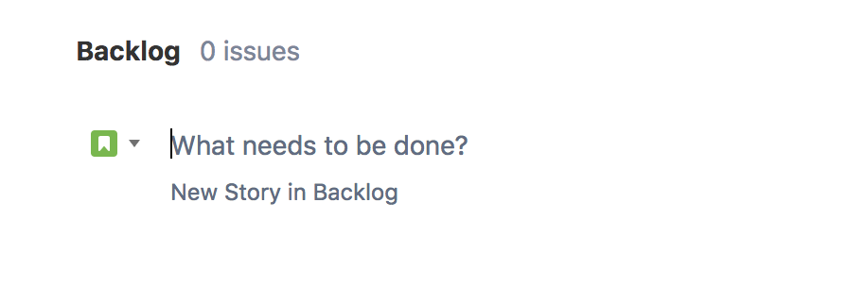

WHAT ARE USER STORIES?

[User stories](https://www.atlassian.com/agile/project-management/user-stories) are used to describe work items in a non-technical language and from a user's perspective. . As a {type of user}, I want {goal} so that I {receive benefit}.

Let's use a website as a simple example to create a user story.

As a customer, I want to be able to create an account so that I can see my previous purchases.

User stories are usually sketched out and prioritized by the product owner, and then the development team determines detailed tasks necessary to complete the story in an upcoming sprint. The development team is also responsible for estimating the relative effort required to complete the work of the story.

Once you've created a few user stories, you can start prioritizing them in the backlog. In Jira Software, you rank or prioritize your stories by dragging and dropping them in the order that they should be worked on.

These are just the starting stories for your project. You will continue to create stories for the project's lifetime. This is because agility involves continuously learning and adapting.

### Step 3: Create a sprint

Create your first sprint in the backlog so you can start planning the sprint.

WHAT IS A SPRINT?

In Scrum, teams forecast to complete a set of user stories or other work items during a fixed time duration, known as a sprint. Generally speaking, sprints are one, two, or four weeks long. It's up to the team to determine the length of a sprint — we recommend starting with two weeks. That's long enough to get something accomplished, but not so long that the team isn't getting regular feedback. Once a sprint cadence is determined, the team perpetually operates on that cadence. Fixed length sprints reinforce estimation skills and predict the future velocity for the team as they work through the backlog.

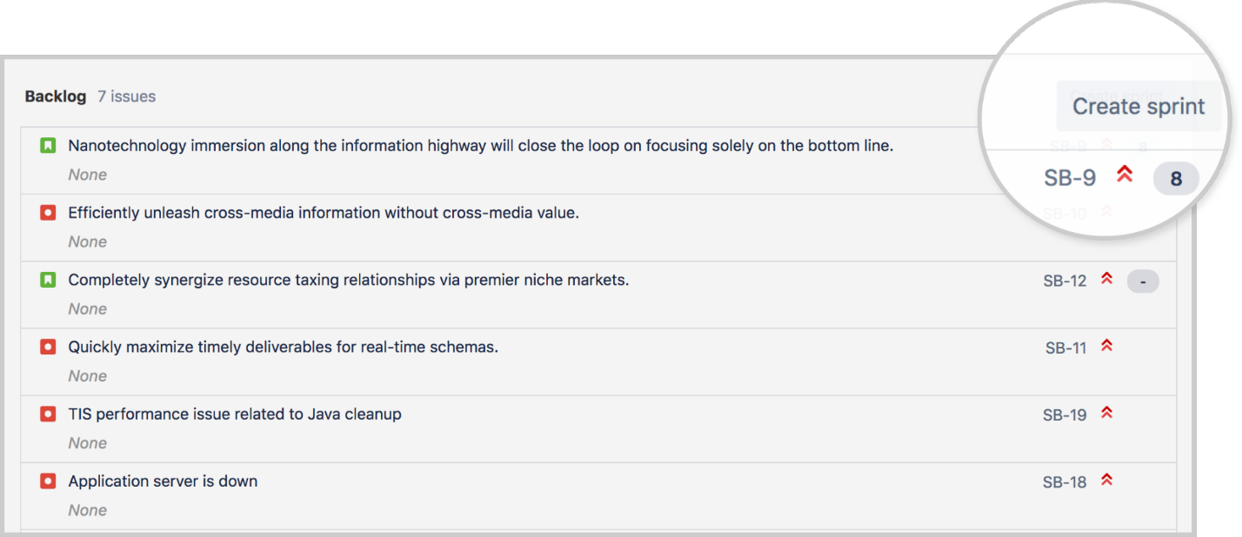

### Step 4: Hold the sprint planning meeting

At the beginning of a sprint, you should hold the sprint planning meeting with the rest of your team. The sprint planning meeting is a ceremony that sets up the entire team for success throughout the sprint. In this meeting, the entire team discusses the sprint goal and the stories in the prioritized product backlog. The development team creates detailed tasks and estimates for the high-priority stories. The development team then commits to completing a certain number of stories in the sprint. These stories and the plan for completing them become what is known as the sprint backlog.

Add story point estimates to your stories by adding a number in the **Story point estimate** field. You can also add more details to the stories or click the **create subtask** icon to further break down the work of the story.

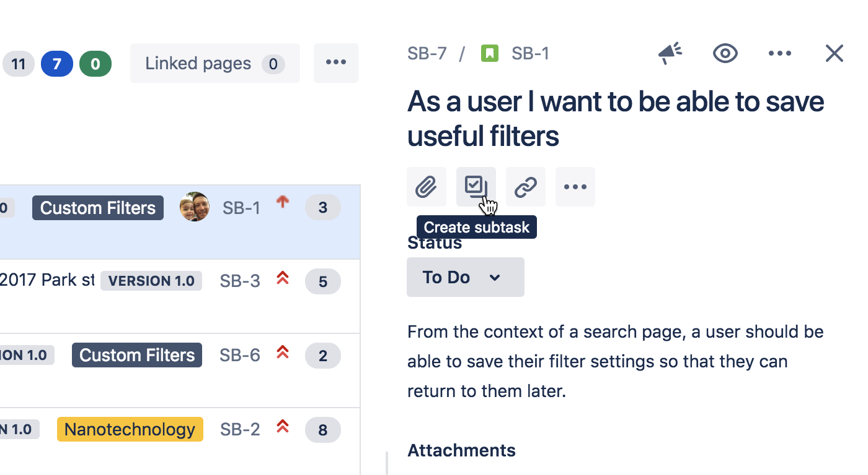

When you're ready, drag the stories agreed to in the sprint planning meeting into the sprint that you just created. This is your sprint backlog.

WHAT IS THE SPRINT PLANNING MEETING?

**Attendees:** Required: development team, [scrum master](https://www.atlassian.com/agile/scrum/scrum-master), product owner

**When:**At the beginning of a sprint.

**Duration:** Usually two hours per week of iteration – e.g. a two-week sprint kicks off with a four-hour planning meeting. The meeting ends when its purpose has been achieved.

**Purpose:** Plan the work of the sprint. The team agrees to the sprint goal and the sprint backlog.

WHAT IS A SPRINT GOAL?

When creating a sprint, the product owner usually identifies a sprint goal. This provides a theme for the work to be completed in the sprint. A sprint goal also provides some flexibility in the number of stories that are completed in a sprint. A sprint is considered a success if the sprint goal is achieved.

WHAT IS AGILE ESTIMATION?

Traditional software teams give estimates in a time format: days, weeks, months.  
Many agile teams, however, have transitioned to story points. Story points rate the relative effort of work, often in a Fibonacci-like format: 0, 0.5, 1, 2, 3, 5, 8, 13, 20, 40, 100.

Estimates help you gauge how much work you should add to the next sprint based on the number of team members you have. After a few sprints, your team will get better at figuring out how much work they can do each sprint, which will help avoid over-committing.

### Step 5: Start the sprint in Jira

Name the sprint. Some teams name the sprint based on their sprint goal. If there is a commonality between the issues in the sprint, name the sprint around that theme. Otherwise, you can name the sprint whatever you like.

Add a duration of the sprint and start and end dates. The start and end dates should align to your team's schedule. For example, some teams start sprints on a Monday and then end on a Friday morning in the next week. Other teams decide to start and end their sprints mid-week. It's up to you! If you're unsure how long your sprints should be, we recommend trying two weeks.

Add the sprint goal as agreed to in the sprint planning meeting.

Once you start your sprint, you will be taken to the Active sprints tab in the project.

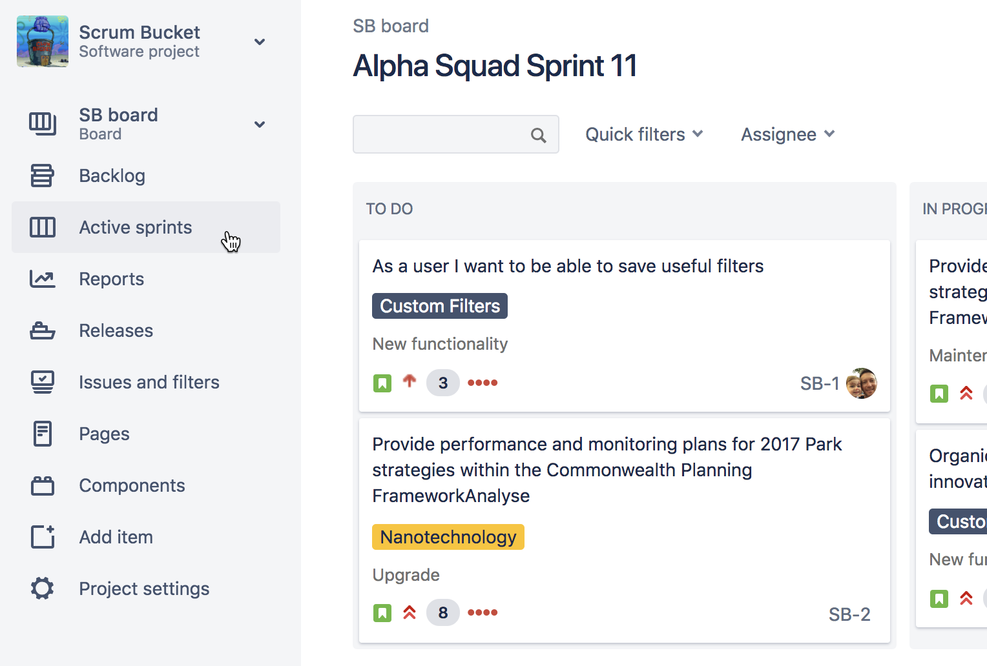

This is where your team will work to pick up items from the to-do column and move them into in-progress and eventually, done!

If you’re using the team-managed scrum template, this will be called a **Board**.

### Step 6: Hold the daily standup meetings

After your sprint has started, have your team meet daily, typically in the morning, to review what everyone is working on. The purpose of this is to see if anyone on your team is experiencing any roadblocks towards the completion of sprint tasks.

WHAT IS THE DAILY STANDUP MEETING?

**Attendees (Primarily):** development team

**When:**Once per day, typically in the morning

**Duration:** No more than 15 minutes. Don't book a conference room and conduct the standup sitting down. Standing up helps keep the meeting short!

**Purpose:**The daily standup is designed to inform everyone quickly of what's going on across the team and to plan the work of the day. It's not a full status meeting. The tone should be light and fun, but informative. Have each team member answer the following questions:

* What did I complete yesterday?
* What will I work on today?
* Am I blocked by anything?

There's an implicit accountability in reporting what work you completed yesterday in front of your peers. No one wants to be the team member who is constantly doing the same thing and not making progress.

**ProTip:**Some teams use timers to keep everyone on track. Others toss a ball across the team to make sure everyone's paying attention. Many distributed teams use video-conferencing or group chat to close the distance gap. Your team is unique — your standup should be, too!

You can use the active sprints of your [scrum board](https://www.atlassian.com/software/jira/features/scrum-boards) during the daily standup, so that each member can view the tasks they're working on.

### Step 7: View the Burndown Chart

It's a good idea to check the Burndown Chart during a sprint. In Jira Software, the Burndown Chart shows the actual and estimated amount of work to be done in a sprint. The Burndown Chart is automatically updated by Jira as you complete work items. To view this chart, click Reports from the sidebar, and then select the Burndown Chart from the reports dropdown.

WHAT IS A BURNDOWN CHART AND HOW DO YOU READ IT

A Burndown Chart shows the actual and estimated amount of work to be done in a sprint. The horizontal x-axis in a Burndown Chart indicates time, while the vertical y-axis typically indicates story points.

Use the Burndown Chart to track the total work remaining for a sprint, and to project the likelihood of achieving the sprint goal. By tracking the remaining work throughout the iteration, a team can manage its progress and respond accordingly.

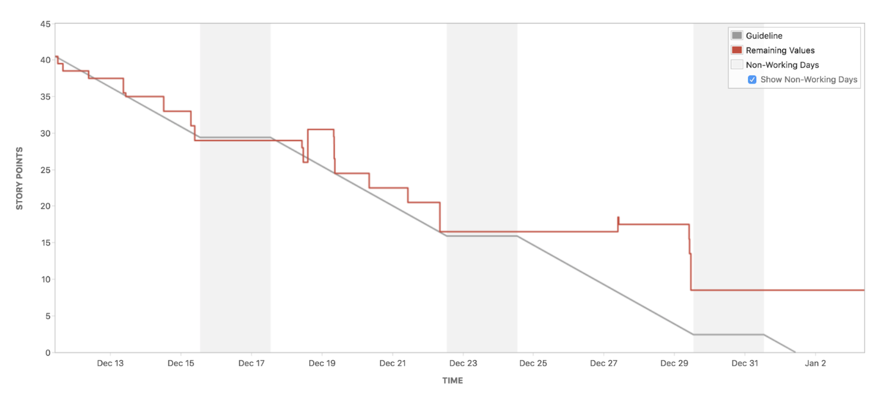

ANTI-PATTERNS TO WATCH FOR

* The team finishes early sprint after sprint because they aren't committing to enough work.
* The team misses their forecast sprint after sprint because they're committing to too much work.
* The burndown line makes steep drops rather than a more gradual burndown because the work hasn't been broken down into granular pieces.
* The product owner adds or changes the scope mid-sprint.

### Step 8: View the sprint report

At any point during or after the sprint, you can view the Sprint Report to monitor the sprint.

WHAT IS THE SPRINT REPORT?

The Sprint Report includes the Burndown Chart, and lists the work completed, work not completed, and any work added after the sprint started.

### Step 9: Hold the sprint review meeting

The sprint review, or sprint demo, is a sharing meeting where the team shows what they've shipped in that sprint. Each sprint usually produces a working part of the product called an increment.

This is a meeting with a lot of feedback on the project and includes a brainstorming session to help decide what to do next.

**Attendees (Primarily):** development team, scrum master, product owner.  
**Optional:** stakeholders

**When:**Typically on the last day of the sprint

**Duration:** Typically two hours for a two-week sprint

**Purpose:**Inspect the increment and collaboratively update the product backlog.

**Questions to ask:**

* Did the team meet the sprint forecast?
* Was there work added or removed during the middle of the sprint?
* Did any work not get completed within the sprint?
* If so, why?

### Step 10: Hold the sprint retrospective meeting

After you complete the sprint, have your team do a retrospective. Document your retrospective somewhere. May we suggest [Confluence](https://www.atlassian.com/software/confluence)?

WHAT IS A SPRINT RETROSPECTIVE MEETING?

**Attendees:** development team, scrum master, product owner.

**When:**At the end of an iteration.

**Duration:**  Typically 90 minutes for a two-week sprint.

**Purpose:**The team inspects itself, including its processes, tools and team interaction. Improvement issues are often added to the next sprint's backlog.

Retrospectives aren't just a time for complaints without action. Use retrospectives to find out what's working so the team can continue to focus on those areas. Also, find out what's not working and use the time to find creative solutions and develop an action plan. Continuous improvement is what sustains and drives development within an agile team, and retrospectives are a key part of that.

**Questions to ask:**

* What did we do well during the sprint?
* What could we have done better?
* What are we going to do better for next time?

**ProTip:** Even if things are going well across the team, don't stop doing retrospectives. Retrospectives provide ongoing guidance for the team to keep things going well.

### Step 11: Complete the sprint in Jira

At the end of the sprint, you must complete it.

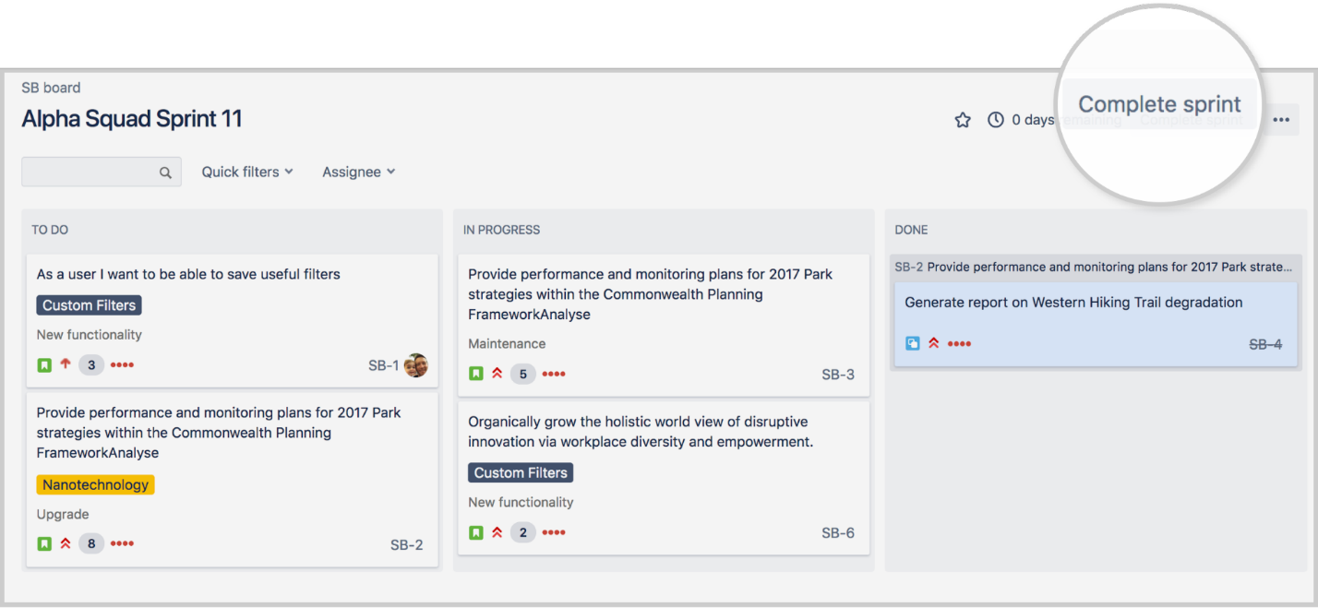

If the sprint has incomplete issues, you can:

* Move the issue(s) to the backlog.
* Move the issue(s) to a future sprint.
* Move the issue(s) to a new sprint, which Jira will create for you.

### Step 12: Repeat from step 2

At this point, you've got the basics on building your backlog with user stories, organizing your user stories into sprints, starting your sprint, and holding Scrum ceremonies. You can decide if this is working for your team

## Task:

Create a new Project, add Tasks in backlog, create sprint and explore the Jira environment. Insert the screenshots here.

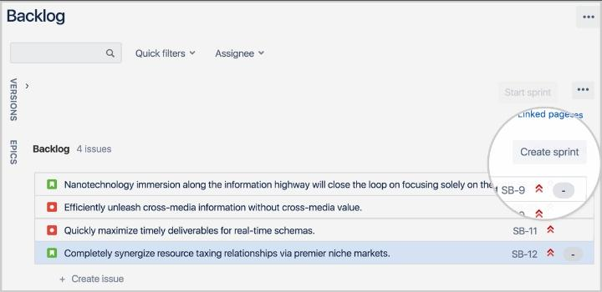

## Observations:

Please write your observation after conducting this lab, you have to write in few lines, what did you learn in this lab.

Jira is a software application used for issue tracking and project management. The tool, developed by the Australian software company Atlassian, has become widely used by agile development teams to track bugs, stories, epics, and other tasks.

## Rubrics

|  |  |  |  |  |  |  |
| --- | --- | --- | --- | --- | --- | --- |
| **Demonstration** | Absent | Student is unable to follow the provided instructions properly.  The student can name the hardware or simulation platform, but unable to implement anything practically or on the software | Student can understand the provided laboratory instructions and familiar with the lab environment (Trainer/ software/ IDE), but cannot implement on the platform practically or on the software | Student has followed instructions to construct the fundamental schematic/ block diagram/ code/ model on the protoboard/ trainer/ simulation software. | Student has constructed the functional/ working schematic/ model/ block diagram/ code, and have successfully executed the program/ run circuit on software platform | Student perfectly implemented a working model/ logic/ circuit/ block diagram/ code and successfully executed the lab objective in Realtime or in a simulation environment and produced the desired results |
| **Category** | ***Ungraded*** | **Very Poor** | **Poor** | **Fair** | **Good** | **Excellent** |
| **Percentage** | [0] | [1-20] | [21-40] | [41-60] | [61-80] | [81-100] |
| **Marks** | 0.0 | 0.01 - 0.20 | 0.21 - 0.40 | 0.41 - 0.60 | 0.61 - 0.80 | 0.81 - 1.0 |
| **Date** |  | **Total Marks** |  | **Instructor’s Signature** | |  |

|  |  |  |  |  |  |  |
| --- | --- | --- | --- | --- | --- | --- |
| **Laboratory Reports** | Report not submitted | Plagiarized content presented or incomplete submission | Requirements are listed and experimental procedure is presented | Observations are recorded along with detailed procedure | Appropriate computations or numerical analysis is performed | Correctly drawn conclusion with  exact results and complete report in all respects |
| **Category** | ***Ungraded*** | **Very Poor** | **Poor** | **Fair** | **Good** | **Excellent** |
| **Percentage** | [0] | [1-20] | [21-40] | [41-60] | [61-80] | [81-100] |
| **Marks** | 0.0 | 0.01 - 0.20 | 0.21 - 0.40 | 0.41 - 0.60 | 0.61 - 0.80 | 0.81 - 1.0 |
| **Date** |  | **Total Marks** |  | **Instructor’s Signature** | |  |